

MS5105 Handup Exercise 6 | Total Pages: 164
Student Name: Jayakarthi Boovendran | Student Number: 19230487

Question: | Exercise: | Page Number:
1 Part A | Ch 06 - Exercise 02A | 1
1 Part B | Ch 06 - Exercise 02B | 20
2 Part A | Ch 06 - Exercise 06A | 39
2 Part B | Ch 06 - Exercise 06B | 57
3 Part A | Ch 06 - Exercise 08A | 75
3 Part B | Ch 06 - Exercise 08B | 95
4 Part A | Ch 07 - Exercise 04A | 113
4 Part B | Ch 07 - Exercise 04B | 121
5 Part A | Ch 08 - Exercise 06A | 129
5 Part B | Ch 08 - Exercise 06B | 143
6 Part A | Ch 09 - Exercise 01A | 157
6 Part B | Ch 09 - Exercise 01B | 161

Exercise Number: Ch 06 - Exercise 02A
Dataset Used : [DataSet1] C:\Users\Jaya Karthi Booven\Desktop\SPSS\6.2\Ch 06 - Exercise 02A.sav
Selection of Test :
The primary objective of the given exercise is to compare three different groups of continuous variables and decide on the groups that outperform the others. Since we are comparing more than two groups of continuous variables, we prefer ANOVA test.

Groups
Group 1: Freshmen with no mentor (Control Group)
Group 2: Freshmen with In-person mentor (Treatment Group 1)
Group 3: Freshmen with E-mentor (Treatment Group 2)

Hypotheses
H₀ – There is no difference between the overall grades of freshmen of these groups (Null Hypotheses)
H₁ – At least one group outperforms another in terms of the overall grades (Alternative Hypotheses)

Pre-test Checklist for ANOVA Test
Following are the pre-test conditions for running ANOVA,
- Normality
- n quota
- Homogeneity of Variance

Description of the Test : Pre-test Conditions for ANOVA
Pre-Test Condition - 1 : Normality
Warning # 5281. Command name: GET FILE
SPSS Statistics is running in Unicode encoding mode. This file is encoded in a locale-specific (code page) encoding. The defined width of any string variables are automatically tripled in order to avoid possible data loss. You can use ALTER TYPE to set the width of string variables to the width of the longest observed value for each string variable.
DATASET NAME DataSet1 WINDOW=FRONT.

Group 1: Freshmen with no mentor

USE ALL.
COMPUTE filter_$=(group=1).
VARIABLE LABELS filter_$ 'group=1 (FILTER)'.
VALUE LABELS filter_$ 0 'Not Selected' 1 'Selected'.
FORMATS filter_$ (f1.0).
FILTER BY filter_$.
EXECUTE.

FREQUENCIES VARIABLES=grade
/STATISTICS=STDDEV VARIANCE RANGE MINIMUM MAXIMUM MEAN MEDIAN MODE
/HISTOGRAM NORMAL
/ORDER=ANALYSIS.

Descriptive Statistics

Statistics
grade
N | Valid | 25
N | Missing | 0
Mean |  | 68.84
Median |  | 71.00
Mode |  | 72ª
Std. Deviation |  | 7.565
Variance |  | 57.223
Range |  | 26
Minimum |  | 53
Maximum |  | 79

Fig 1 : Descriptive Statistics of Group1

Frequencies
grade
 |  | Frequency | Percent | Valid Percent | Cumulative Percent
Valid | 53 | 1 | 4.0 | 4.0 | 4.0
Valid | 55 | 1 | 4.0 | 4.0 | 8.0
Valid | 58 | 1 | 4.0 | 4.0 | 12.0
Valid | 59 | 1 | 4.0 | 4.0 | 16.0
Valid | 61 | 1 | 4.0 | 4.0 | 20.0
Valid | 62 | 2 | 8.0 | 8.0 | 28.0
Valid | 64 | 1 | 4.0 | 4.0 | 32.0
Valid | 67 | 1 | 4.0 | 4.0 | 36.0
Valid | 69 | 1 | 4.0 | 4.0 | 40.0
Valid | 70 | 1 | 4.0 | 4.0 | 44.0
Valid | 71 | 2 | 8.0 | 8.0 | 52.0
Valid | 72 | 3 | 12.0 | 12.0 | 64.0
Valid | 73 | 2 | 8.0 | 8.0 | 72.0
Valid | 74 | 2 | 8.0 | 8.0 | 80.0
Valid | 76 | 1 | 4.0 | 4.0 | 84.0
Valid | 78 | 3 | 12.0 | 12.0 | 96.0
Valid | 79 | 1 | 4.0 | 4.0 | 100.0
Valid | Total | 25 | 100.0 | 100.0

Fig 2 : Frequencies of Group 1

Group 2: Freshmen with In-person mentor

USE ALL.
COMPUTE filter_$=(group=2).
VARIABLE LABELS filter_$ 'group=2 (FILTER)'.
VALUE LABELS filter_$ 0 'Not Selected' 1 'Selected'.
FORMATS filter_$ (f1.0).
FILTER BY filter_$.
EXECUTE.

FREQUENCIES VARIABLES=grade
/STATISTICS=STDDEV VARIANCE RANGE MINIMUM MAXIMUM MEAN MEDIAN MODE
/HISTOGRAM NORMAL
/ORDER=ANALYSIS.

Descriptive Statistics

Statistics
grade
N | Valid | 25
N | Missing | 0
Mean |  | 69.12
Median |  | 67.00
Mode |  | 65
Std. Deviation |  | 7.322
Variance |  | 53.610
Range |  | 28
Minimum |  | 57
Maximum |  | 85

Fig 3 : Descriptive Statistics of Group 2
Frequencies
grade
 |  | Frequency | Percent | Valid Percent | Cumulative Percent
Valid | 57 | 1 | 4.0 | 4.0 | 4.0
Valid | 60 | 1 | 4.0 | 4.0 | 8.0
Valid | 62 | 1 | 4.0 | 4.0 | 12.0
Valid | 63 | 2 | 8.0 | 8.0 | 20.0
Valid | 64 | 2 | 8.0 | 8.0 | 28.0
Valid | 65 | 4 | 16.0 | 16.0 | 44.0
Valid | 66 | 1 | 4.0 | 4.0 | 48.0
Valid | 67 | 2 | 8.0 | 8.0 | 56.0
Valid | 68 | 1 | 4.0 | 4.0 | 60.0
Valid | 72 | 2 | 8.0 | 8.0 | 68.0
Valid | 73 | 2 | 8.0 | 8.0 | 76.0
Valid | 74 | 1 | 4.0 | 4.0 | 80.0
Valid | 76 | 1 | 4.0 | 4.0 | 84.0
Valid | 77 | 1 | 4.0 | 4.0 | 88.0
Valid | 82 | 1 | 4.0 | 4.0 | 92.0
Valid | 83 | 1 | 4.0 | 4.0 | 96.0
Valid | 85 | 1 | 4.0 | 4.0 | 100.0
Valid | Total | 25 | 100.0 | 100.0

Fig 4 : Frequencies of Group 2

Group 3: Freshmen with E-mentor

USE ALL.
COMPUTE filter_$=(group=3).
VARIABLE LABELS filter_$ 'group=3 (FILTER)'.
VALUE LABELS filter_$ 0 'Not Selected' 1 'Selected'.
FORMATS filter_$ (f1.0).
FILTER BY filter_$.
EXECUTE.

FREQUENCIES VARIABLES=grade
/STATISTICS=STDDEV VARIANCE RANGE MINIMUM MAXIMUM MEAN MEDIAN MODE
/HISTOGRAM NORMAL
/ORDER=ANALYSIS.

Descriptive Statistics
Statistics
grade
N | Valid | 25
N | Missing | 0
Mean |  | 75.28
Median |  | 75.00
Mode |  | 75ª
Std. Deviation |  | 10.616
Variance |  | 112.710
Range |  | 40
Minimum |  | 50
Maximum |  | 90

a. Multiple modes exist. The smallest value is shown

Fig 5 : Descriptive Statistics of Group 3

Frequencies
grade
 |  | Frequency | Percent | Valid Percent | Cumulative Percent
Valid | 50 | 1 | 4.0 | 4.0 | 4.0
Valid | 56 | 1 | 4.0 | 4.0 | 8.0
Valid | 60 | 1 | 4.0 | 4.0 | 12.0
Valid | 64 | 1 | 4.0 | 4.0 | 16.0
Valid | 66 | 1 | 4.0 | 4.0 | 20.0
Valid | 68 | 1 | 4.0 | 4.0 | 24.0
Valid | 69 | 1 | 4.0 | 4.0 | 28.0
Valid | 70 | 1 | 4.0 | 4.0 | 32.0
Valid | 71 | 1 | 4.0 | 4.0 | 36.0
Valid | 73 | 1 | 4.0 | 4.0 | 40.0
Valid | 74 | 1 | 4.0 | 4.0 | 44.0
Valid | 75 | 2 | 8.0 | 8.0 | 52.0
Valid | 77 | 1 | 4.0 | 4.0 | 56.0
Valid | 80 | 1 | 4.0 | 4.0 | 60.0
Valid | 82 | 1 | 4.0 | 4.0 | 64.0
Valid | 83 | 1 | 4.0 | 4.0 | 68.0
Valid | 84 | 2 | 8.0 | 8.0 | 76.0
Valid | 85 | 2 | 8.0 | 8.0 | 84.0
Valid | 86 | 1 | 4.0 | 4.0 | 88.0
Valid | 87 | 1 | 4.0 | 4.0 | 92.0
Valid | 88 | 1 | 4.0 | 4.0 | 96.0
Valid | 90 | 1 | 4.0 | 4.0 | 100.0
Valid | Total | 25 | 100.0 | 100.0

Fig 6 : Frequencies of Group 3
Normality Assessment
In this exercise, Normality is assessed in a two-step process,
- Graphical Tests of Normality
- Numerical Tests of Normality

Graphical Tests of Normality
- In graphical tests, the normality is assessed through the visual interpretation of Histograms, Normal Q-Q Plots and Box plots
Numerical Tests of Normality
- In the numerical tests, the normality of the distribution is determined based on the Shapiro -Wilk’s p value and the Skewness and Kurtosis test’s z values

Graphical Tests of Normality

- Histogram with a normal curve

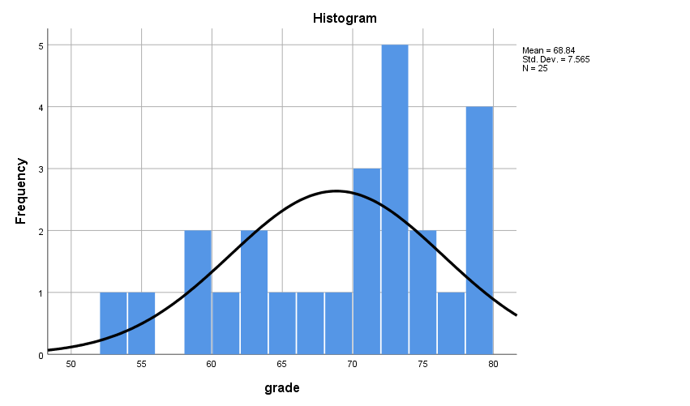
Fig 7 : Histogram with a normal curve for Group1

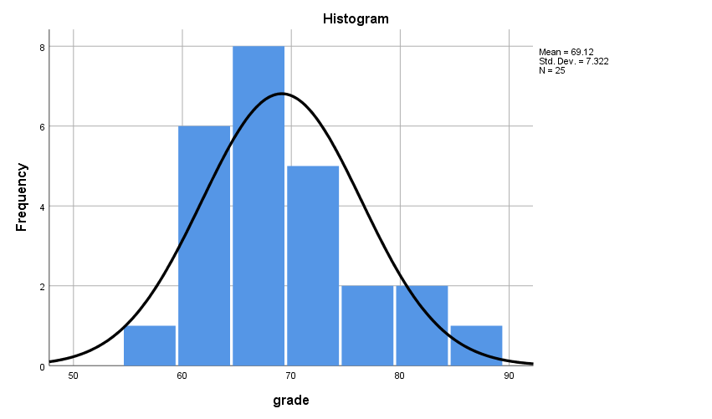

Fig 8 : Histogram with a normal curve for Group2

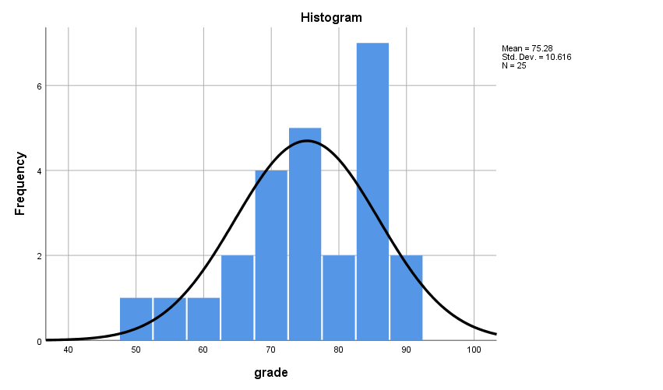
Fig 9 : Histogram with a normal curve for Group3

Visual Interpretation of Histograms

- Group 1: Since majority of the values are accumulated towards the right of the histogram, there is a slight skewness towards the left (negatively skewed).
- Group 2: The normal curve is perfectly bell shaped and is fairly symmetrical. Therefore, the group is considered to be approximately normally distributed
- Group 3: From the visual inspection of the histograms it is quite evident that the normality curve is bell shaped and shows a good symmetry. Therefore, the group is considered to approximately normally distributed

EXAMINE VARIABLES=grade BY group
/PLOT BOXPLOT NPPLOT
/COMPARE GROUPS
/STATISTICS DESCRIPTIVES
/CINTERVAL 95
/MISSING LISTWISE
/NOTOTAL.

- Normal Q-Q Plots

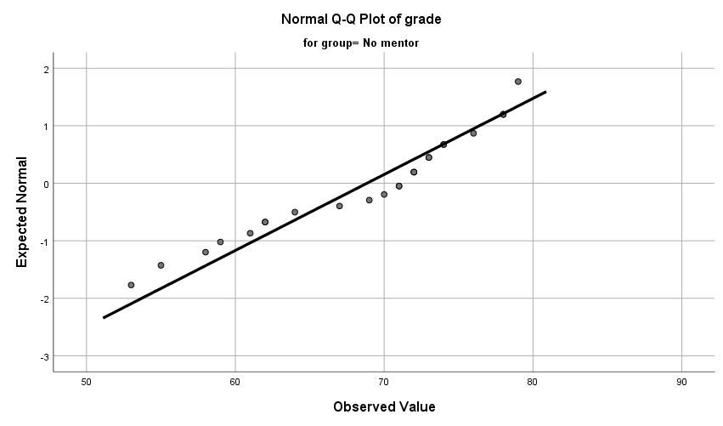
Fig 10 : Normal Q-Q plots –Group1

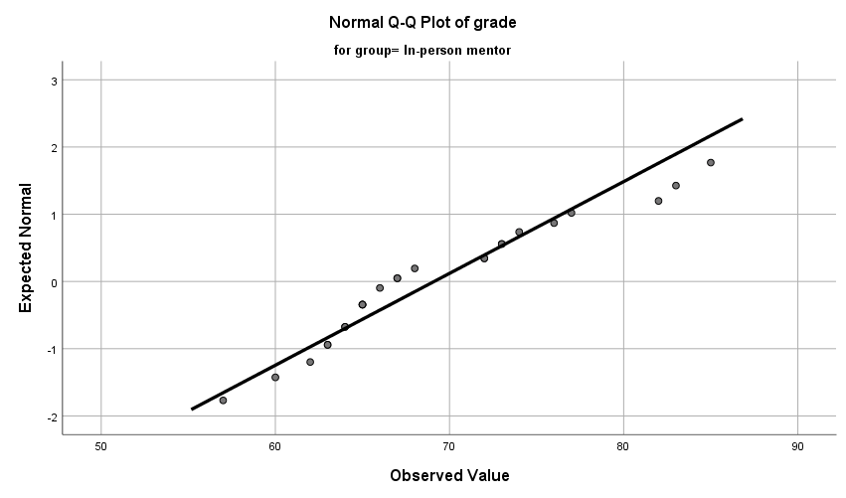

Fig 11 : Normal Q-Q plots – Group2

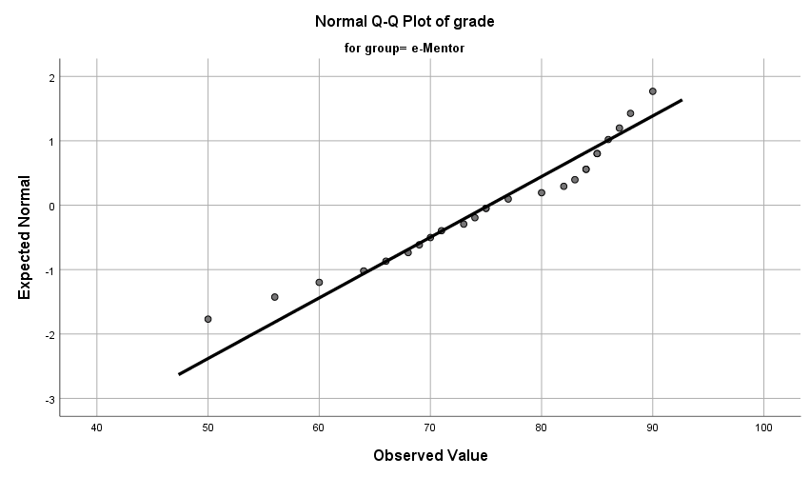

Fig 12 : Normal Q-Q plots – Group3

Visual Interpretation of Normal Q-Q Plots
In all the three groups, majority of the Normal Q-Q plots are aligned to QQ line. Thus, represents a reasonably normal distribution

- Box Plots

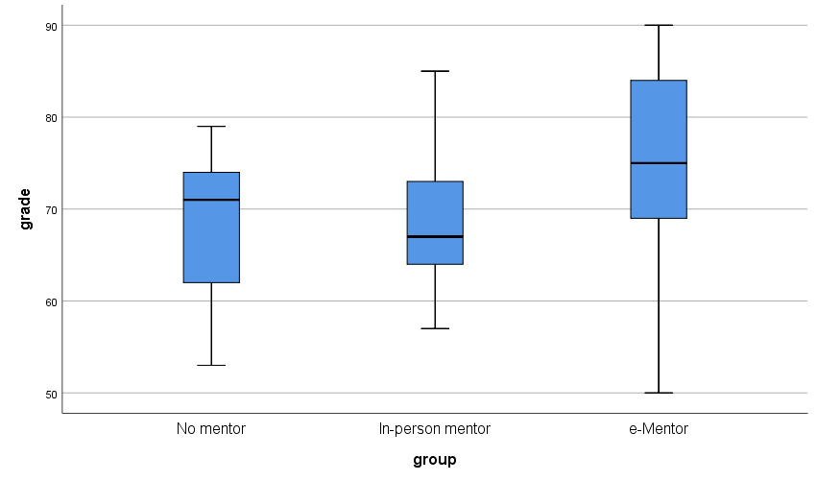
Fig 13 : Box plot – Group1, Group2 and Group3

Visual Interpretation of Box Plots
The box plots of the groups are reasonably symmetrical. Therefore, the groups are considered to be approximately normal distribution.

Numerical Tests of Normality

Case Processing Summary
 | group | Cases
 | group | Valid |  | Missing |  | Total
 | group | N | Percent | N | Percent | N | Percent
grade | No mentor | 25 | 100.0% | 0 | 0.0% | 25 | 100.0%
grade | In-person mentor | 25 | 100.0% | 0 | 0.0% | 25 | 100.0%
grade | e-Mentor | 25 | 100.0% | 0 | 0.0% | 25 | 100.0%

- Shapiro-Wilk’s Test of Normality

Tests of Normality
 | group | Kolmogorov-Smirnovª |  |  | Shapiro-Wilk
 | group | Statistic | df | Sig. | Statistic | df | Sig.
grade | No mentor | .172 | 25 | .054 | .926 | 25 | .071
grade | In-person mentor | .174 | 25 | .049 | .935 | 25 | .111
grade | e-Mentor | .137 | 25 | .200* | .944 | 25 | .182

*. This is a lower bound of the true significance.
a. Lilliefors Significance Correction

Hypotheses
H₀ – The sample distribution is normally distributed (Null Hypotheses)

Discussion
The value of p of Shapiro-Wilk’s test for Group1 is .071
The value of p of Shapiro-Wilk’s test for Group2 is .111
The value of p of Shapiro-Wilk’s test for Group3 is .182

Hypotheses Resolution
Since the Shapiro-Wilk’s value of p > α (α=0.05) in all the cases, H₀ is accepted. Therefore, the distributions of the groups are considered to be approximately normally distributed.
Skewness and Kurtosis Test
Descriptives
 | group |  |  | Statistic | Std. Error | z value
grade | No mentor | Mean |  | 68.84 | 1.513
grade | No mentor | 95% Confidence Interval for Mean | Lower Bound | 65.72
grade | No mentor | 95% Confidence Interval for Mean | Upper Bound | 71.96
grade | No mentor | 5% Trimmed Mean |  | 69.14
grade | No mentor | Median |  | 71.00
grade | No mentor | Variance |  | 57.223
grade | No mentor | Std. Deviation |  | 7.565
grade | No mentor | Minimum |  | 53
grade | No mentor | Maximum |  | 79
grade | No mentor | Range |  | 26
grade | No mentor | Interquartile Range |  | 12
grade | No mentor | Skewness |  | -.611 | .464 | -1.316
grade | No mentor | Kurtosis |  | -.664 | .902 | -0.713
grade | In-person mentor | Mean |  | 69.12 | 1.464
grade | In-person mentor | 95% Confidence Interval for Mean | Lower Bound | 66.10
grade | In-person mentor | 95% Confidence Interval for Mean | Upper Bound | 72.14
grade | In-person mentor | 5% Trimmed Mean |  | 68.90
grade | In-person mentor | Median |  | 67.00
grade | In-person mentor | Variance |  | 53.610
grade | In-person mentor | Std. Deviation |  | 7.322
grade | In-person mentor | Minimum |  | 57
grade | In-person mentor | Maximum |  | 85
grade | In-person mentor | Range |  | 28
grade | In-person mentor | Interquartile Range |  | 10
grade | In-person mentor | Skewness |  | .687 | .464 | 1.480
grade | In-person mentor | Kurtosis |  | -.211 | .902 | -0.233
grade | e-Mentor | Mean |  | 75.28 | 2.123
grade | e-Mentor | 95% Confidence Interval for Mean | Lower Bound | 70.90
grade | e-Mentor | 95% Confidence Interval for Mean | Upper Bound | 79.66
grade | e-Mentor | 5% Trimmed Mean |  | 75.82
grade | e-Mentor | Median |  | 75.00
grade | e-Mentor | Variance |  | 112.710
grade | e-Mentor | Std. Deviation |  | 10.616
grade | e-Mentor | Minimum |  | 50
grade | e-Mentor | Maximum |  | 90
grade | e-Mentor | Range |  | 40
grade | e-Mentor | Interquartile Range |  | 16
grade | e-Mentor | Skewness |  | -.676 | .464 | -1.456
grade | e-Mentor | Kurtosis |  | -.167 | .902 | -0.185

Discussion on Skewness and Kurtosis
Group 1 :
- The value of z obtained by Skewness/Std. Error =-.611/.464 = -1.316 is within the range of -1.96 and +1.96. Therefore is acceptable
- The value of z obtained by Kurtosis/Std. Error =-.664/.902 = -0.713 is within the range of -1.96 and +1.96. Therefore is acceptable

Group 2 :
- The value of z obtained by Skewness/Std. Error =.687/.464 = 1.480 is within the range of -1.96 and +1.96. Therefore is acceptable
- The value of z obtained by Kurtosis/Std. Error =-.211/.902 = -0.233 is within the range of -1.96 and +1.96. Therefore is acceptable

Group 3:
- The value of z obtained by Skewness/Std. Error =-.676/.464 = -1.456 is within the range of -1.96 and +1.96. Therefore is acceptable
- The value of z obtained by Kurtosis/Std. Error =-.167/.902 = -0.185 is within the range of -1.96 and +1.96. Therefore is acceptable

From the numerical analysis of Skewness and Kurtosis it is clear that the distribution of the groups are approximately normally distributed

Discussion on Normality
From the visual interpretation of the graphical test results and through the analysis of numerical tests it is quite evident that the distributions of all the three groups are approximately normally distributed. Therefore, the pre-test criterion of Normality is satisfied

Pre-Test Condition -2 : n Quota

ONEWAY grade BY group
/STATISTICS DESCRIPTIVES HOMOGENEITY
/MISSING ANALYSIS
/POSTHOC=TUKEY ALPHA(0.05).

Descriptives
grade
 | N | Mean | Std. Deviation | Std. Error | 95% Confidence Interval for Mean
 |  |  |  |  | Lower Bound | Upper Bound
No mentor | 25 | 68.84 | 7.565 | 1.513 | 65.72 | 71.96
In-person mentor | 25 | 69.12 | 7.322 | 1.464 | 66.10 | 72.14
e-Mentor | 25 | 75.28 | 10.616 | 2.123 | 70.90 | 79.66
Total | 75 | 71.08 | 9.025 | 1.042 | 69.00 | 73.16

Discussion on n-quota

Since the value of n is less than 30 for all the groups, the pre-test condition of n-quota is not met.

Pre-Test Condition -3 : Homogeneity of Variance

Test of Homogeneity of Variances
 |  | Levene Statistic | df1 | df2 | Sig.
grade | Based on Mean | 2.234 | 2 | 72 | .114
grade | Based on Median | 2.268 | 2 | 72 | .111
grade | Based on Median and with adjusted df | 2.268 | 2 | 69.727 | .111
grade | Based on trimmed mean | 2.325 | 2 | 72 | .105

ANOVA
grade
 | Sum of Squares | df | Mean Square | F | Sig.
Between Groups | 662.480 | 2 | 331.240 | 4.445 | .015
Within Groups | 5365.040 | 72 | 74.514
Total | 6027.520 | 74

Discussion
The value of p > α (p=.114, α=.05) suggests that there is no statistically significant difference between the variances of the groups. Hence, the criterion of Homogeneity of Variance is satisfied.

Documenting the Results of Pre-test Conditions of ANOVA
Following are the results of the pre-test conditions,
- Normality
- n quota
- Homogeneity of Variance

Discussion

Since one of the pre-test conditions of ANOVA is not met, Kruskal-Wallis Test is performed as the best alternative

Description of the Test : Kruskal-Wallis Test
Kruskal-Wallis Test

NPAR TESTS
/K-W=grade BY group(1 3)
/MISSING ANALYSIS.

Ranks
 | group | N | Mean Rank
grade | No mentor | 25 | 33.40
grade | In-person mentor | 25 | 32.52
grade | e-Mentor | 25 | 48.08
grade | Total | 75

Test Statistics^{a,b}
 | grade
Kruskal-Wallis H | 8.054
df | 2
Asymp. Sig. | .018

a. Kruskal Wallis Test
b. Grouping Variable: group

Discussion
- The value of p obtained from Kruskal Wallis is .018
- Since the value of p<α (p=.018, α=0.05), there is a statistically significant difference between the grades of the groups.

Hypothesis Resolution
Reject => H₀ – There is no difference between the overall grades of freshmen of these groups
Accept => H₁ – At least one group outperforms another in terms of the overall grades

Kruskal Wallis – Post Hoc Test
Since there is a statistically significant difference between the groups, we perform pair-wise tests to identify the group that outperforms the others.

Groups | Description | Comparison of Means
Group 1 : Group 2 | No mentor: In-person mentor | µ(G1):µ(G2)
Group 2 : Group 3 | In-person mentor : E-mentor | µ(G2):µ(G3)
Group 1 : Group 3 | No mentor : E-mentor | µ(G1):µ(G3)

- Kruskal Wallis – Group 1 : Group 2
USE ALL.
COMPUTE filter_$=(group = 1 or group = 2).
VARIABLE LABELS filter_$ 'group = 1 or group = 2 (FILTER)'.
VALUE LABELS filter_$ 0 'Not Selected' 1 'Selected'.
FORMATS filter_$ (f1.0).
FILTER BY filter_$.
EXECUTE.

NPAR TESTS
/K-W=grade BY group(1 3)
/MISSING ANALYSIS.

Ranks
 | group | N | Mean Rank
grade | No mentor | 25 | 25.78
grade | In-person mentor | 25 | 25.22
grade | Total | 50

Test Statistics^{a,b}
 | grade
Kruskal-Wallis H | .019
df | 1
Asymp. Sig. | .892

a. Kruskal Wallis Test
b. Grouping Variable: group

- Kruskal Wallis – Group 2 : Group 3

USE ALL.
COMPUTE filter_$=(group = 2 or group = 3).
VARIABLE LABELS filter_$ 'group = 2 or group = 3 (FILTER)'.
VALUE LABELS filter_$ 0 'Not Selected' 1 'Selected'.
FORMATS filter_$ (f1.0).
FILTER BY filter_$.
EXECUTE.

NPAR TESTS
/K-W=grade BY group(1 3)
/MISSING ANALYSIS.

Ranks
 | group | N | Mean Rank
grade | In-person mentor | 25 | 20.30
grade | e-Mentor | 25 | 30.70
grade | Total | 50

Test Statistics^{a,b}
 | grade
Kruskal-Wallis H | 6.373
df | 1
Asymp. Sig. | .012

a. Kruskal Wallis Test
b. Grouping Variable: group

- Kruskal Wallis – Group 1 : Group 3

USE ALL.
COMPUTE filter_$=(group = 1 or group = 3).
VARIABLE LABELS filter_$ 'group = 1 or group = 3 (FILTER)'.
VALUE LABELS filter_$ 0 'Not Selected' 1 'Selected'.
FORMATS filter_$ (f1.0).
FILTER BY filter_$.
EXECUTE.
NPAR TESTS
/K-W=grade BY group(1 3)
/MISSING ANALYSIS.

Ranks
 | group | N | Mean Rank
grade | No mentor | 25 | 20.62
grade | e-Mentor | 25 | 30.38
grade | Total | 50

Test Statistics^{a,b}
 | grade
Kruskal-Wallis H | 5.611
df | 1
Asymp. Sig. | .018

a. Kruskal Wallis Test
b. Grouping Variable: group

Documenting Results of Pair-wise Kruskal Wallis

Groups | Comparison | p value | Discussion
Group 1 : Group 2 | µ(G1) : µ(G2)  68.84 : 69.12 | .892 | - Since p > 0.05, there is no statistically significant difference between Group 1 and Group2
Group 2 : Group 3 | µ(G2) : µ(G3)  69.12 : 75.28 | .012 | - Since the value of p < α (p = .012, α=0.05), there is a statistically significant difference between the groups.  - By comparing the means it is quite evident that Group 3 outperforms Group 2
Group 1 : Group 3 | µ(G1) : µ(G3)  68.84 : 75.28 | .018 | - Since the value of p < α (p = .012, α=0.05), there is a statistically significant difference between the groups.  - By comparing the means it is quite evident that Group 3 outperforms Group 1

Discussion of the Test
In order to assess if having a mentor will improve the overall grades of freshman, the incoming freshman of the program are alternatively assigned to three groups, the control group (with no mentor), In-person mentor (Treatment group 1) and E-mentor (Treatment group2). Freshman in the In-person mentor group are assigned a mentor each and are asked to meet their mentors once every week for the entire term. However, the freshman under the control group has no mentors. Whereas, the e-mentor groups have online meetings every week. All the three groups are have equal distribution (n=25) and are asked to submit academic transcripts by the end of the term.

Since we are comparing more than two groups, we chose ANOVA. However, we proceeded with Kruskal Wallis as one of the pre-test conditions of ANOVA was not satisfied. The Kruskal Wallis’s value of p < α (where p=.018 and α =0.5) indicates a statistically significant difference between the groups. Therefore, we reject H₀ and accept H₁. To figure out which of groups outperformed; we run the pair-wise post hoc tests.

From the results of Post hoc test, we observed a statistically significant difference between the grades of Group 2 and Group 3, also, between Group1 and Group 3. To determine which of these groups outperformed, we compare their means.

Comparing the means of the three groups,
µ(G₁) : µ(G₂) : µ(G₃)
68.84 : 69.12 : 75.28

Since Group 3 had higher mean than others it is quite evident that the E-mentor group statistically outperformed others.

Exercise Number: Ch 06 - Exercise 02B
Dataset Used : [DataSet1] C:\Users\Jaya Karthi Booven\Desktop\SPSS\6.2\Ch 06 - Exercise 02B.sav
Selection of Test :
The primary objective of the given exercise is to compare three different groups of continuous variables and decide on the groups that outperform the others. Since we are comparing more than two groups of continuous variables, we prefer ANOVA test.

Groups
Group 1: Freshmen with no mentor (Control Group)
Group 2: Freshmen with In-person mentor (Treatment Group 1)
Group 3: Freshmen with E-mentor (Treatment Group 2)

Hypotheses
H₀ – There is no difference between the overall grades of freshmen of these groups (Null Hypotheses)
H₁ – At least one group outperforms another in terms of the overall grades (Alternative Hypotheses)

Pre-test Checklist for ANOVA Test
Following are the pre-test conditions for running ANOVA,
- Normality
- n quota
- Homogeneity of Variance

Description of the Test : Pre-test Conditions for ANOVA
Pre-Test Condition - 1 : Normality
Warning # 5281. Command name: GET FILE
SPSS Statistics is running in Unicode encoding mode. This file is encoded in a locale-specific (code page) encoding. The defined width of any string variables are automatically tripled in order to avoid possible data loss. You can use ALTER TYPE to set the width of string variables to the width of the longest observed value for each string variable.
DATASET NAME DataSet1 WINDOW=FRONT.

Group 1: Freshmen with no mentor

USE ALL.
COMPUTE filter_$=(group=1).
VARIABLE LABELS filter_$ 'group=1 (FILTER)'.
VALUE LABELS filter_$ 0 'Not Selected' 1 'Selected'.
FORMATS filter_$ (f1.0).
FILTER BY filter_$.
EXECUTE.

FREQUENCIES VARIABLES=grade
/STATISTICS=STDDEV VARIANCE RANGE MINIMUM MAXIMUM MEAN MEDIAN MODE
/HISTOGRAM NORMAL
/ORDER=ANALYSIS.

Descriptive Statistics

Statistics
grade
N | Valid | 25
N | Missing | 0
Mean |  | 63.56
Median |  | 63.00
Mode |  | 57ª
Std. Deviation |  | 7.042
Variance |  | 49.590
Range |  | 29
Minimum |  | 48
Maximum |  | 77

a. Multiple modes exist. The smallest value is shown

Fig 1 : Descriptive Statistics of Group1

Frequencies

grade
 |  | Frequency | Percent | Valid Percent | Cumulative Percent
Valid | 48 | 1 | 4.0 | 4.0 | 4.0
Valid | 49 | 1 | 4.0 | 4.0 | 8.0
Valid | 57 | 3 | 12.0 | 12.0 | 20.0
Valid | 60 | 3 | 12.0 | 12.0 | 32.0
Valid | 61 | 2 | 8.0 | 8.0 | 40.0
Valid | 62 | 2 | 8.0 | 8.0 | 48.0
Valid | 63 | 1 | 4.0 | 4.0 | 52.0
Valid | 65 | 2 | 8.0 | 8.0 | 60.0
Valid | 67 | 3 | 12.0 | 12.0 | 72.0
Valid | 69 | 3 | 12.0 | 12.0 | 84.0
Valid | 71 | 2 | 8.0 | 8.0 | 92.0
Valid | 75 | 1 | 4.0 | 4.0 | 96.0
Valid | 77 | 1 | 4.0 | 4.0 | 100.0
Valid | Total | 25 | 100.0 | 100.0

Fig 2 : Frequencies of Group 1

Group 2: Freshmen with In-person mentor

USE ALL.
COMPUTE filter_$=(group=2).
VARIABLE LABELS filter_$ 'group=2 (FILTER)'.
VALUE LABELS filter_$ 0 'Not Selected' 1 'Selected'.
FORMATS filter_$ (f1.0).
FILTER BY filter_$.
EXECUTE.

FREQUENCIES VARIABLES=grade
/STATISTICS=STDDEV VARIANCE RANGE MINIMUM MAXIMUM MEAN MEDIAN MODE
/HISTOGRAM NORMAL
/ORDER=ANALYSIS.

Descriptive Statistics

Statistics
grade
N | Valid | 25
N | Missing | 0
Mean |  | 69.40
Median |  | 70.00
Mode |  | 75
Std. Deviation |  | 7.539
Variance |  | 56.833
Range |  | 29
Minimum |  | 54
Maximum |  | 83

Fig 3 : Descriptive Statistics of Group 2
Frequencies
grade
 |  | Frequency | Percent | Valid Percent | Cumulative Percent
Valid | 54 | 1 | 4.0 | 4.0 | 4.0
Valid | 55 | 1 | 4.0 | 4.0 | 8.0
Valid | 61 | 1 | 4.0 | 4.0 | 12.0
Valid | 63 | 3 | 12.0 | 12.0 | 24.0
Valid | 64 | 1 | 4.0 | 4.0 | 28.0
Valid | 65 | 1 | 4.0 | 4.0 | 32.0
Valid | 66 | 1 | 4.0 | 4.0 | 36.0
Valid | 67 | 2 | 8.0 | 8.0 | 44.0
Valid | 69 | 1 | 4.0 | 4.0 | 48.0
Valid | 70 | 2 | 8.0 | 8.0 | 56.0
Valid | 71 | 2 | 8.0 | 8.0 | 64.0
Valid | 75 | 4 | 16.0 | 16.0 | 80.0
Valid | 76 | 2 | 8.0 | 8.0 | 88.0
Valid | 79 | 1 | 4.0 | 4.0 | 92.0
Valid | 82 | 1 | 4.0 | 4.0 | 96.0
Valid | 83 | 1 | 4.0 | 4.0 | 100.0
Valid | Total | 25 | 100.0 | 100.0

Fig 4 : Frequencies of Group 2

Group 3: Freshmen with E-mentor

USE ALL.
COMPUTE filter_$=(group=3).
VARIABLE LABELS filter_$ 'group=3 (FILTER)'.
VALUE LABELS filter_$ 0 'Not Selected' 1 'Selected'.
FORMATS filter_$ (f1.0).
FILTER BY filter_$.
EXECUTE.

FREQUENCIES VARIABLES=grade
/STATISTICS=STDDEV VARIANCE RANGE MINIMUM MAXIMUM MEAN MEDIAN MODE
/HISTOGRAM NORMAL
/ORDER=ANALYSIS.

Descriptive Statistics

Statistics
grade
N | Valid | 25
N | Missing | 0
Mean |  | 69.88
Median |  | 70.00
Mode |  | 69
Std. Deviation |  | 7.468
Variance |  | 55.777
Range |  | 28
Minimum |  | 55
Maximum |  | 83

Fig 5 : Descriptive Statistics of Group 3

Frequencies

grade
 |  | Frequency | Percent | Valid Percent | Cumulative Percent
Valid | 55 | 1 | 4.0 | 4.0 | 4.0
Valid | 57 | 1 | 4.0 | 4.0 | 8.0
Valid | 59 | 1 | 4.0 | 4.0 | 12.0
Valid | 60 | 1 | 4.0 | 4.0 | 16.0
Valid | 63 | 1 | 4.0 | 4.0 | 20.0
Valid | 64 | 1 | 4.0 | 4.0 | 24.0
Valid | 65 | 1 | 4.0 | 4.0 | 28.0
Valid | 66 | 1 | 4.0 | 4.0 | 32.0
Valid | 69 | 3 | 12.0 | 12.0 | 44.0
Valid | 70 | 2 | 8.0 | 8.0 | 52.0
Valid | 71 | 1 | 4.0 | 4.0 | 56.0
Valid | 72 | 2 | 8.0 | 8.0 | 64.0
Valid | 74 | 2 | 8.0 | 8.0 | 72.0
Valid | 75 | 2 | 8.0 | 8.0 | 80.0
Valid | 76 | 1 | 4.0 | 4.0 | 84.0
Valid | 77 | 1 | 4.0 | 4.0 | 88.0
Valid | 79 | 1 | 4.0 | 4.0 | 92.0
Valid | 83 | 2 | 8.0 | 8.0 | 100.0
Valid | Total | 25 | 100.0 | 100.0

Fig 6 : Frequencies of Group 3

Normality Assessment
In this exercise, Normality is assessed in a two-step process,
- Graphical Tests of Normality
- Numerical Tests of Normality

Graphical Tests of Normality
- In graphical tests, the normality is assessed through the visual interpretation of Histograms, Normal Q-Q Plots and Box plots
Numerical Tests of Normality
- In the numerical tests, the normality of the distribution is determined based on the Shapiro -Wilk’s p value and the Skewness and Kurtosis test’s z values

Graphical Tests of Normality

- Histogram with a normal curve
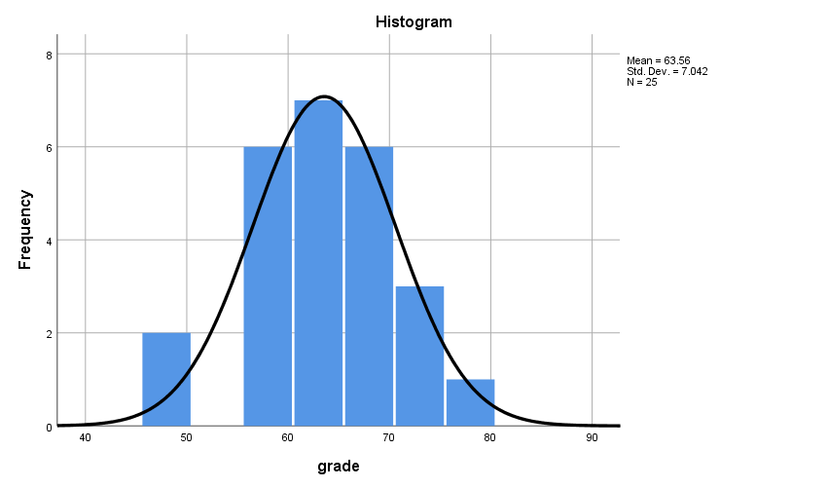

Fig 7 : Histogram with a normal curve for Group1

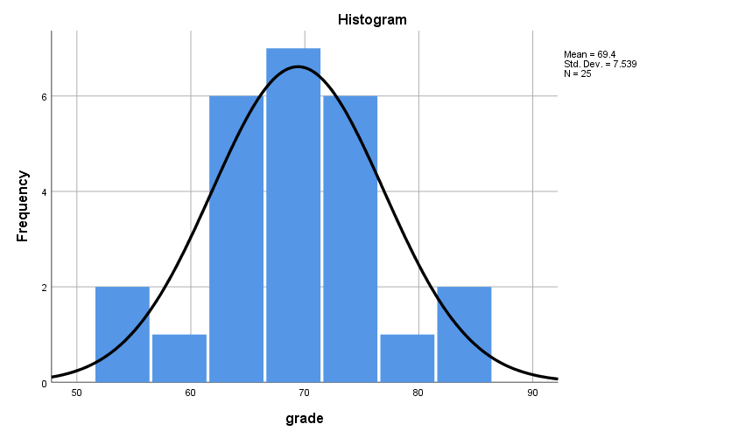

Fig 8 : Histogram with a normal curve for Group2

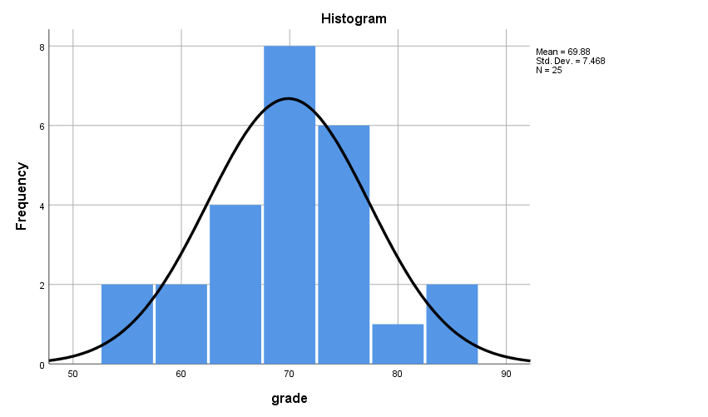
Fig 9 : Histogram with a normal curve for Group3

Visual Interpretation of Histograms

- Group 1: Since majority of the values are accumulated in the middle of the histogram, the normal curve looks perfectly bell shaped and is also fairly symmetrical. Therefore, the group is considered to be approximately normally distributed
- Group 2: The normal curve is perfectly bell shaped and is fairly symmetrical. Therefore, the group is considered to be approximately normally distributed
- Group 3: From the visual inspection of the histograms it is quite evident that the normality curve is bell shaped and shows a good symmetry. Therefore, the group is considered to approximately normally distributed

EXAMINE VARIABLES=grade BY group
/PLOT BOXPLOT NPPLOT
/COMPARE GROUPS
/STATISTICS DESCRIPTIVES
/CINTERVAL 95
/MISSING LISTWISE
/NOTOTAL.

- Normal Q-Q Plots

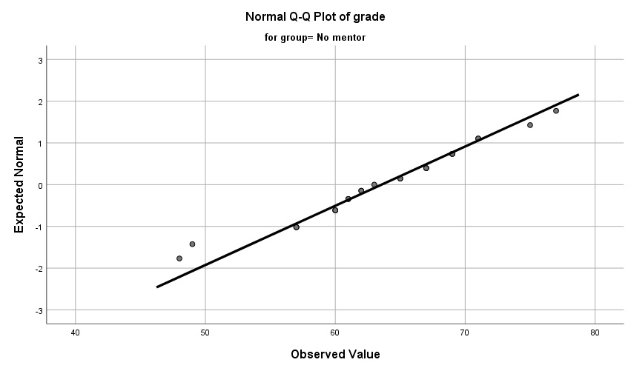
Fig 10 : Normal Q-Q plots –Group1

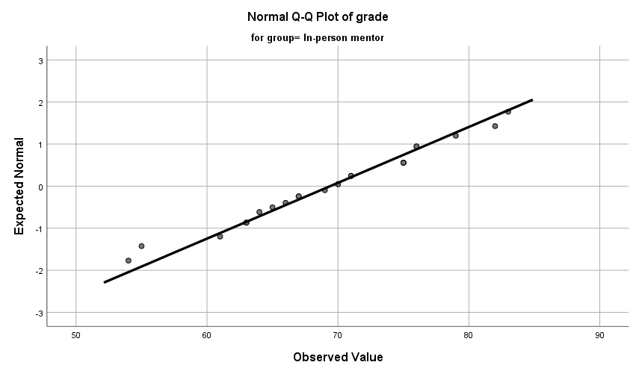
Fig 11 : Normal Q-Q plots – Group2

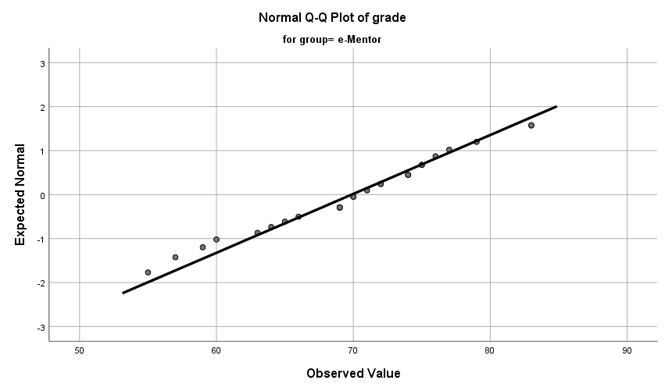

Fig 12 : Normal Q-Q plots – Group3

Visual Interpretation of Normal Q-Q Plots
In all the three groups, majority of the Normal Q-Q plots are aligned to QQ line. Thus, represents a reasonably normal distribution

- Box Plots

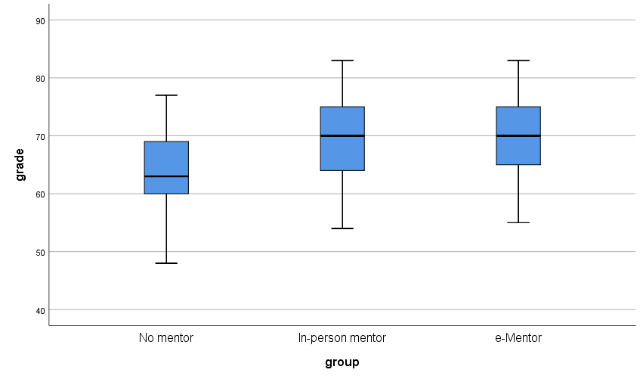
Fig 13 : Box plot – Group1, Group2 and Group3

Visual Interpretation of Box Plots
The box plots of the Group 2 and Group 3 shows perfect symmetry. Whereas, the box plot of Group 1 is reasonably symmetrical Therefore, the groups are considered to be approximately normal distribution.

Numerical Tests of Normality

Case Processing Summary
 | group | Cases
 | group | Valid |  | Missing |  | Total
 | group | N | Percent | N | Percent | N | Percent
grade | No mentor | 25 | 100.0% | 0 | 0.0% | 25 | 100.0%
grade | In-person mentor | 25 | 100.0% | 0 | 0.0% | 25 | 100.0%
grade | e-Mentor | 25 | 100.0% | 0 | 0.0% | 25 | 100.0%

- Shapiro-Wilk’s Test of Normality

Tests of Normality
 | group | Kolmogorov-Smirnovª |  |  | Shapiro-Wilk
 | group | Statistic | df | Sig. | Statistic | df | Sig.
grade | No mentor | .107 | 25 | .200* | .970 | 25 | .648
grade | In-person mentor | .131 | 25 | .200* | .973 | 25 | .728
grade | e-Mentor | .133 | 25 | .200* | .975 | 25 | .773

*. This is a lower bound of the true significance.
a. Lilliefors Significance Correction

Hypotheses
H₀ – The sample distribution is normally distributed (null Hypotheses)

Discussion
The value of p of Shapiro-Wilk’s test for Group1 is .648
The value of p of Shapiro-Wilk’s test for Group2 is .728
The value of p of Shapiro-Wilk’s test for Group3 is .773

Hypotheses Resolution
Since the Shapiro-Wilk’s value of p > α (α=0.05) in all the cases, H₀ is accepted. Therefore, the distributions of the groups are considered to be approximately normally distributed.
Skewness and Kurtosis Test
Descriptives
 | group |  |  | Statistic | Std. Error | z value
grade | No mentor | Mean |  | 63.56 | 1.408
grade | No mentor | 95% Confidence Interval for Mean | Lower Bound | 60.65
grade | No mentor | 95% Confidence Interval for Mean | Upper Bound | 66.47
grade | No mentor | 5% Trimmed Mean |  | 63.69
grade | No mentor | Median |  | 63.00
grade | No mentor | Variance |  | 49.590
grade | No mentor | Std. Deviation |  | 7.042
grade | No mentor | Minimum |  | 48
grade | No mentor | Maximum |  | 77
grade | No mentor | Range |  | 29
grade | No mentor | Interquartile Range |  | 9
grade | No mentor | Skewness |  | -.327 | .464 | -0.704
grade | No mentor | Kurtosis |  | .255 | .902 | 0.282
grade | In-person mentor | Mean |  | 69.40 | 1.508
grade | In-person mentor | 95% Confidence Interval for Mean | Lower Bound | 66.29
grade | In-person mentor | 95% Confidence Interval for Mean | Upper Bound | 72.51
grade | In-person mentor | 5% Trimmed Mean |  | 69.50
grade | In-person mentor | Median |  | 70.00
grade | In-person mentor | Variance |  | 56.833
grade | In-person mentor | Std. Deviation |  | 7.539
grade | In-person mentor | Minimum |  | 54
grade | In-person mentor | Maximum |  | 83
grade | In-person mentor | Range |  | 29
grade | In-person mentor | Interquartile Range |  | 12
grade | In-person mentor | Skewness |  | -.173 | .464 | -0.372
grade | In-person mentor | Kurtosis |  | -.327 | .902 | -0.362
grade | e-Mentor | Mean |  | 69.88 | 1.494
grade | e-Mentor | 95% Confidence Interval for Mean | Lower Bound | 66.80
grade | e-Mentor | 95% Confidence Interval for Mean | Upper Bound | 72.96
grade | e-Mentor | 5% Trimmed Mean |  | 69.96
grade | e-Mentor | Median |  | 70.00
grade | e-Mentor | Variance |  | 55.777
grade | e-Mentor | Std. Deviation |  | 7.468
grade | e-Mentor | Minimum |  | 55
grade | e-Mentor | Maximum |  | 83
grade | e-Mentor | Range |  | 28
grade | e-Mentor | Interquartile Range |  | 11
grade | e-Mentor | Skewness |  | -.228 | .464 | -0.491
grade | e-Mentor | Kurtosis |  | -.379 | .902 | -0.420

Discussion on Skewness and Kurtosis
Group 1 :
- The value of z obtained by Skewness/Std. Error =-.327/.464 = -0.704 is within the range of -1.96 and +1.96. Therefore is acceptable
- The value of z obtained by Kurtosis/Std. Error =-.255/.902 = 0.282 is within the range of -1.96 and +1.96. Therefore is acceptable

Group 2 :
- The value of z obtained by Skewness/Std. Error =-.173/.464 = -0.372 is within the range of -1.96 and +1.96. Therefore is acceptable
- The value of z obtained by Kurtosis/Std. Error =-.327/.902 = -0.362 is within the range of -1.96 and +1.96. Therefore is acceptable

Group 3:
- The value of z obtained by Skewness/Std. Error =-.228/.464 = -0.491 is within the range of -1.96 and +1.96. Therefore is acceptable
- The value of z obtained by Kurtosis/Std. Error =-.379/.902 = -0.420 is within the range of -1.96 and +1.96. Therefore is acceptable

From the numerical analysis of Skewness and Kurtosis it is clear that the distribution of the groups are approximately normally distributed

Discussion on Normality
From the visual interpretation of the graphical test results and through the analysis of numerical tests it is quite evident that the distributions of all the three groups are approximately normally distributed. Therefore, the pre-test criterion of Normality is satisfied

Pre-Test Condition -2 : n Quota

ONEWAY grade BY group
/STATISTICS DESCRIPTIVES HOMOGENEITY
/MISSING ANALYSIS
/POSTHOC=TUKEY ALPHA(0.05).

Descriptives
grade
 | N | Mean | Std. Deviation | Std. Error | 95% Confidence Interval for Mean
 |  |  |  |  | Lower Bound | Upper Bound
No mentor | 25 | 63.56 | 7.042 | 1.408 | 60.65 | 66.47
In-person mentor | 25 | 69.40 | 7.539 | 1.508 | 66.29 | 72.51
e-Mentor | 25 | 69.88 | 7.468 | 1.494 | 66.80 | 72.96
Total | 75 | 67.61 | 7.808 | .902 | 65.82 | 69.41

Discussion on n-quota

Since the value of n is less than 30 for all the groups, the pre-test condition of n-quota is not met.

Pre-Test Condition -3 : Homogeneity of Variance

Test of Homogeneity of Variances
 |  | Levene Statistic | df1 | df2 | Sig.
grade | Based on Mean | .090 | 2 | 72 | .914
grade | Based on Median | .087 | 2 | 72 | .916
grade | Based on Median and with adjusted df | .087 | 2 | 71.786 | .916
grade | Based on trimmed mean | .087 | 2 | 72 | .917

ANOVA
grade
 | Sum of Squares | df | Mean Square | F | Sig.
Between Groups | 618.987 | 2 | 309.493 | 5.724 | .005
Within Groups | 3892.800 | 72 | 54.067
Total | 4511.787 | 74

Discussion
The value of p > α (p=.914, α=.05) suggests that there is no statistically significant difference between the variances of the groups. Hence, the criterion of Homogeneity of Variance is satisfied.

Documenting the Results of Pre-test Conditions of ANOVA
Following are the results of the pre-test conditions,
- Normality
- n quota
- Homogeneity of Variance

Discussion

Since one of the pre-test conditions of ANOVA is not met, Kruskal-Wallis Test is performed as the best alternative

Description of the Test : Kruskal-Wallis Test
Kruskal-Wallis Test

NPAR TESTS
/K-W=grade BY group(1 3)
/MISSING ANALYSIS.

Ranks
 | group | N | Mean Rank
grade | No mentor | 25 | 26.82
grade | In-person mentor | 25 | 42.94
grade | e-Mentor | 25 | 44.24
grade | Total | 75

Test Statistics^{a,b}
 | grade
Kruskal-Wallis H | 9.945
df | 2
Asymp. Sig. | .007

a. Kruskal Wallis Test
b. Grouping Variable: group

Discussion
- The value of p obtained from Kruskal Wallis is .007
- Since the value of p<α (p=.007, α=0.05), there is a statistically significant difference between the grades of the groups. Therefore, we accept H₁.

Hypothesis Resolution
Reject => H₀ – There is no difference between the overall grades of freshmen of these groups
Accept => H₁ – At least one group outperforms another in terms of the overall grades

Kruskal Wallis – Post Hoc Test
Since there is a statistically significant difference between the groups, we perform pair-wise tests to identify the group that outperforms the others.

Groups | Description | Comparison of Means
Group 1 : Group 2 | No mentor: In-person mentor | µ(G1):µ(G2)
Group 2 : Group 3 | In-person mentor : E-mentor | µ(G2):µ(G3)
Group 1 : Group 3 | No mentor : E-mentor | µ(G1):µ(G3)

- Kruskal Wallis – Group 1 : Group 2
USE ALL.
COMPUTE filter_$=(group = 1 or group = 2).
VARIABLE LABELS filter_$ 'group = 1 or group = 2 (FILTER)'.
VALUE LABELS filter_$ 0 'Not Selected' 1 'Selected'.
FORMATS filter_$ (f1.0).
FILTER BY filter_$.
EXECUTE.
NPAR TESTS
/K-W=grade BY group(1 3)
/MISSING ANALYSIS.

Ranks
 | group | N | Mean Rank
grade | No mentor | 25 | 20.08
grade | In-person mentor | 25 | 30.92
grade | Total | 50

Test Statistics^{a,b}
 | grade
Kruskal-Wallis H | 6.942
df | 1
Asymp. Sig. | .008

a. Kruskal Wallis Test
b. Grouping Variable: group

- Kruskal Wallis – Group 2 : Group 3

USE ALL.
COMPUTE filter_$=(group=2 or group=3).
VARIABLE LABELS filter_$ 'group=2 or group=3 (FILTER)'.
VALUE LABELS filter_$ 0 'Not Selected' 1 'Selected'.
FORMATS filter_$ (f1.0).
FILTER BY filter_$.
EXECUTE.
NPAR TESTS
/K-W=grade BY group(1 3)
/MISSING ANALYSIS.

Ranks
 | group | N | Mean Rank
grade | In-person mentor | 25 | 25.02
grade | e-Mentor | 25 | 25.98
grade | Total | 50

Test Statistics^{a,b}
 | grade
Kruskal-Wallis H | .054
df | 1
Asymp. Sig. | .816

a. Kruskal Wallis Test
b. Grouping Variable: group

- Kruskal Wallis – Group 1 : Group 3

USE ALL.
COMPUTE filter_$=(group = 1 or group = 3).
VARIABLE LABELS filter_$ 'group = 1 or group = 3 (FILTER)'.
VALUE LABELS filter_$ 0 'Not Selected' 1 'Selected'.
FORMATS filter_$ (f1.0).
FILTER BY filter_$.
EXECUTE.
NPAR TESTS
/K-W=grade BY group(1 3)
/MISSING ANALYSIS.

Ranks
 | group | N | Mean Rank
grade | No mentor | 25 | 19.74
grade | e-Mentor | 25 | 31.26
grade | Total | 50

Test Statistics^{a,b}
 | grade
Kruskal-Wallis H | 7.836
df | 1
Asymp. Sig. | .005

a. Kruskal Wallis Test
b. Grouping Variable: group

Documenting Results of Pair-wise Kruskal Wallis

Groups | Comparison | p value | Discussion
Group 1 : Group 2 | µ(G1) : µ(G2)  63.56 : 69.40 | .008 | - Since the value of p < α (p = .008, α=0.05), there is a statistically significant difference between the groups.  - By comparing the means it is quite evident that Group 2 outperforms Group 1
Group 2 : Group 3 | µ(G2) : µ(G3)  69.40 : 69.88 | .816 | - Since p > 0.05, there is no statistically significant difference between Group 2 and Group 3
Group 1 : Group 3 | µ(G1) : µ(G3)  63.56 : 69.88 | .005 | - Since the value of p < α (p = .005, α=0.05), there is a statistically significant difference between the groups.  - By comparing the means it is quite evident that Group 3 outperforms Group 1

Discussion of the Test
In order to assess if having a mentor will improve the overall grades of freshman, the incoming freshman of the program are alternatively assigned to three groups, the control group (with no mentor), In-person mentor (Treatment group 1) and E-mentor (Treatment group2). Freshman in the In-person mentor group are assigned a mentor each and are asked to meet their mentors once every week for the entire term. However, the freshman under the control group has no mentors. Whereas, the e-mentor groups have online meetings every week. All the three groups are have equal distribution (n=25) and are asked to submit academic transcripts by the end of the term.

Since we are comparing more than two groups, we chose ANOVA. However, we proceeded with Kruskal Wallis as one of the pre-test conditions of ANOVA was not satisfied. The Kruskal Wallis’s value of p < α (where p=.007 and α =0.5) indicates a statistically significant difference between the groups. Therefore, we reject H₀ and accept H₁. To figure out which of groups outperformed; we run the pair-wise post hoc tests.

From the results of Post hoc test, we observed a statistically significant difference between the grades of Group 1 and Group 2, also, between Group1 and Group 3. To determine which of these groups outperformed, we compare their means.

Comparing the means of the three groups,
µ(G₁) : µ(G₂) : µ(G₃)
63.56 : 69.40 : 69.88

On comparing Group 1 and Group 2, Group 2 had higher mean than Group 1. Therefore, In-Person mentor group statistically outperformed the control group. Furthermore, on comparing Group 1 and Group 3, Group 3 had higher mean than Group 1. Hence the E-mentor group statistically outperformed the control group. Eventhough E-mentor group has higher mean than In-person, this difference is insignificant.

Exercise Number: Ch 06 - Exercise 06A
Dataset Used : [DataSet1] C:\Users\Jaya Karthi Booven\Desktop\SPSS\6.6\Ch 06 - Exercise 06A.sav
Selection of Test :
The primary objective of the given exercise is to compare three different groups of continuous variables and decide on the groups that outperform the others. Since we are comparing more than two groups of continuous variables, we prefer ANOVA test.

Groups
Group 1: Video with no laugh track (Control Group)
Group 2: Video with 50-person audience laugh track (Treatment Group 1)
Group 3: Video with 100-person audience laugh track (Treatment Group 2)

Hypotheses
H₀ – There is no difference between the enjoyment levels of audience of these groups(Null Hypotheses)
H₁ – At least one group outperforms another in terms of the level of enjoyment(Alternative Hypotheses)

Pre-test Checklist for ANOVA Test
Following are the pre-test conditions for running ANOVA,
- Normality
- n quota
- Homogeneity of Variance

Description of the Test : Pre-test Conditions for ANOVA
Pre-Test Condition - 1 : Normality
Warning # 5281. Command name: GET FILE
SPSS Statistics is running in Unicode encoding mode. This file is encoded in a locale-specific (code page) encoding. The defined width of any string variables are automatically tripled in order to avoid possible data loss. You can use ALTER TYPE to set the width of string variables to the width of the longest observed value for each string variable.
DATASET NAME DataSet1 WINDOW=FRONT.

Group 1: Video with no laugh track

USE ALL.
COMPUTE filter_$=(group=1).
VARIABLE LABELS filter_$ 'group=1 (FILTER)'.
VALUE LABELS filter_$ 0 'Not Selected' 1 'Selected'.
FORMATS filter_$ (f1.0).
FILTER BY filter_$.
EXECUTE.
FREQUENCIES VARIABLES=enjoy
/STATISTICS=STDDEV VARIANCE RANGE MINIMUM MAXIMUM MEAN MEDIAN MODE
/HISTOGRAM NORMAL
/ORDER=ANALYSIS.

Descriptive Statistics
Statistics
enjoy
N | Valid | 32
N | Missing | 0
Mean |  | 3.47
Median |  | 3.50
Mode |  | 4
Std. Deviation |  | 1.646
Variance |  | 2.709
Range |  | 7
Minimum |  | 1
Maximum |  | 8

Fig 1 : Descriptive Statistics of Group1
Frequencies
enjoy
 |  | Frequency | Percent | Valid Percent | Cumulative Percent
Valid | 1 | 4 | 12.5 | 12.5 | 12.5
Valid | 2 | 5 | 15.6 | 15.6 | 28.1
Valid | 3 | 7 | 21.9 | 21.9 | 50.0
Valid | 4 | 9 | 28.1 | 28.1 | 78.1
Valid | 5 | 5 | 15.6 | 15.6 | 93.8
Valid | 7 | 1 | 3.1 | 3.1 | 96.9
Valid | 8 | 1 | 3.1 | 3.1 | 100.0
Valid | Total | 32 | 100.0 | 100.0

Fig 2 : Frequencies of Group 1

Group 2: Video with 50-person audience laugh track
USE ALL.
COMPUTE filter_$=(group=2).
VARIABLE LABELS filter_$ 'group=2 (FILTER)'.
VALUE LABELS filter_$ 0 'Not Selected' 1 'Selected'.
FORMATS filter_$ (f1.0).
FILTER BY filter_$.
EXECUTE.
FREQUENCIES VARIABLES=enjoy
/STATISTICS=STDDEV VARIANCE RANGE MINIMUM MAXIMUM MEAN MEDIAN MODE
/HISTOGRAM NORMAL
/ORDER=ANALYSIS.
Descriptive Statistics
Statistics
enjoy
N | Valid | 33
N | Missing | 0
Mean |  | 4.21
Median |  | 4.00
Mode |  | 4
Std. Deviation |  | 1.364
Variance |  | 1.860
Range |  | 5
Minimum |  | 2
Maximum |  | 7

Fig 3 : Descriptive Statistics of Group 2
Frequencies
enjoy
 |  | Frequency | Percent | Valid Percent | Cumulative Percent
Valid | 2 | 5 | 15.2 | 15.2 | 15.2
Valid | 3 | 3 | 9.1 | 9.1 | 24.2
Valid | 4 | 13 | 39.4 | 39.4 | 63.6
Valid | 5 | 5 | 15.2 | 15.2 | 78.8
Valid | 6 | 6 | 18.2 | 18.2 | 97.0
Valid | 7 | 1 | 3.0 | 3.0 | 100.0
Valid | Total | 33 | 100.0 | 100.0

Fig 4 : Frequencies of Group 2

Group 3: Video with 100-person audience laugh track

USE ALL.
COMPUTE filter_$=(group=3).
VARIABLE LABELS filter_$ 'group=3 (FILTER)'.
VALUE LABELS filter_$ 0 'Not Selected' 1 'Selected'.
FORMATS filter_$ (f1.0).
FILTER BY filter_$.
EXECUTE.
FREQUENCIES VARIABLES=enjoy
/STATISTICS=STDDEV VARIANCE RANGE MINIMUM MAXIMUM MEAN MEDIAN MODE
/HISTOGRAM NORMAL
/ORDER=ANALYSIS.

Descriptive Statistics
Statistics
enjoy
N | Valid | 33
N | Missing | 0
Mean |  | 4.48
Median |  | 4.00
Mode |  | 4
Std. Deviation |  | 1.034
Variance |  | 1.070
Range |  | 4
Minimum |  | 2
Maximum |  | 6

Fig 5 : Descriptive Statistics of Group 3
Frequencies
enjoy
 |  | Frequency | Percent | Valid Percent | Cumulative Percent
Valid | 2 | 1 | 3.0 | 3.0 | 3.0
Valid | 3 | 4 | 12.1 | 12.1 | 15.2
Valid | 4 | 12 | 36.4 | 36.4 | 51.5
Valid | 5 | 10 | 30.3 | 30.3 | 81.8
Valid | 6 | 6 | 18.2 | 18.2 | 100.0
Valid | Total | 33 | 100.0 | 100.0

Fig 6 : Frequencies of Group 3

Normality Assessment
In this exercise, Normality is assessed in a two-step process,
- Graphical Tests of Normality
- Numerical Tests of Normality

Graphical Tests of Normality
- In graphical tests, the normality is assessed through the visual interpretation of Histograms, Normal Q-Q Plots and Box plots
Numerical Tests of Normality
- In the numerical tests, the normality of the distribution is determined based on the Shapiro -Wilk’s p value and the Skewness and Kurtosis test’s z values

Graphical Tests of Normality

- Histogram with a normal curve

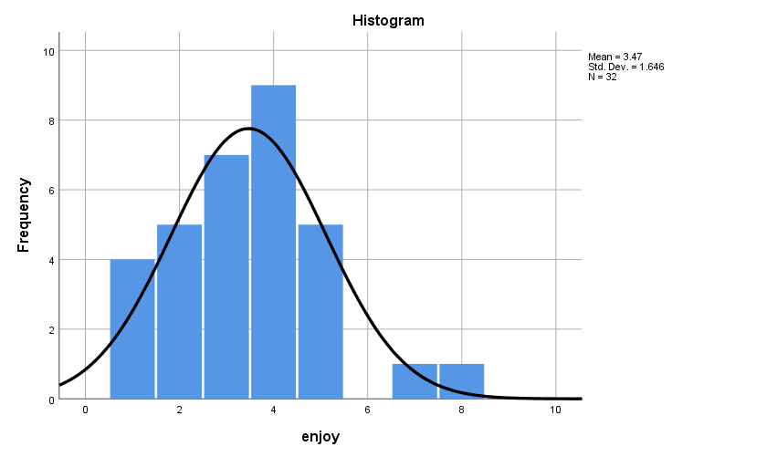
Fig 7 : Histogram with a normal curve for Group1

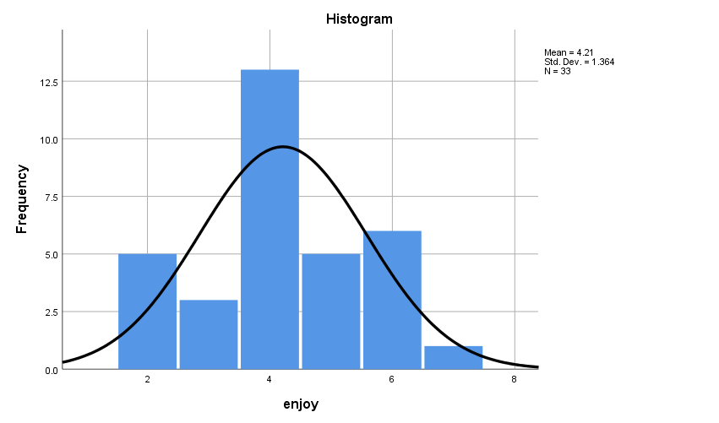
Fig 8 : Histogram with a normal curve for Group2

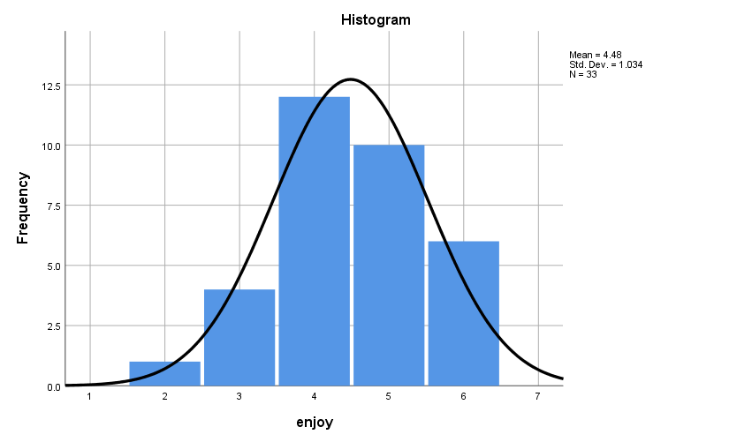
Fig 9 : Histogram with a normal curve for Group3

Visual Interpretation of Histograms

- Group 1: Since majority of the values are accumulated towards the left of the histogram, there is a slight skewness towards the right(positively skewed). However, the distribution is considered reasonably normal
- Group 2: The normal curve is perfectly bell shaped and is fairly symmetrical. Therefore, the group is considered to be approximately normally distributed
- Group 3: From the visual inspection of the histograms it is quite evident that the normality curve is bell shaped and shows a good symmetry with a very slight skewness towards left. Therefore, the group is considered to approximately normally distributed

EXAMINE VARIABLES=enjoy BY group
/PLOT BOXPLOT NPPLOT
/COMPARE GROUPS
/STATISTICS DESCRIPTIVES
/CINTERVAL 95
/MISSING LISTWISE
/NOTOTAL.

- Normal Q-Q Plots

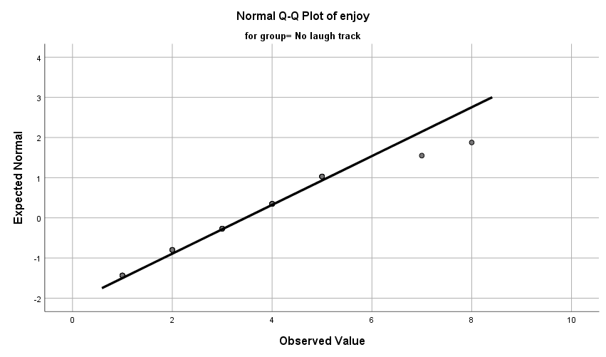
Fig 10 : Normal Q-Q plots –Group1

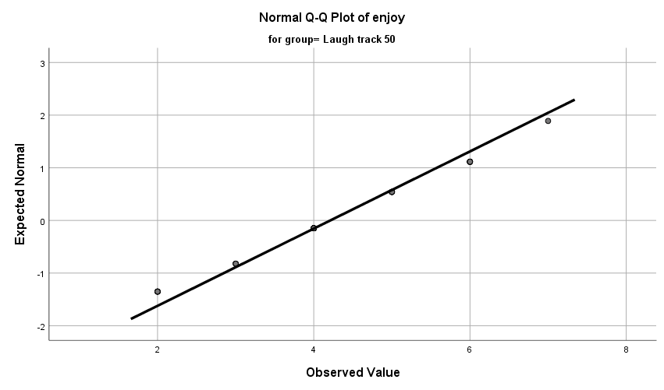

Fig 11 : Normal Q-Q plots – Group2

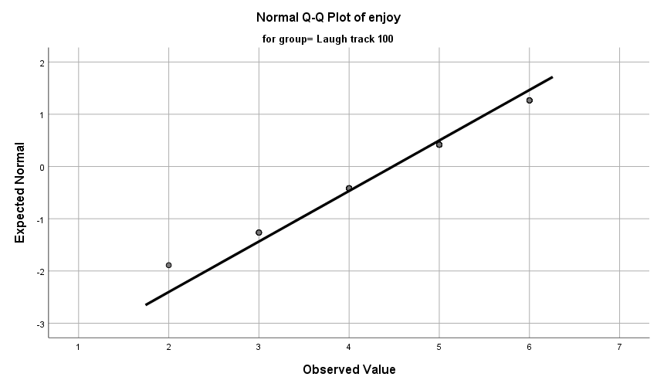

Fig 12 : Normal Q-Q plots – Group3

Visual Interpretation of Normal Q-Q Plots
In all the three groups, majority of the Normal Q-Q plots are aligned to QQ line. Thus, represents a reasonably normal distribution

- Box Plots

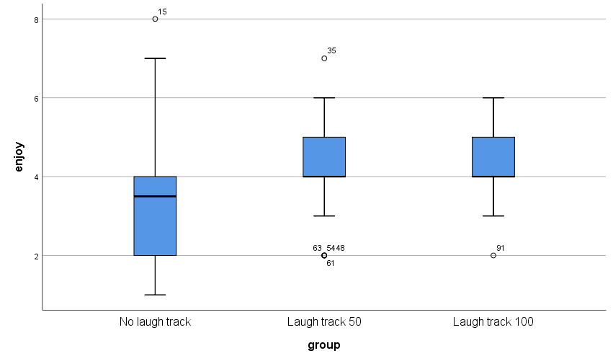
Fig 13 : Box plot – Group1, Group2 and Group3

Visual Interpretation of Box Plots
The box plots of the Group 1 is reasonably symmetrical. However, the box plots of Group 2 and Group 3 are not symmetrical

Numerical Tests of Normality

Case Processing Summary
 | group | Cases
 | group | Valid |  | Missing |  | Total
 | group | N | Percent | N | Percent | N | Percent
enjoy | No laugh track | 32 | 100.0% | 0 | 0.0% | 32 | 100.0%
enjoy | Laugh track 50 | 33 | 100.0% | 0 | 0.0% | 33 | 100.0%
enjoy | Laugh track 100 | 33 | 100.0% | 0 | 0.0% | 33 | 100.0%

- Shapiro-Wilk’s Test of Normality
Tests of Normality
Shapiro-Wilk
dfSig.groupKolmogorov-Smirnovª |  | Statistic |  |  | df
dfSig.groupKolmogorov-Smirnovª |  | .155 | 32 | .050 | .928 | 32 | .035
 | Laugh track 50 | .198 | 33 | .002 | .915 | 33 | .014
 | Laugh track 100 | .196 | 33 | .003 | .906 | 33 | .007

Hypotheses
H₀ – The sample distribution is normally distributed (Null Hypotheses)

Discussion
- The value of p of Shapiro-Wilk’s test for Group1 is .035
- The value of p of Shapiro-Wilk’s test for Group2 is .014
- The value of p of Shapiro-Wilk’s test for Group3 is .007

Hypotheses Resolution
Group 1 :
- Since the Shapiro-Wilk’s value of p < α (p=.035 and α=0.05) , H₀ is rejected. Therefore, the distributions of the groups are considered to be not normally distributed.
Group 2 :
- Since the Shapiro-Wilk’s value of p < α (p=.014 and α=0.05) , H₀ is rejected. Therefore, the distributions of the groups are considered to be not normally distributed.
Group 3 :
Since the Shapiro-Wilk’s value of p < α (p=.007 and α=0.05) , H₀ is rejected. Therefore, the distributions of the groups are considered to be not normally distributed.

Skewness and Kurtosis Test
Descriptives
 | group |  |  | Statistic | Std. Error | z value
enjoy | No laugh track | Mean |  | 3.47 | .291
enjoy | No laugh track | 95% Confidence Interval for Mean | Lower Bound | 2.88
enjoy | No laugh track | 95% Confidence Interval for Mean | Upper Bound | 4.06
enjoy | No laugh track | 5% Trimmed Mean |  | 3.37
enjoy | No laugh track | Median |  | 3.50
enjoy | No laugh track | Variance |  | 2.709
enjoy | No laugh track | Std. Deviation |  | 1.646
enjoy | No laugh track | Minimum |  | 1
enjoy | No laugh track | Maximum |  | 8
enjoy | No laugh track | Range |  | 7
enjoy | No laugh track | Interquartile Range |  | 2
enjoy | No laugh track | Skewness |  | .615 | .414 | 1.485
enjoy | No laugh track | Kurtosis |  | .835 | .809 | 1.032
enjoy | Laugh track 50 | Mean |  | 4.21 | .237
enjoy | Laugh track 50 | 95% Confidence Interval for Mean | Lower Bound | 3.73
enjoy | Laugh track 50 | 95% Confidence Interval for Mean | Upper Bound | 4.70
enjoy | Laugh track 50 | 5% Trimmed Mean |  | 4.20
enjoy | Laugh track 50 | Median |  | 4.00
enjoy | Laugh track 50 | Variance |  | 1.860
enjoy | Laugh track 50 | Std. Deviation |  | 1.364
enjoy | Laugh track 50 | Minimum |  | 2
enjoy | Laugh track 50 | Maximum |  | 7
enjoy | Laugh track 50 | Range |  | 5
enjoy | Laugh track 50 | Interquartile Range |  | 2
enjoy | Laugh track 50 | Skewness |  | -.016 | .409 | -0.039
enjoy | Laugh track 50 | Kurtosis |  | -.580 | .798 | -0.726
enjoy | Laugh track 100 | Mean |  | 4.48 | .180
enjoy | Laugh track 100 | 95% Confidence Interval for Mean | Lower Bound | 4.12
enjoy | Laugh track 100 | 95% Confidence Interval for Mean | Upper Bound | 4.85
enjoy | Laugh track 100 | 5% Trimmed Mean |  | 4.52
enjoy | Laugh track 100 | Median |  | 4.00
enjoy | Laugh track 100 | Variance |  | 1.070
enjoy | Laugh track 100 | Std. Deviation |  | 1.034
enjoy | Laugh track 100 | Minimum |  | 2
enjoy | Laugh track 100 | Maximum |  | 6
enjoy | Laugh track 100 | Range |  | 4
enjoy | Laugh track 100 | Interquartile Range |  | 1
enjoy | Laugh track 100 | Skewness |  | -.227 | .409 | -0.555
enjoy | Laugh track 100 | Kurtosis |  | -.322 | .798 | -0.403

Discussion on Skewness and Kurtosis
Group 1 :
- The value of z obtained by Skewness/Std. Error =.615/.414 = 1.485 is within the range of -1.96 and +1.96. Therefore, is acceptable
- The value of z obtained by Kurtosis/Std. Error =.835/.809 = 1.032 is within the range of -1.96 and +1.96. Therefore, is acceptable

Group 2 :
- The value of z obtained by Skewness/Std. Error =-.016/.409 = -0.039 is within the range of -1.96 and +1.96. Therefore, is acceptable
- The value of z obtained by Kurtosis/Std. Error =-.580/.798 = -0.726 is within the range of -1.96 and +1.96. Therefore, is acceptable

Group 3:
- The value of z obtained by Skewness/Std. Error =-.227/.409 = -0.555 is within the range of -1.96 and +1.96. Therefore, is acceptable
- The value of z obtained by Kurtosis/Std. Error =-.322/.798 = -0.403 is within the range of -1.96 and +1.96. Therefore, is acceptable

From the numerical analysis of Skewness and Kurtosis it is clear that the distribution of the groups are approximately normally distributed

Discussion on Normality
From the visual interpretation of the graphical test results and through the analysis of numerical tests it is quite evident that the distributions of all the three groups are approximately normally distributed. Therefore, the pre-test criterion of Normality is not satisfied

Pre-Test Condition -2 : n Quota

ONEWAY enjoy BY group
/STATISTICS DESCRIPTIVES HOMOGENEITY
/MISSING ANALYSIS
/POSTHOC=SIDAK ALPHA(0.05).

Descriptives
enjoy
 | N | Mean | Std. Deviation | Std. Error | 95% Confidence Interval for Mean
 |  |  |  |  | Lower Bound | Upper Bound
No laugh track | 32 | 3.47 | 1.646 | .291 | 2.88 | 4.06
Laugh track 50 | 33 | 4.21 | 1.364 | .237 | 3.73 | 4.70
Laugh track 100 | 33 | 4.48 | 1.034 | .180 | 4.12 | 4.85
Total | 98 | 4.06 | 1.420 | .143 | 3.78 | 4.35

Discussion on n-quota

Since the value of n is greater than 30 for all the groups, the pre-test condition of n-quota is met.

Pre-Test Condition -3 : Homogeneity of Variance

Test of Homogeneity of Variances
 |  | Levene Statistic | df1 | df2 | Sig.
enjoy | Based on Mean | 2.120 | 2 | 95 | .126
enjoy | Based on Median | 1.910 | 2 | 95 | .154
enjoy | Based on Median and with adjusted df | 1.910 | 2 | 90.345 | .154
enjoy | Based on trimmed mean | 2.097 | 2 | 95 | .129

ANOVA
enjoy
 | Sum of Squares | df | Mean Square | F | Sig.
Between Groups | 17.906 | 2 | 8.953 | 4.786 | .010
Within Groups | 177.726 | 95 | 1.871
Total | 195.633 | 97

Discussion
The value of p > α (p=.126, α=.05) suggests that there is no statistically significant difference between the variances of the groups. Hence, the criterion of Homogeneity of Variance is satisfied.

Documenting the Results of Pre-test Conditions of ANOVA
Following are the results of the pre-test conditions,
- Normality
- n quota
- Homogeneity of Variance

Discussion

Since one of the pre-test conditions of ANOVA is not met, Kruskal-Wallis Test is performed as the best alternative

Description of the Test : Kruskal-Wallis Test
Kruskal-Wallis Test

NPAR TESTS
/K-W=enjoy BY group(1 3)
/MISSING ANALYSIS.

Ranks
 | group | N | Mean Rank
enjoy | No laugh track | 32 | 37.44
enjoy | Laugh track 50 | 33 | 52.21
enjoy | Laugh track 100 | 33 | 58.48
enjoy | Total | 98

Test Statistics^{a,b}
 | enjoy
Kruskal-Wallis H | 9.913
df | 2
Asymp. Sig. | .007

a. Kruskal Wallis Test
b. Grouping Variable: group

Discussion
- The value of p obtained from Kruskal Wallis is .007
- Since the value of p<α (p=.007, α=0.05), there is a statistically significant difference between the grades of the groups. Therefore, we accept H₁

Hypothesis Resolution
Reject => H₀ – There is no difference between the enjoyment levels of audience of these groups
Accept => H₁ – At least one group outperforms another in terms of the level of enjoyment

Kruskal Wallis – Post Hoc Test
Since there is a statistically significant difference between the groups, we perform pair-wise tests to identify the group that outperforms the others.

Groups | Description | Comparison of Means
Group 1 : Group 2 | No laugh track: 50-person laugh track | µ(G1):µ(G2)
Group 2 : Group 3 | 50-person laugh track: 100-person laugh track | µ(G2):µ(G3)
Group 1 : Group 3 | No laugh track : 100-person laugh track | µ(G1):µ(G3)

- Kruskal Wallis – Group 1 : Group 2
USE ALL.
COMPUTE filter_$=(group=1 or group=2).
VARIABLE LABELS filter_$ 'group=1 or group=2 (FILTER)'.
VALUE LABELS filter_$ 0 'Not Selected' 1 'Selected'.
FORMATS filter_$ (f1.0).
FILTER BY filter_$.
EXECUTE.
NPAR TESTS
/K-W=enjoy BY group(1 3)
/MISSING ANALYSIS.

Ranks
 | group | N | Mean Rank
enjoy | No laugh track | 32 | 28.11
enjoy | Laugh track 50 | 33 | 37.74
enjoy | Total | 65

Test Statistics^{a,b}
 | enjoy
Kruskal-Wallis H | 4.441
df | 1
Asymp. Sig. | .035

a. Kruskal Wallis Test
b. Grouping Variable: group

- Kruskal Wallis – Group 2 : Group 3

USE ALL.
COMPUTE filter_$=(group=2 or group=3).
VARIABLE LABELS filter_$ 'group=2 or group=3 (FILTER)'.
ALUE LABELS filter_$ 0 'Not Selected' 1 'Selected'.
FORMATS filter_$ (f1.0).
FILTER BY filter_$.
EXECUTE.
NPAR TESTS
/K-W=enjoy BY group(1 3)
/MISSING ANALYSIS.

Ranks
 | group | N | Mean Rank
enjoy | Laugh track 50 | 33 | 31.47
enjoy | Laugh track 100 | 33 | 35.53
enjoy | Total | 66

Test Statistics^{a,b}
 | enjoy
Kruskal-Wallis H | .797
df | 1
Asymp. Sig. | .372

a. Kruskal Wallis Test
b. Grouping Variable: group

- Kruskal Wallis – Group 1 : Group 3

USE ALL.
COMPUTE filter_$=(group=1 or group=3).
VARIABLE LABELS filter_$ 'group=1 or group=3 (FILTER)'.
VALUE LABELS filter_$ 0 'Not Selected' 1 'Selected'.
FORMATS filter_$ (f1.0).
FILTER BY filter_$.
EXECUTE.
NPAR TESTS
/K-W=enjoy BY group(1 3)
/MISSING ANALYSIS.

Ranks
 | group | N | Mean Rank
enjoy | No laugh track | 32 | 25.83
enjoy | Laugh track 100 | 33 | 39.95
enjoy | Total | 65

Test Statistics^{a,b}
 | enjoy
Kruskal-Wallis H | 9.571
df | 1
Asymp. Sig. | .002

a. Kruskal Wallis Test
b. Grouping Variable: group

Documenting Results of Pair-wise Kruskal Wallis

Groups | Comparison | p value | Discussion
Group 1 : Group 2 | µ(G1) : µ(G2)  3.47 : 4.21 | .035 | - Since the value of p < α (p = .035, α=0.05), there is a statistically significant difference between the groups.  - By comparing the means it is quite evident that Group 2 outperforms Group 1
Group 2 : Group 3 | µ(G2) : µ(G3)  4.21 : 4.48 | .372 | - Since p > 0.05, there is no statistically significant difference between Group 2 and Group 3
Group 1 : Group 3 | µ(G1) : µ(G3)  3.47 : 4.48 | .002 | - Since the value of p < α (p = .002, α=0.05), there is a statistically significant difference between the groups.  - By comparing the means it is quite evident that Group 3 outperforms Group 1

Discussion of the Test
In order to assess if having a laugh track in a comedy video will improve the enjoyment levels of the audience, the audience are alternatively assigned to three groups, the control group (with no laugh track), video with laugh track of 50-person audience (Treatment group 1) and video with laugh track of 100-person audience (Treatment group2). The control group had about 32 audience (n=32). Whereaas, the Treatment group1 and Treatment Group2 had around 33 audience members (n=33)All the three groups are asked to rate their level of enjoyment on a scale of 1 to 5 by the end of the movie (where 1= not very enjoyable and 5=enjoyable)

Since we are comparing more than two groups, we chose ANOVA. However, we proceeded with Kruskal Wallis as one of the pre-test conditions of ANOVA was not satisfied. The Kruskal Wallis’s value of p < α (where p=.007 and α =0.5) indicates a statistically significant difference between the groups. Therefore, we reject H₀ and accept H₁. To figure out which of groups outperformed; we run the pair-wise post hoc tests.

From the results of Post hoc test, we observed a statistically significant difference between the grades of Group 1 and Group 2, also, between Group1 and Group 3. To determine which of these groups outperformed, we compare their means.

Comparing the means of the three groups,
µ(G₁) : µ(G₂) : µ(G₃)
3.47 : 4.21 : 4.48

On comparing Group 1 and Group 2, the Group 2 had higher mean. Therefore, 50-person laugh track group outperformed the control group. Furthermore, on comparing Group 1 and Group 3, Group 3 had higher mean than the control group. Therefore, it is quite evident that the 100-person laugh track group outperformed the control group. Eventhough the mean of Group 3 is higher than Group 2, this difference is insignificant.

Exercise Number: Ch 06 - Exercise 06B
Dataset Used : [DataSet1] C:\Users\Jaya Karthi Booven\Desktop\SPSS\6.6\Ch 06 - Exercise 06B.sav
Selection of Test :
The primary objective of the given exercise is to compare three different groups of continuous variables and decide on the groups that outperform the others. Since we are comparing more than two groups of continuous variables, we prefer ANOVA test.

Groups
Group 1: Video with no laugh track (Control Group)
Group 2: Video with 50-person audience laugh track (Treatment Group 1)
Group 3: Video with 100-person audience laugh track (Treatment Group 2)

Hypotheses
H₀ – There is no difference between the enjoyment levels of audience of these groups(Null Hypotheses)
H₁ – At least one group outperforms another in terms of the level of enjoyment(Alternative Hypotheses)

Pre-test Checklist for ANOVA Test
Following are the pre-test conditions for running ANOVA,
- Normality
- n quota
- Homogeneity of Variance

Description of the Test : Pre-test Conditions for ANOVA
Pre-Test Condition - 1 : Normality
Warning # 5281. Command name: GET FILE
SPSS Statistics is running in Unicode encoding mode. This file is encoded in a locale-specific (code page) encoding. The defined width of any string variables are automatically tripled in order to avoid possible data loss. You can use ALTER TYPE to set the width of string variables to the width of the longest observed value for each string variable.
DATASET NAME DataSet1 WINDOW=FRONT.

Group 1: Video with no laugh track

USE ALL.
COMPUTE filter_$=(group=1).
VARIABLE LABELS filter_$ 'group=1 (FILTER)'.
VALUE LABELS filter_$ 0 'Not Selected' 1 'Selected'.
FORMATS filter_$ (f1.0).
FILTER BY filter_$.
EXECUTE.
FREQUENCIES VARIABLES=enjoy
/STATISTICS=STDDEV VARIANCE RANGE MINIMUM MAXIMUM MEAN MEDIAN MODE
/HISTOGRAM NORMAL
/ORDER=ANALYSIS.

Descriptive Statistics
Statistics
enjoy
N | Valid | 35
N | Missing | 0
Mean |  | 2.49
Median |  | 3.00
Mode |  | 3
Std. Deviation |  | .853
Variance |  | .728
Range |  | 3
Minimum |  | 1
Maximum |  | 4

Fig 1 : Descriptive Statistics of Group1
Frequencies
enjoy
 |  | Frequency | Percent | Valid Percent | Cumulative Percent
Valid | 1 | 5 | 14.3 | 14.3 | 14.3
Valid | 2 | 11 | 31.4 | 31.4 | 45.7
Valid | 3 | 16 | 45.7 | 45.7 | 91.4
Valid | 4 | 3 | 8.6 | 8.6 | 100.0
Valid | Total | 35 | 100.0 | 100.0

Fig 2 : Frequencies of Group 1

Group 2: Video with 50-person audience laugh track
USE ALL.
COMPUTE filter_$=(group=2).
VARIABLE LABELS filter_$ 'group=2 (FILTER)'.
VALUE LABELS filter_$ 0 'Not Selected' 1 'Selected'.
FORMATS filter_$ (f1.0).
FILTER BY filter_$.
EXECUTE.
FREQUENCIES VARIABLES=enjoy
/STATISTICS=STDDEV VARIANCE RANGE MINIMUM MAXIMUM MEAN MEDIAN MODE
/HISTOGRAM NORMAL
/ORDER=ANALYSIS.
Descriptive Statistics
Statistics
enjoy
N | Valid | 26
N | Missing | 0
Mean |  | 2.62
Median |  | 3.00
Mode |  | 3
Std. Deviation |  | 1.098
Variance |  | 1.206
Range |  | 5
Minimum |  | 1
Maximum |  | 6

Fig 3 : Descriptive Statistics of Group 2
Frequencies
enjoy
 |  | Frequency | Percent | Valid Percent | Cumulative Percent
Valid | 1 | 4 | 15.4 | 15.4 | 15.4
Valid | 2 | 7 | 26.9 | 26.9 | 42.3
Valid | 3 | 12 | 46.2 | 46.2 | 88.5
Valid | 4 | 2 | 7.7 | 7.7 | 96.2
Valid | 6 | 1 | 3.8 | 3.8 | 100.0
Valid | Total | 26 | 100.0 | 100.0

Fig 4 : Frequencies of Group 2

Group 3: Video with 100-person audience laugh track
USE ALL.
COMPUTE filter_$=(group=3).
VARIABLE LABELS filter_$ 'group=3 (FILTER)'.
VALUE LABELS filter_$ 0 'Not Selected' 1 'Selected'.
FORMATS filter_$ (f1.0).
FILTER BY filter_$.
EXECUTE.
FREQUENCIES VARIABLES=enjoy
/STATISTICS=STDDEV VARIANCE RANGE MINIMUM MAXIMUM MEAN MEDIAN MODE
/HISTOGRAM NORMAL
/ORDER=ANALYSIS.

Descriptive Statistics
Statistics
enjoy
N | Valid | 27
N | Missing | 0
Mean |  | 2.52
Median |  | 3.00
Mode |  | 3
Std. Deviation |  | .975
Variance |  | .952
Range |  | 3
Minimum |  | 1
Maximum |  | 4

Fig 5 : Descriptive Statistics of Group 3

Frequencies
enjoy
 |  | Frequency | Percent | Valid Percent | Cumulative Percent
Valid | 1 | 5 | 18.5 | 18.5 | 18.5
Valid | 2 | 7 | 25.9 | 25.9 | 44.4
Valid | 3 | 11 | 40.7 | 40.7 | 85.2
Valid | 4 | 4 | 14.8 | 14.8 | 100.0
Valid | Total | 27 | 100.0 | 100.0

Fig 6 : Frequencies of Group 3

Normality Assessment
In this exercise, Normality is assessed in a two-step process,
- Graphical Tests of Normality
- Numerical Tests of Normality

Graphical Tests of Normality
- In graphical tests, the normality is assessed through the visual interpretation of Histograms, Normal Q-Q Plots and Box plots
Numerical Tests of Normality
- In the numerical tests, the normality of the distribution is determined based on the Shapiro -Wilk’s p value and the Skewness and Kurtosis test’s z values

Graphical Tests of Normality

- Histogram with a normal curve

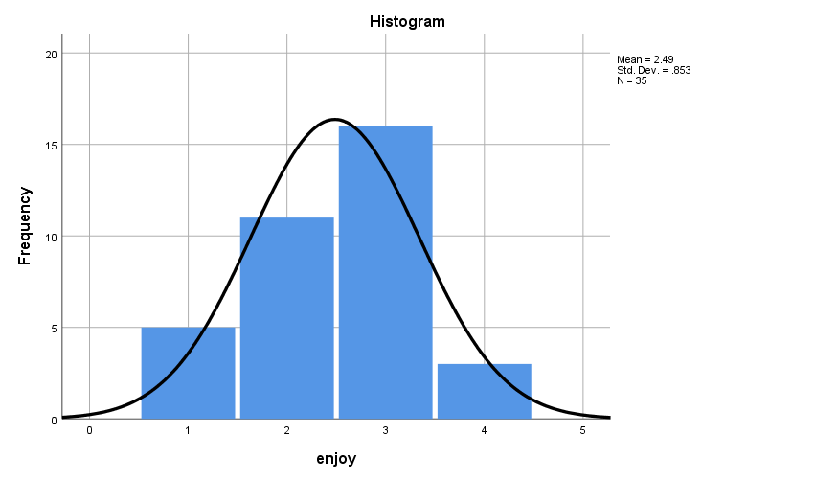
Fig 7 : Histogram with a normal curve for Group1

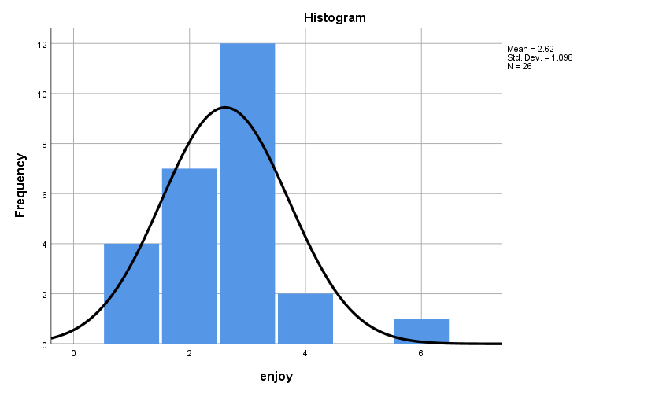
Fig 8 : Histogram with a normal curve for Group2

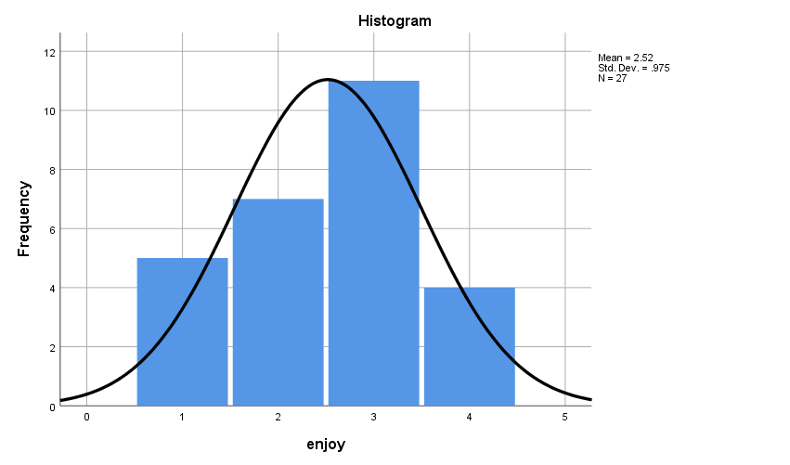
Fig 9 : Histogram with a normal curve for Group3

Visual Interpretation of Histograms

- Group 1: The normal curve is perfectly bell shaped and is fairly symmetrical. Therefore, the group is considered to be approximately normally distributed
- Group 2: Since majority of the values are accumulated towards the left of the histogram, there is a slight skewness towards the right(positively skewed). However, the distribution is considered reasonably normal
- Group 3: From the visual inspection of the histograms it is quite evident that the normality curve is bell shaped and shows a good symmetry. Therefore, the group is considered to approximately normally distributed

EXAMINE VARIABLES=enjoy BY group
/PLOT BOXPLOT NPPLOT
/COMPARE GROUPS
/STATISTICS DESCRIPTIVES
/CINTERVAL 95
/MISSING LISTWISE
/NOTOTAL.

- Normal Q-Q Plots

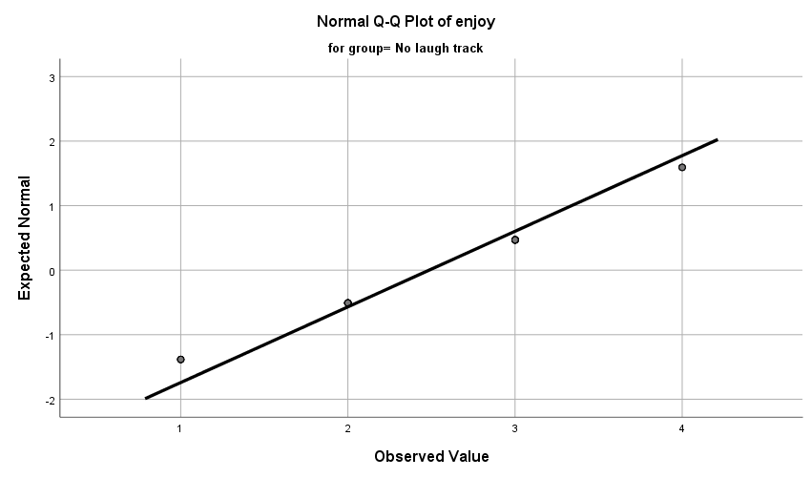
Fig 10 : Normal Q-Q plots –Group1

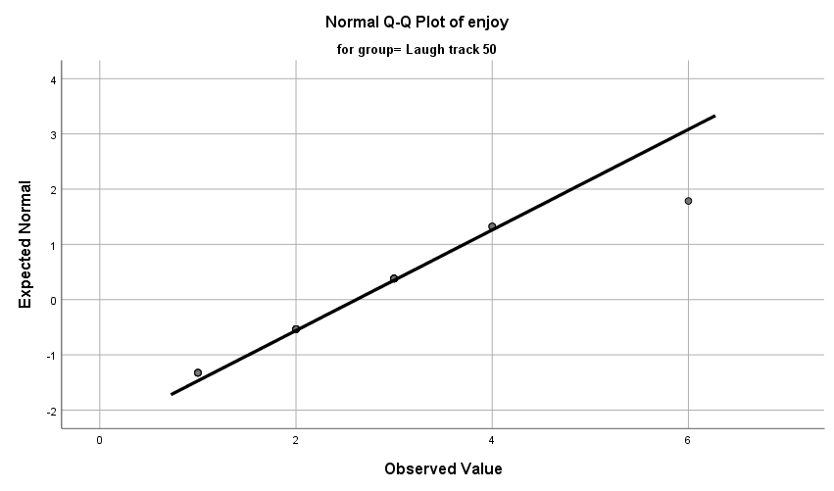

Fig 11 : Normal Q-Q plots – Group2

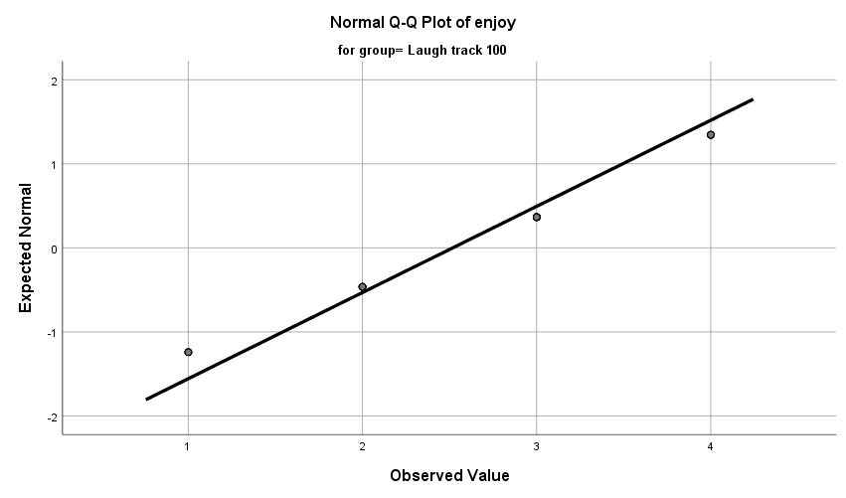

Fig 12 : Normal Q-Q plots – Group3

Visual Interpretation of Normal Q-Q Plots
In all the three groups, majority of the Normal Q-Q plots are aligned to QQ line. Thus, represents a reasonably normal distribution

- Box Plots

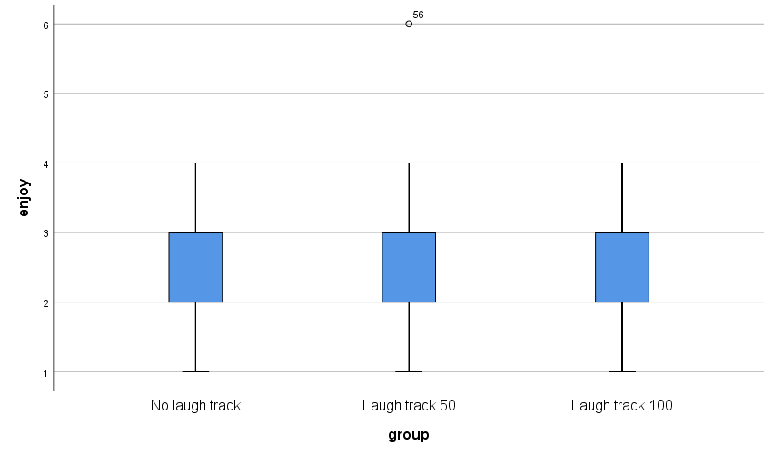
Fig 13 : Box plot – Group1, Group2 and Group3

Visual Interpretation of Box Plots
The box plots of the Group 1 ,Group 2 and Group 3 are not symmetrical .Therefore, the is considered to be not normally distributed

Numerical Tests of Normality

Case Processing Summary
 | group | Cases
 | group | Valid |  | Missing |  | Total
 | group | N | Percent | N | Percent | N | Percent
enjoy | No laugh track | 35 | 100.0% | 0 | 0.0% | 35 | 100.0%
enjoy | Laugh track 50 | 26 | 100.0% | 0 | 0.0% | 26 | 100.0%
enjoy | Laugh track 100 | 27 | 100.0% | 0 | 0.0% | 27 | 100.0%

- Shapiro-Wilk’s Test of Normality

Tests of Normality
 | group | Kolmogorov-Smirnovª |  |  | Shapiro-Wilk
 | group | Statistic | df | Sig. | Statistic | df | Sig.
enjoy | No laugh track | .270 | 35 | .000 | .862 | 35 | .000
enjoy | Laugh track 50 | .248 | 26 | .000 | .858 | 26 | .002
enjoy | Laugh track 100 | .245 | 27 | .000 | .876 | 27 | .004

Hypotheses
H₀ – The sample distribution is normally distributed (null Hypotheses)

Discussion
- The value of p of Shapiro-Wilk’s test for Group1 is .000
- The value of p of Shapiro-Wilk’s test for Group2 is .002
- The value of p of Shapiro-Wilk’s test for Group3 is .004

Hypotheses Resolution
Group 1 :
- Since the Shapiro-Wilk’s value of p < α (p=.000 and α=0.05) , H₀ is rejected. Therefore, the distributions of the groups are considered to be not normally distributed.
Group 2 :
- Since the Shapiro-Wilk’s value of p < α (p=.002 and α=0.05) , H₀ is rejected. Therefore, the distributions of the groups are considered to be not normally distributed.
Group 3 :
- Since the Shapiro-Wilk’s value of p < α (p=.004 and α=0.05) , H₀ is rejected. Therefore, the distributions of the groups are considered to be not normally distributed.

Skewness and Kurtosis Test
Descriptives
 | group |  |  | Statistic | Std. Error | z value
enjoy | No laugh track | Mean |  | 2.49 | .144
enjoy | No laugh track | 95% Confidence Interval for Mean | Lower Bound | 2.19
enjoy | No laugh track | 95% Confidence Interval for Mean | Upper Bound | 2.78
enjoy | No laugh track | 5% Trimmed Mean |  | 2.48
enjoy | No laugh track | Median |  | 3.00
enjoy | No laugh track | Variance |  | .728
enjoy | No laugh track | Std. Deviation |  | .853
enjoy | No laugh track | Minimum |  | 1
enjoy | No laugh track | Maximum |  | 4
enjoy | No laugh track | Range |  | 3
enjoy | No laugh track | Interquartile Range |  | 1
enjoy | No laugh track | Skewness |  | -.254 | .398 | -0.638
enjoy | No laugh track | Kurtosis |  | -.510 | .778 | -0.655
enjoy | Laugh track 50 | Mean |  | 2.62 | .215
enjoy | Laugh track 50 | 95% Confidence Interval for Mean | Lower Bound | 2.17
enjoy | Laugh track 50 | 95% Confidence Interval for Mean | Upper Bound | 3.06
enjoy | Laugh track 50 | 5% Trimmed Mean |  | 2.54
enjoy | Laugh track 50 | Median |  | 3.00
enjoy | Laugh track 50 | Variance |  | 1.206
enjoy | Laugh track 50 | Std. Deviation |  | 1.098
enjoy | Laugh track 50 | Minimum |  | 1
enjoy | Laugh track 50 | Maximum |  | 6
enjoy | Laugh track 50 | Range |  | 5
enjoy | Laugh track 50 | Interquartile Range |  | 1
enjoy | Laugh track 50 | Skewness |  | .859 | .456 | 1.883
enjoy | Laugh track 50 | Kurtosis |  | 2.446 | .887 | 2.757
enjoy | Laugh track 100 | Mean |  | 2.52 | .188
enjoy | Laugh track 100 | 95% Confidence Interval for Mean | Lower Bound | 2.13
enjoy | Laugh track 100 | 95% Confidence Interval for Mean | Upper Bound | 2.90
enjoy | Laugh track 100 | 5% Trimmed Mean |  | 2.52
enjoy | Laugh track 100 | Median |  | 3.00
enjoy | Laugh track 100 | Variance |  | .952
enjoy | Laugh track 100 | Std. Deviation |  | .975
enjoy | Laugh track 100 | Minimum |  | 1
enjoy | Laugh track 100 | Maximum |  | 4
enjoy | Laugh track 100 | Range |  | 3
enjoy | Laugh track 100 | Interquartile Range |  | 1
enjoy | Laugh track 100 | Skewness |  | -.190 | .448 | -0.424
enjoy | Laugh track 100 | Kurtosis |  | -.867 | .872 | -0.994

Discussion on Skewness and Kurtosis
Group 1 :
- The value of z obtained by Skewness/Std. Error =-.254/.398 = -0.638 is within the range of -1.96 and +1.96. Therefore, is acceptable
- The value of z obtained by Kurtosis/Std. Error =-.510/.778 = -0.655 is within the range of -1.96 and +1.96. Therefore, is acceptable

Group 2 :
- The value of z obtained by Skewness/Std. Error =-.859/.456 = 1.883 is within the range of -1.96 and +1.96. Therefore, is acceptable
- The value of z obtained by Kurtosis/Std. Error =2.446/.887 = 2.757 is not within the range of -1.96 and +1.96. Therefore, is not acceptable

Group 3:
- The value of z obtained by Skewness/Std. Error =-.190/.448 = -0.424 is within the range of -1.96 and +1.96. Therefore, is acceptable
- The value of z obtained by Kurtosis/Std. Error =-.867/.872 = -0.994 is within the range of -1.96 and +1.96. Therefore, is acceptable

From the numerical analysis of Skewness and Kurtosis it is clear that the distribution of the Groups 1 and 3 are reasonably normal. Whereas, Group 2 is not normally distributed

Discussion on Normality
From the visual interpretation of the graphical test results and through the analysis of numerical tests it is quite evident that the distributions of all the three groups are approximately normally distributed. Therefore, the pre-test criterion of Normality is not satisfied

Pre-Test Condition -2 : n Quota

ONEWAY enjoy BY group
/STATISTICS DESCRIPTIVES HOMOGENEITY
/MISSING ANALYSIS
/POSTHOC=SIDAK ALPHA(0.05).

Descriptives
enjoy
 | N | Mean | Std. Deviation | Std. Error | 95% Confidence Interval for Mean
 |  |  |  |  | Lower Bound | Upper Bound
No laugh track | 35 | 2.49 | .853 | .144 | 2.19 | 2.78
Laugh track 50 | 26 | 2.62 | 1.098 | .215 | 2.17 | 3.06
Laugh track 100 | 27 | 2.52 | .975 | .188 | 2.13 | 2.90
Total | 88 | 2.53 | .958 | .102 | 2.33 | 2.74

Discussion on n-quota

Since the value of n is not atleast 30 for all the groups, the pre-test condition of n-quota is not met.

Pre-Test Condition -3 : Homogeneity of Variance

Test of Homogeneity of Variances
 |  | Levene Statistic | df1 | df2 | Sig.
enjoy | Based on Mean | .366 | 2 | 85 | .694
enjoy | Based on Median | .137 | 2 | 85 | .872
enjoy | Based on Median and with adjusted df | .137 | 2 | 82.830 | .872
enjoy | Based on trimmed mean | .413 | 2 | 85 | .663

ANOVA
enjoy
 | Sum of Squares | df | Mean Square | F | Sig.
Between Groups | .260 | 2 | .130 | .139 | .871
Within Groups | 79.637 | 85 | .937
Total | 79.898 | 87

Discussion
The value of p > α (p=.694, α=.05) suggests that there is no statistically significant difference between the variances of the groups. Hence, the criterion of Homogeneity of Variance is satisfied.

Documenting the Results of Pre-test Conditions of ANOVA
Following are the results of the pre-test conditions,
- Normality
- n quota
- Homogeneity of Variance

Discussion

Since one of the pre-test conditions of ANOVA is not met, Kruskal-Wallis Test is performed as the best alternative

Description of the Test : Kruskal-Wallis Test
Kruskal-Wallis Test

NPAR TESTS
/K-W=enjoy BY group(1 3)
/MISSING ANALYSIS.

Ranks
 | group | N | Mean Rank
enjoy | No laugh track | 35 | 43.64
enjoy | Laugh track 50 | 26 | 45.42
enjoy | Laugh track 100 | 27 | 44.72
enjoy | Total | 88

Test Statistics^{a,b}
 | enjoy
Kruskal-Wallis H | .085
df | 2
Asymp. Sig. | .958

a. Kruskal Wallis Test
b. Grouping Variable: group

Discussion
- The value of p obtained from Kruskal Wallis is .958
- Since the value of p>α (p=.958, α=0.05), there is no statistically significant difference between the groups. Therefore, we accept H₀

Hypothesis Resolution
Accept => H₀ – There is no difference between the enjoyment levels of audience of these groups
Reject => H₁ – At least one group outperforms another in terms of the level of enjoyment

Kruskal Wallis – Post Hoc Test
Eventhough there is no statistically significant difference between the groups, we perform pair-wise tests to identify if any group that outperforms the others.

Groups | Description | Comparison of Means
Group 1 : Group 2 | No laugh track: 50-person laugh track | µ(G1):µ(G2)
Group 2 : Group 3 | 50-person laugh track: 100-person laugh track | µ(G2):µ(G3)
Group 1 : Group 3 | No laugh track : 100-person laugh track | µ(G1):µ(G3)

- Kruskal Wallis – Group 1 : Group 2
USE ALL.
COMPUTE filter_$=(group=1 or group=2).
VARIABLE LABELS filter_$ 'group=1 or group=2 (FILTER)'.
VALUE LABELS filter_$ 0 'Not Selected' 1 'Selected'.
FORMATS filter_$ (f1.0).
FILTER BY filter_$.
EXECUTE.
NPAR TESTS
/K-W=enjoy BY group(1 3)
/MISSING ANALYSIS.

Ranks
 | group | N | Mean Rank
enjoy | No laugh track | 35 | 30.47
enjoy | Laugh track 50 | 26 | 31.71
enjoy | Total | 61

Test Statistics^{a,b}
 | enjoy
Kruskal-Wallis H | .083
df | 1
Asymp. Sig. | .773

a. Kruskal Wallis Test
b. Grouping Variable: group

- Kruskal Wallis – Group 2 : Group 3

USE ALL.
COMPUTE filter_$=(group=2 or group=3).
VARIABLE LABELS filter_$ 'group=2 or group=3 (FILTER)'.
ALUE LABELS filter_$ 0 'Not Selected' 1 'Selected'.
FORMATS filter_$ (f1.0).
FILTER BY filter_$.
EXECUTE.
NPAR TESTS
/K-W=enjoy BY group(1 3)
/MISSING ANALYSIS.

Ranks
 | group | N | Mean Rank
enjoy | Laugh track 50 | 26 | 27.21
enjoy | Laugh track 100 | 27 | 26.80
enjoy | Total | 53

Test Statistics^{a,b}
 | enjoy
Kruskal-Wallis H | .011
df | 1
Asymp. Sig. | .918

a. Kruskal Wallis Test
b. Grouping Variable: group

- Kruskal Wallis – Group 1 : Group 3

USE ALL.
COMPUTE filter_$=(group=1 or group=3).
VARIABLE LABELS filter_$ 'group=1 or group=3 (FILTER)'.
VALUE LABELS filter_$ 0 'Not Selected' 1 'Selected'.
FORMATS filter_$ (f1.0).
FILTER BY filter_$.
EXECUTE.
NPAR TESTS
/K-W=enjoy BY group(1 3)
/MISSING ANALYSIS.

Ranks
 | group | N | Mean Rank
enjoy | No laugh track | 35 | 31.17
enjoy | Laugh track 100 | 27 | 31.93
enjoy | Total | 62

Test Statistics^{a,b}
 | enjoy
Kruskal-Wallis H | .030
df | 1
Asymp. Sig. | .862

a. Kruskal Wallis Test
b. Grouping Variable: group

Documenting Results of Pair-wise Kruskal Wallis

Groups | Comparison | p value | Discussion
Group 1 : Group 2 | µ(G1) : µ(G2)  2.49 : 2.62 | .773 | - Since p > 0.05, there is no statistically significant difference between Group 1 and Group 2
Group 2 : Group 3 | µ(G2) : µ(G3)  2.62 : 2.52 | .918 | - Since p > 0.05, there is no statistically significant difference between Group 2 and Group 3
Group 1 : Group 3 | µ(G1) : µ(G3)  2.49 : 2.52 | .862 | - Since p > 0.05, there is no statistically significant difference between Group 1 and Group 3

Discussion of the Test
In order to assess if having a laugh track in a comedy video will improve the enjoyment levels of the audience, the audience are alternatively assigned to three groups, the control group (with no laugh track), video with laugh track of 50-person audience (Treatment group 1) and video with laugh track of 100-person audience (Treatment group2). The control group had about 32 audience (n=32). Whereaas, the Treatment group1 and Treatment Group2 had around 33 audience members (n=33)All the three groups are asked to rate their level of enjoyment on a scale of 1 to 5 by the end of the movie (where 1= not very enjoyable and 5=enjoyable)

Since we are comparing more than two groups, we chose ANOVA. However, we proceeded with Kruskal Wallis as one of the pre-test conditions of ANOVA was not satisfied. The Kruskal Wallis’s value of p > α (where p=.958 and α =0.5) indicates that there is no statistically significant difference between the groups. Therefore, we reject H₁ and accept H₀. From the results of Post hoc test, no statistically significant differences were found between the groups.

Comparing the means of the three groups,
µ(G₁) : µ(G₂) : µ(G₃)
2.49 : 2.62 : 2.52

Eventhough there is a difference in the means of the three Groups, it is statistically insignificant. Therefore, there is no difference between the enjoyment levels of audience of these groups.

Exercise Number: Ch 06 - Exercise 08A
Dataset Used : [DataSet1] C:\Users\Jaya Karthi Booven\Desktop\SPSS\6.8\Ch 06 - Exercise 08A.sav
Selection of Test :
The primary objective of the given exercise is to compare three different groups of continuous variables and decide on the groups that outperform the others. Since we are comparing more than two groups of continuous variables, we prefer ANOVA test.

Groups
Group 1: Subjects doing no walking (Control Group)
Group 2: Subjects doing 30 minutes of walk everyday (Treatment Group 1)
Group 3: Subjects doing 60 minutes of walk everyday (Treatment Group 2)

Hypotheses
H₀ – There is no difference between the energy levels of the groups (Null Hypotheses)
H₁ – At least one group outperforms another in terms of the energy level (Alternative Hypotheses)

Pre-test Checklist for ANOVA Test
Following are the pre-test conditions for running ANOVA,
- Normality
- n quota
- Homogeneity of Variance

Description of the Test : Pre-test Conditions for ANOVA
Pre-Test Condition - 1 : Normality
Warning # 5281. Command name: GET FILE
SPSS Statistics is running in Unicode encoding mode. This file is encoded in a locale-specific (code page) encoding. The defined width of any string variables are automatically tripled in order to avoid possible data loss. You can use ALTER TYPE to set the width of string variables to the width of the longest observed value for each string variable.
DATASET NAME DataSet1 WINDOW=FRONT.

Group 1: Subjects doing no walking

USE ALL.
COMPUTE filter_$=(group=1).
VARIABLE LABELS filter_$ 'group=1 (FILTER)'.
VALUE LABELS filter_$ 0 'Not Selected' 1 'Selected'.
FORMATS filter_$ (f1.0).
FILTER BY filter_$.
EXECUTE.

FREQUENCIES VARIABLES=energy
/STATISTICS=STDDEV VARIANCE RANGE MINIMUM MAXIMUM MEAN MEDIAN
/HISTOGRAM NORMAL
/ORDER=ANALYSIS.

Descriptive Statistics

Statistics
energy
N | Valid | 132
N | Missing | 0
Mean |  | 81.23
Median |  | 82.00
Mode |  | 82
Std. Deviation |  | 4.328
Variance |  | 18.731
Range |  | 27
Minimum |  | 61
Maximum |  | 88

Fig 1 : Descriptive Statistics of Group1

Frequencies

energy
 |  | Frequency | Percent | Valid Percent | Cumulative Percent
Valid | 61 | 1 | .8 | .8 | .8
Valid | 63 | 1 | .8 | .8 | 1.5
Valid | 65 | 1 | .8 | .8 | 2.3
Valid | 74 | 3 | 2.3 | 2.3 | 4.5
Valid | 75 | 4 | 3.0 | 3.0 | 7.6
Valid | 76 | 4 | 3.0 | 3.0 | 10.6
Valid | 77 | 7 | 5.3 | 5.3 | 15.9
Valid | 78 | 5 | 3.8 | 3.8 | 19.7
Valid | 79 | 11 | 8.3 | 8.3 | 28.0
Valid | 80 | 8 | 6.1 | 6.1 | 34.1
Valid | 81 | 13 | 9.8 | 9.8 | 43.9
Valid | 82 | 18 | 13.6 | 13.6 | 57.6
Valid | 83 | 14 | 10.6 | 10.6 | 68.2
Valid | 84 | 16 | 12.1 | 12.1 | 80.3
Valid | 85 | 11 | 8.3 | 8.3 | 88.6
Valid | 86 | 6 | 4.5 | 4.5 | 93.2
Valid | 87 | 8 | 6.1 | 6.1 | 99.2
Valid | 88 | 1 | .8 | .8 | 100.0
Valid | Total | 132 | 100.0 | 100.0

Fig 2 : Frequencies of Group 1

Group 2: Subjects doing 30 minutes of walk everyday

USE ALL.
COMPUTE filter_$=(group=2).
VARIABLE LABELS filter_$ 'group=2 (FILTER)'.
VALUE LABELS filter_$ 0 'Not Selected' 1 'Selected'.
FORMATS filter_$ (f1.0).
FILTER BY filter_$.
EXECUTE.

FREQUENCIES VARIABLES=energy
/STATISTICS=STDDEV VARIANCE RANGE MINIMUM MAXIMUM MEAN MEDIAN MODE
/HISTOGRAM NORMAL
/ORDER=ANALYSIS.

Descriptive Statistics

Statistics
energy
N | Valid | 124
N | Missing | 0
Mean |  | 82.60
Median |  | 82.50
Mode |  | 82
Std. Deviation |  | 4.320
Variance |  | 18.664
Range |  | 20
Minimum |  | 73
Maximum |  | 93

Fig 3 : Descriptive Statistics of Group 2
Frequencies
energy
 |  | Frequency | Percent | Valid Percent | Cumulative Percent
Valid | 73 | 1 | .8 | .8 | .8
Valid | 74 | 2 | 1.6 | 1.6 | 2.4
Valid | 75 | 2 | 1.6 | 1.6 | 4.0
Valid | 76 | 5 | 4.0 | 4.0 | 8.1
Valid | 77 | 9 | 7.3 | 7.3 | 15.3
Valid | 78 | 5 | 4.0 | 4.0 | 19.4
Valid | 79 | 8 | 6.5 | 6.5 | 25.8
Valid | 80 | 7 | 5.6 | 5.6 | 31.5
Valid | 81 | 11 | 8.9 | 8.9 | 40.3
Valid | 82 | 12 | 9.7 | 9.7 | 50.0
Valid | 83 | 8 | 6.5 | 6.5 | 56.5
Valid | 84 | 11 | 8.9 | 8.9 | 65.3
Valid | 87 | 7 | 5.6 | 5.6 | 86.3
Valid | 88 | 7 | 5.6 | 5.6 | 91.9
Valid | 89 | 2 | 1.6 | 1.6 | 93.5
Valid | 90 | 4 | 3.2 | 3.2 | 96.8
Valid | 91 | 3 | 2.4 | 2.4 | 99.2
Valid | 93 | 1 | .8 | .8 | 100.0
Valid | Total | 124 | 100.0 | 100.0

Fig 4 : Frequencies of Group 2

Group 3: Subjects doing 60 minutes of walk everyday

USE ALL.
COMPUTE filter_$=(group=3).
VARIABLE LABELS filter_$ 'group=3 (FILTER)'.
VALUE LABELS filter_$ 0 'Not Selected' 1 'Selected'.
FORMATS filter_$ (f1.0).
FILTER BY filter_$.
EXECUTE.

FREQUENCIES VARIABLES=energy
/STATISTICS=STDDEV VARIANCE RANGE MINIMUM MAXIMUM MEAN MEDIAN MODE
/HISTOGRAM NORMAL
/ORDER=ANALYSIS.

Descriptive Statistics
Statistics
energy
N | Valid | 95
N | Missing | 0
Mean |  | 82.77
Median |  | 83.00
Mode |  | 81ª
Std. Deviation |  | 4.716
Variance |  | 22.244
Range |  | 20
Minimum |  | 73
Maximum |  | 93

a. Multiple modes exist. The smallest value is shown

Fig 5 : Descriptive Statistics of Group 3

Frequencies
energy
 |  | Frequency | Percent | Valid Percent | Cumulative Percent
Valid | 73 | 1 | 1.1 | 1.1 | 1.1
Valid | 74 | 3 | 3.2 | 3.2 | 4.2
Valid | 76 | 4 | 4.2 | 4.2 | 8.4
Valid | 77 | 5 | 5.3 | 5.3 | 13.7
Valid | 78 | 8 | 8.4 | 8.4 | 22.1
Valid | 79 | 5 | 5.3 | 5.3 | 27.4
Valid | 80 | 4 | 4.2 | 4.2 | 31.6
Valid | 81 | 9 | 9.5 | 9.5 | 41.1
Valid | 82 | 8 | 8.4 | 8.4 | 49.5
Valid | 83 | 9 | 9.5 | 9.5 | 58.9
Valid | 84 | 7 | 7.4 | 7.4 | 66.3
Valid | 85 | 4 | 4.2 | 4.2 | 70.5
Valid | 86 | 6 | 6.3 | 6.3 | 76.8
Valid | 87 | 4 | 4.2 | 4.2 | 81.1
Valid | 88 | 5 | 5.3 | 5.3 | 86.3
Valid | 89 | 5 | 5.3 | 5.3 | 91.6
Valid | 90 | 2 | 2.1 | 2.1 | 93.7
Valid | 91 | 3 | 3.2 | 3.2 | 96.8
Valid | 92 | 1 | 1.1 | 1.1 | 97.9
Valid | 93 | 2 | 2.1 | 2.1 | 100.0
Valid | Total | 95 | 100.0 | 100.0

Fig 6 : Frequencies of Group 3

Normality Assessment
In this exercise, Normality is assessed in a two-step process,
- Graphical Tests of Normality
- Numerical Tests of Normality

Graphical Tests of Normality
- In graphical tests, the normality is assessed through the visual interpretation of Histograms, Normal Q-Q Plots and Box plots
Numerical Tests of Normality
- In the numerical tests, the normality of the distribution is determined based on the Shapiro -Wilk’s p value and the Skewness and Kurtosis test’s z values

Graphical Tests of Normality

- Histogram with a normal curve

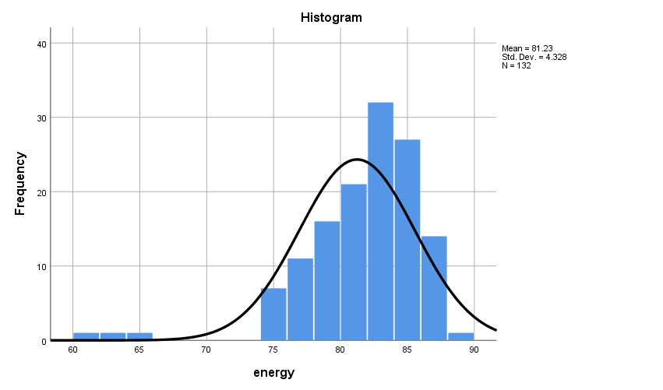
Fig 7 : Histogram with a normal curve for Group1

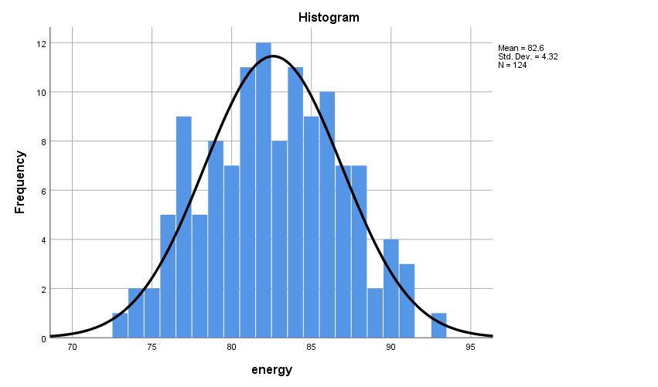
Fig 8 : Histogram with a normal curve for Group2

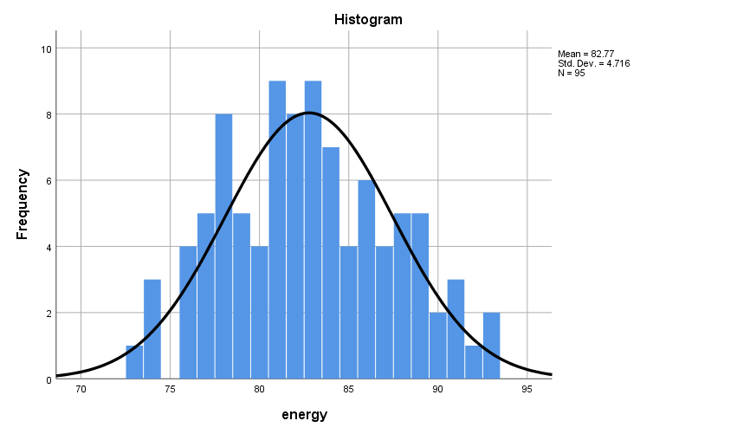
Fig 9 : Histogram with a normal curve for Group3

Visual Interpretation of Histograms

- Group 1: Since majority of the values are accumulated towards the left of the histogram, there is a skewness towards the right(positively skewed).
- Group 2: The normal curve is perfectly bell shaped and is fairly symmetrical. Therefore, the group is considered to be approximately normally distributed
- Group 3: From the visual inspection of the histograms it is quite evident that the normality curve is bell shaped and shows a good symmetry. Therefore, the group is considered to approximately normally distributed

EXAMINE VARIABLES=energy BY group
/PLOT BOXPLOT NPPLOT
/COMPARE GROUPS
/STATISTICS DESCRIPTIVES
/CINTERVAL 95
/MISSING LISTWISE
/NOTOTAL.

- Normal Q-Q Plots

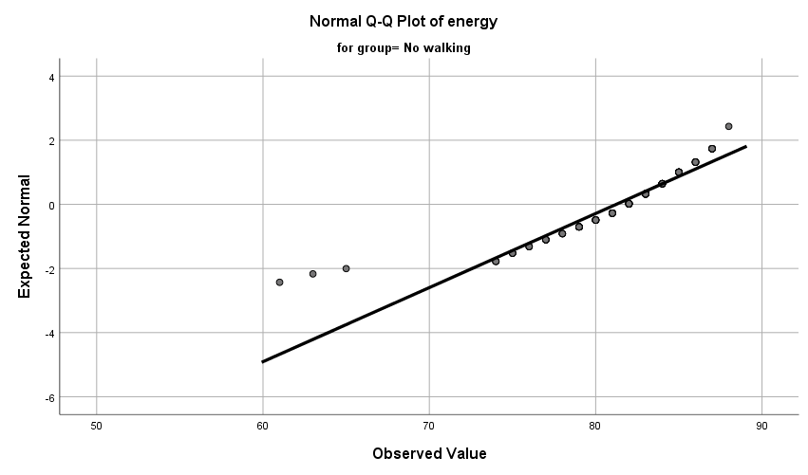
Fig 10 : Normal Q-Q plots –Group1

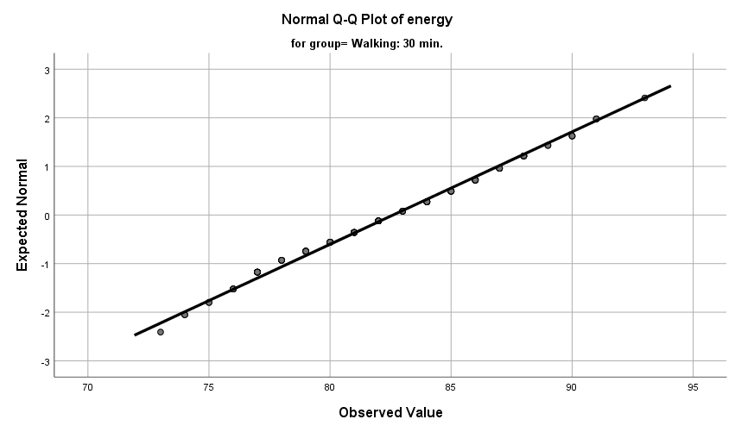

Fig 11 : Normal Q-Q plots – Group2

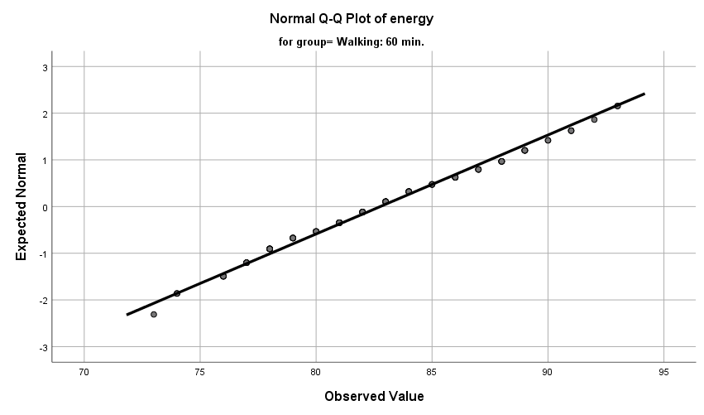

Fig 12 : Normal Q-Q plots – Group3

Visual Interpretation of Normal Q-Q Plots
In all the three groups, majority of the Normal Q-Q plots are aligned to QQ line with a few outliers in Group1. Thus, represents a reasonably normal distribution

- Box Plots

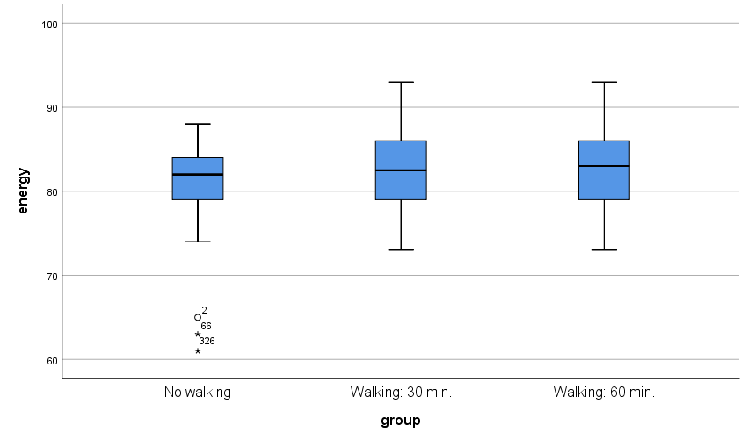
Fig 13 : Box plot – Group1, Group2 and Group3

Visual Interpretation of Box Plots
The box plots of the Group 1 ,Group 2 and Group 3 are fairly symmetrical .Therefore, the is considered to be not normally distributed

Numerical Tests of Normality

Case Processing Summary
 | group | Cases
 | group | Valid |  | Missing |  | Total
 | group | N | Percent | N | Percent | N | Percent
energy | No walking | 132 | 100.0% | 0 | 0.0% | 132 | 100.0%
energy | Walking: 30 min. | 124 | 100.0% | 0 | 0.0% | 124 | 100.0%
energy | Walking: 60 min. | 95 | 100.0% | 0 | 0.0% | 95 | 100.0%

- Shapiro-Wilk’s Test of Normality

Tests of Normality
 | group | Kolmogorov-Smirnovª |  |  | Shapiro-Wilk
 | group | Statistic | df | Sig. | Statistic | df | Sig.
energy | No walking | .137 | 132 | .000 | .869 | 132 | .000
energy | Walking: 30 min. | .062 | 124 | .200* | .987 | 124 | .275
energy | Walking: 60 min. | .070 | 95 | .200* | .983 | 95 | .239

*. This is a lower bound of the true significance.
a. Lilliefors Significance Correction

Hypotheses
H₀ – The sample distribution is normally distributed (Null Hypotheses)

Discussion
- The value of p of Shapiro-Wilk’s test for Group1 is .000
- The value of p of Shapiro-Wilk’s test for Group2 is .275
- The value of p of Shapiro-Wilk’s test for Group3 is .239

Hypotheses Resolution
Group 1 :
- Since the Shapiro-Wilk’s value of p < α (p=.000 and α=0.05) , H₀ is rejected. Therefore, the distributions of the groups are considered to be not normally distributed.
Group 2 :
- Since the Shapiro-Wilk’s value of p > α (p=.275 and α=0.05) , H₀ is accepted. Therefore, the distributions of the group is considered to be normally distributed.
Group 3 :
- Since the Shapiro-Wilk’s value of p > α (p=.239 and α=0.05) , H₀ is accepted. Therefore, the distributions of the groups is considered to be normally distributed.

Skewness and Kurtosis Test
Descriptives
 | Group |  |  | Statistic | Std. Error | z value
energy | No walking | Mean |  | 81.23 | .377
energy | No walking | 95% Confidence Interval for Mean | Lower Bound | 80.49
energy | No walking | 95% Confidence Interval for Mean | Upper Bound | 81.98
energy | No walking | 5% Trimmed Mean |  | 81.58
energy | No walking | Median |  | 82.00
energy | No walking | Variance |  | 18.731
energy | No walking | Std. Deviation |  | 4.328
energy | No walking | Minimum |  | 61
energy | No walking | Maximum |  | 88
energy | No walking | Range |  | 27
energy | No walking | Interquartile Range |  | 5
energy | No walking | Skewness |  | -1.783 | .211 | -8.45
energy | No walking | Kurtosis |  | 5.708 | .419 | 13.6
energy | Walking: 30 min. | Mean |  | 82.60 | .388
energy | Walking: 30 min. | 95% Confidence Interval for Mean | Lower Bound | 81.84
energy | Walking: 30 min. | 95% Confidence Interval for Mean | Upper Bound | 83.37
energy | Walking: 30 min. | 5% Trimmed Mean |  | 82.59
energy | Walking: 30 min. | Median |  | 82.50
energy | Walking: 30 min. | Variance |  | 18.664
energy | Walking: 30 min. | Std. Deviation |  | 4.320
energy | Walking: 30 min. | Minimum |  | 73
energy | Walking: 30 min. | Maximum |  | 93
energy | Walking: 30 min. | Range |  | 20
energy | Walking: 30 min. | Interquartile Range |  | 7
energy | Walking: 30 min. | Skewness |  | .018 | .217 | 0.08
energy | Walking: 30 min. | Kurtosis |  | -.608 | .431 | -1.41
energy | Walking: 60 min. | Mean |  | 82.77 | .484
energy | Walking: 60 min. | 95% Confidence Interval for Mean | Lower Bound | 81.81
energy | Walking: 60 min. | 95% Confidence Interval for Mean | Upper Bound | 83.73
energy | Walking: 60 min. | 5% Trimmed Mean |  | 82.73
energy | Walking: 60 min. | Median |  | 83.00
energy | Walking: 60 min. | Variance |  | 22.244
energy | Walking: 60 min. | Std. Deviation |  | 4.716
energy | Walking: 60 min. | Minimum |  | 73
energy | Walking: 60 min. | Maximum |  | 93
energy | Walking: 60 min. | Range |  | 20
energy | Walking: 60 min. | Interquartile Range |  | 7
energy | Walking: 60 min. | Skewness |  | .147 | .247 | 0.595
energy | Walking: 60 min. | Kurtosis |  | -.623 | .490 | -1.27

Discussion on Skewness and Kurtosis
Group 1 :
- The value of z obtained by Skewness/Std. Error =-1.783/0.211 = -8.45 is not within the range of -1.96 and +1.96. Therefore is not acceptable
- The value of z obtained by Kurtosis/Std. Error =5.708/0.419=13.6 is not within the range of -1.96 and +1.96. Therefore is not acceptable

Group 2 :
- The value of z obtained by Skewness/Std. Error =0.0018/.217 = 0.08 is within the range of -1.96 and +1.96. Therefore is acceptable
- The value of z obtained by Kurtosis/Std. Error =-0.608/0.431 = -1.41 is not within the range of -1.96 and +1.96. Therefore is acceptable

Group 3:
- The value of z obtained by Skewness/Std. Error =0.147/0.247 = 0.595 is within the range of -1.96 and +1.96. Therefore is acceptable
- The value of z obtained by Kurtosis/Std. Error =-0.623/0.490 = 0.490 is within the range of -1.96 and +1.96. Therefore is acceptable

From the numerical analysis of Skewness and Kurtosis it is clear that the distribution of the Groups 2 and 3 are reasonably normal. Whereas, Group 1 is not normally distributed

Discussion on Normality
From the visual interpretation of the graphical test results and through the analysis of numerical tests it is quite evident that the distributions of all the three groups are approximately normally distributed. Therefore, the pre-test criterion of Normality is not satisfied

Pre-Test Condition -2 : n Quota

ONEWAY energy BY group
/STATISTICS DESCRIPTIVES HOMOGENEITY
/MISSING ANALYSIS
/POSTHOC=SIDAK ALPHA(0.05).

Descriptives
Energy
 | N | Mean | Std. Deviation | Std. Error | 95% Confidence Interval for Mean
 |  |  |  |  | Lower Bound | Upper Bound
No walking | 132 | 81.23 | 4.328 | .377 | 80.49 | 81.98
Walking: 30 min. | 124 | 82.60 | 4.320 | .388 | 81.84 | 83.37
Walking: 60 min. | 95 | 82.77 | 4.716 | .484 | 81.81 | 83.73
Total | 351 | 82.13 | 4.476 | .239 | 81.66 | 82.60

Discussion on n-quota

Since the value of n is atleast 30 for all the groups, the pre-test condition of n-quota is met.

Pre-Test Condition -3 : Homogeneity of Variance

Test of Homogeneity of Variances
 |  | Levene Statistic | df1 | df2 | Sig.
energy | Based on Mean | 2.019 | 2 | 348 | .134
energy | Based on Median | 2.476 | 2 | 348 | .086
energy | Based on Median and with adjusted df | 2.476 | 2 | 330.703 | .086
energy | Based on trimmed mean | 2.247 | 2 | 348 | .107

ANOVA
Energy
 | Sum of Squares | df | Mean Square | F | Sig.
Between Groups | 172.444 | 2 | 86.222 | 4.387 | .013
Within Groups | 6840.262 | 348 | 19.656
Total | 7012.707 | 350

Discussion
The value of p > α (p=.134, α=.05) suggests that there is no statistically significant difference between the variances of the groups. Hence, the criterion of Homogeneity of Variance is satisfied.

Documenting the Results of Pre-test Conditions of ANOVA
Following are the results of the pre-test conditions,
- Normality
- n quota
- Homogeneity of Variance

Discussion

Since one of the pre-test conditions of ANOVA is not met, Kruskal-Wallis Test is performed as the best alternative

Description of the Test : Kruskal-Wallis Test
Kruskal-Wallis Test

NPAR TESTS
/K-W=energy BY group(1 3)
/MISSING ANALYSIS.

Ranks
 | group | N | Mean Rank
energy | No walking | 132 | 160.58
energy | Walking: 30 min. | 124 | 184.83
energy | Walking: 60 min. | 95 | 185.89
energy | Total | 351

Test Statistics^{a,b}
 | energy
Kruskal-Wallis H | 4.916
df | 2
Asymp. Sig. | .086

a. Kruskal Wallis Test
b. Grouping Variable: group

Discussion
- The value of p obtained from Kruskal Wallis is .086
- Since the value of p>α (p=.086, α=0.05), there is no statistically significant difference between the groups. Therefore, accept H₀

Hypothesis Resolution
Accept => H₀ – There is no difference between the energy levels of the groups
Reject => H₁ – At least one group outperforms another in terms of the energy level

Kruskal Wallis – Post Hoc Test
Eventhough there is no statistically significant difference between the groups, we perform pair-wise tests to identify if any group that outperforms the others.

Groups | Description | Comparison of Means
Group 1 : Group 2 | No walking: 30 mins walking | µ(G1):µ(G2)
Group 2 : Group 3 | 30 mins walking: 60 mins walking | µ(G2):µ(G3)
Group 1 : Group 3 | No walking: 60 mins walking | µ(G1):µ(G3)

- Kruskal Wallis – Group 1 : Group 2
USE ALL.
COMPUTE filter_$=(group = 1 or group = 2).
VARIABLE LABELS filter_$ 'group = 1 or group = 2 (FILTER)'.
VALUE LABELS filter_$ 0 'Not Selected' 1 'Selected'.
FORMATS filter_$ (f1.0).
FILTER BY filter_$.
EXECUTE.
NPAR TESTS
/K-W=energy BY group(1 3)
/MISSING ANALYSIS.

Ranks
 | group | N | Mean Rank
energy | No walking | 132 | 119.69
energy | Walking: 30 min. | 124 | 137.88
energy | Total | 256

Test Statistics^{a,b}
 | energy
Kruskal-Wallis H | 3.886
df | 1
Asymp. Sig. | .049

a. Kruskal Wallis Test
b. Grouping Variable: group

- Kruskal Wallis – Group 2 : Group 3

USE ALL.
COMPUTE filter_$=(group = 2 or group = 3).
VARIABLE LABELS filter_$ 'group = 2 or group = 3 (FILTER)'.
VALUE LABELS filter_$ 0 'Not Selected' 1 'Selected'.
FORMATS filter_$ (f1.0).
FILTER BY filter_$.
EXECUTE.
NPAR TESTS
/K-W=energy BY group(1 3)
/MISSING ANALYSIS.

Ranks
 | group | N | Mean Rank
energy | Walking: 30 min. | 124 | 109.45
energy | Walking: 60 min. | 95 | 110.72
energy | Total | 219

Test Statistics^{a,b}
 | energy
Kruskal-Wallis H | .022
df | 1
Asymp. Sig. | .883

a. Kruskal Wallis Test
b. Grouping Variable: group

- Kruskal Wallis – Group 1 : Group 3

USE ALL.
COMPUTE filter_$=(group = 1 or group = 3).
VARIABLE LABELS filter_$ 'group = 1 or group = 3 (FILTER)'.
VALUE LABELS filter_$ 0 'Not Selected' 1 'Selected'.
FORMATS filter_$ (f1.0).
FILTER BY filter_$.
EXECUTE.
NPAR TESTS
/K-W=energy BY group(1 3)
/MISSING ANALYSIS.

Ranks
 | group | N | Mean Rank
energy | No walking | 132 | 107.40
energy | Walking: 60 min. | 95 | 123.17
energy | Total | 227

Test Statistics^{a,b}
 | energy
Kruskal-Wallis H | 3.207
df | 1
Asymp. Sig. | .073

a. Kruskal Wallis Test
b. Grouping Variable: group

Documenting Results of Pair-wise Kruskal Wallis

Groups | Comparison | p value | Discussion
Group 1 : Group 2 | µ(G1) : µ(G2)  81.23 : 82.60 | .049 | - Since p < 0.05, there is a statistically significant difference between Group 1 and Group 2  - By comparing the means it is quite evident that Group 2 outperforms Group 1
Group 2 : Group 3 | µ(G2) : µ(G3)  82.60 : 82.77 | .883 | - Since p > 0.05, there is no statistically significant difference between Group 2 and Group 3
Group 1 : Group 3 | µ(G1) : µ(G3)  81.23 : 82.77 | .073 | - Since p > 0.05, there is no statistically significant difference between Group 1 and Group 3

Discussion of the Test
In order to assess if early morning exercises will improve the energy levels of the subjects, a number of subjects are recruited and alternatively assigned to three groups, the control group (with no walking), Treatment Group1 (with 30 mins of walking everyday)and Treatment Group2 (with 60 mins of walking everyday). The control group had about 132 subjects (n=132). Whereaas, the Treatment Group1 had 124 (n=124) and Treatment Group2 had around 95 members (n=95). All the three groups are asked to rate their level of energy by the end of the month, on a scale of 1 to 100 (where 1= low energy and 100=extremely high energy)

Since we are comparing more than two groups, we chose ANOVA. However, we proceeded with Kruskal Wallis as one of the pre-test conditions of ANOVA was not satisfied. The Kruskal Wallis’s value of p > α (where p=.086 and α =0.5) indicates that there is no statistically significant difference between the groups. Therefore, we reject H₁ and accept H₀. From the results of Post hoc tests, we observed a statistically difference between the energy levels of Groups1 and Group2. To identify which group outperformed, we are comparing the means.

Comparing the means of the three groups,
µ(G₁) : µ(G₂) : µ(G₃)
81.23 : 82.60 : 82.77

Eventhough there is a difference in the means of the Group 1 and Group 2, it is statistically insignificant. Therefore, there is no difference between the energy levels of these groups.

Exercise Number: Ch 06 - Exercise 08B
Dataset Used : [DataSet1] C:\Users\Jaya Karthi Booven\Desktop\SPSS\6.8\Ch 06 - Exercise 08B.sav
Selection of Test :
The primary objective of the given exercise is to compare three different groups of continuous variables and decide on the groups that outperform the others. Since we are comparing more than two groups of continuous variables, we prefer ANOVA test.

Groups
Group 1: Subjects doing no walking (Control Group)
Group 2: Subjects doing 30 minutes of walk everyday (Treatment Group 1)
Group 3: Subjects doing 60 minutes of walk everyday (Treatment Group 2)

Hypotheses
H₀ – There is no difference between the energy levels of the groups (Null Hypotheses)
H₁ – At least one group outperforms another in terms of the energy level (Alternative Hypotheses)

Pre-test Checklist for ANOVA Test
Following are the pre-test conditions for running ANOVA,
- Normality
- n quota
- Homogeneity of Variance

Description of the Test : Pre-test Conditions for ANOVA
Pre-Test Condition - 1 : Normality
Warning # 5281. Command name: GET FILE
SPSS Statistics is running in Unicode encoding mode. This file is encoded in a locale-specific (code page) encoding. The defined width of any string variables are automatically tripled in order to avoid possible data loss. You can use ALTER TYPE to set the width of string variables to the width of the longest observed value for each string variable.
DATASET NAME DataSet1 WINDOW=FRONT.

Group 1: Subjects doing no walking

USE ALL.
COMPUTE filter_$=(group=1).
VARIABLE LABELS filter_$ 'group=1 (FILTER)'.
VALUE LABELS filter_$ 0 'Not Selected' 1 'Selected'.
FORMATS filter_$ (f1.0).
FILTER BY filter_$.
EXECUTE.

FREQUENCIES VARIABLES=energy
/STATISTICS=STDDEV VARIANCE RANGE MINIMUM MAXIMUM MEAN MEDIAN
/HISTOGRAM NORMAL
/ORDER=ANALYSIS.

Descriptive Statistics
Statistics
energy
N | Valid | 90
N | Missing | 0
Mean |  | 54.22
Median |  | 53.50
Mode |  | 51
Std. Deviation |  | 10.994
Variance |  | 120.871
Range |  | 45
Minimum |  | 32
Maximum |  | 77

Fig 1 : Descriptive Statistics of Group1

Frequencies
energy
 |  | Frequency | Percent | Valid Percent | Cumulative Percent
Valid | 32 | 1 | 1.1 | 1.1 | 1.1
Valid | 33 | 1 | 1.1 | 1.1 | 2.2
Valid | 35 | 1 | 1.1 | 1.1 | 3.3
Valid | 37 | 1 | 1.1 | 1.1 | 4.4
Valid | 38 | 3 | 3.3 | 3.3 | 7.8
Valid | 39 | 3 | 3.3 | 3.3 | 11.1
Valid | 41 | 4 | 4.4 | 4.4 | 15.6
Valid | 42 | 3 | 3.3 | 3.3 | 18.9
Valid | 43 | 1 | 1.1 | 1.1 | 20.0
Valid | 44 | 1 | 1.1 | 1.1 | 21.1
Valid | 45 | 1 | 1.1 | 1.1 | 22.2
Valid | 46 | 5 | 5.6 | 5.6 | 27.8
Valid | 47 | 1 | 1.1 | 1.1 | 28.9
Valid | 49 | 4 | 4.4 | 4.4 | 33.3
Valid | 50 | 2 | 2.2 | 2.2 | 35.6
Valid | 51 | 7 | 7.8 | 7.8 | 43.3
Valid | 52 | 3 | 3.3 | 3.3 | 46.7
Valid | 53 | 3 | 3.3 | 3.3 | 50.0
Valid | 54 | 5 | 5.6 | 5.6 | 55.6
Valid | 55 | 1 | 1.1 | 1.1 | 56.7
Valid | 56 | 2 | 2.2 | 2.2 | 58.9
Valid | 57 | 1 | 1.1 | 1.1 | 60.0
Valid | 58 | 4 | 4.4 | 4.4 | 64.4
Valid | 59 | 4 | 4.4 | 4.4 | 68.9
Valid | 60 | 1 | 1.1 | 1.1 | 70.0
Valid | 61 | 2 | 2.2 | 2.2 | 72.2
Valid | 62 | 2 | 2.2 | 2.2 | 74.4
Valid | 63 | 1 | 1.1 | 1.1 | 75.6
Valid | 64 | 4 | 4.4 | 4.4 | 80.0
Valid | 65 | 3 | 3.3 | 3.3 | 83.3
Valid | 66 | 3 | 3.3 | 3.3 | 86.7
Valid | 68 | 2 | 2.2 | 2.2 | 88.9
Valid | 70 | 2 | 2.2 | 2.2 | 91.1
Valid | 71 | 3 | 3.3 | 3.3 | 94.4
Valid | 72 | 1 | 1.1 | 1.1 | 95.6
Valid | 75 | 2 | 2.2 | 2.2 | 97.8
Valid | 77 | 2 | 2.2 | 2.2 | 100.0
Valid | Total | 90 | 100.0 | 100.0

Fig 2 : Frequencies of Group 1

Group 2: Subjects doing 30 minutes of walk everyday

USE ALL.
COMPUTE filter_$=(group=2).
VARIABLE LABELS filter_$ 'group=2 (FILTER)'.
VALUE LABELS filter_$ 0 'Not Selected' 1 'Selected'.
FORMATS filter_$ (f1.0).
FILTER BY filter_$.
EXECUTE.

FREQUENCIES VARIABLES=energy
/STATISTICS=STDDEV VARIANCE RANGE MINIMUM MAXIMUM MEAN MEDIAN MODE
/HISTOGRAM NORMAL
/ORDER=ANALYSIS.

Descriptive Statistics
Statistics
energy
N | Valid | 90
N | Missing | 0
Mean |  | 55.43
Median |  | 56.00
Mode |  | 58
Std. Deviation |  | 9.971
Variance |  | 99.417
Range |  | 42
Minimum |  | 35
Maximum |  | 77

Fig 3 : Descriptive Statistics of Group 2

Frequencies
energy
 |  | Frequency | Percent | Valid Percent | Cumulative Percent
Valid | 35 | 1 | 1.1 | 1.1 | 1.1
Valid | 36 | 2 | 2.2 | 2.2 | 3.3
Valid | 37 | 3 | 3.3 | 3.3 | 6.7
Valid | 39 | 1 | 1.1 | 1.1 | 7.8
Valid | 41 | 3 | 3.3 | 3.3 | 11.1
Valid | 42 | 1 | 1.1 | 1.1 | 12.2
Valid | 43 | 1 | 1.1 | 1.1 | 13.3
Valid | 44 | 1 | 1.1 | 1.1 | 14.4
Valid | 45 | 4 | 4.4 | 4.4 | 18.9
Valid | 46 | 1 | 1.1 | 1.1 | 20.0
Valid | 47 | 3 | 3.3 | 3.3 | 23.3
Valid | 48 | 1 | 1.1 | 1.1 | 24.4
Valid | 49 | 2 | 2.2 | 2.2 | 26.7
Valid | 50 | 2 | 2.2 | 2.2 | 28.9
Valid | 51 | 1 | 1.1 | 1.1 | 30.0
Valid | 52 | 4 | 4.4 | 4.4 | 34.4
Valid | 53 | 4 | 4.4 | 4.4 | 38.9
Valid | 54 | 5 | 5.6 | 5.6 | 44.4
Valid | 55 | 2 | 2.2 | 2.2 | 46.7
Valid | 56 | 5 | 5.6 | 5.6 | 52.2
Valid | 57 | 4 | 4.4 | 4.4 | 56.7
Valid | 58 | 6 | 6.7 | 6.7 | 63.3
Valid | 59 | 3 | 3.3 | 3.3 | 66.7
Valid | 60 | 5 | 5.6 | 5.6 | 72.2
Valid | 61 | 4 | 4.4 | 4.4 | 76.7
Valid | 62 | 3 | 3.3 | 3.3 | 80.0
Valid | 65 | 1 | 1.1 | 1.1 | 81.1
Valid | 66 | 2 | 2.2 | 2.2 | 83.3
Valid | 67 | 5 | 5.6 | 5.6 | 88.9
Valid | 69 | 1 | 1.1 | 1.1 | 90.0
Valid | 70 | 1 | 1.1 | 1.1 | 91.1
Valid | 71 | 3 | 3.3 | 3.3 | 94.4
Valid | 72 | 2 | 2.2 | 2.2 | 96.7
Valid | 73 | 1 | 1.1 | 1.1 | 97.8
Valid | 75 | 1 | 1.1 | 1.1 | 98.9
Valid | 77 | 1 | 1.1 | 1.1 | 100.0
Valid | Total | 90 | 100.0 | 100.0

Fig 4 : Frequencies of Group 2

Group 3: Subjects doing 60 minutes of walk everyday

USE ALL.
COMPUTE filter_$=(group=3).
VARIABLE LABELS filter_$ 'group=3 (FILTER)'.
VALUE LABELS filter_$ 0 'Not Selected' 1 'Selected'.
FORMATS filter_$ (f1.0).
FILTER BY filter_$.
EXECUTE.

FREQUENCIES VARIABLES=energy
/STATISTICS=STDDEV VARIANCE RANGE MINIMUM MAXIMUM MEAN MEDIAN MODE
/HISTOGRAM NORMAL
/ORDER=ANALYSIS.

Descriptive Statistics

Statistics
energy
N | Valid | 90
N | Missing | 0
Mean |  | 58.33
Median |  | 58.00
Mode |  | 62
Std. Deviation |  | 10.349
Variance |  | 107.101
Range |  | 44
Minimum |  | 35
Maximum |  | 79

Fig 5 : Descriptive Statistics of Group 3

Frequencies
energy
 |  | Frequency | Percent | Valid Percent | Cumulative Percent
Valid | 35 | 1 | 1.1 | 1.1 | 1.1
Valid | 37 | 2 | 2.2 | 2.2 | 3.3
Valid | 38 | 1 | 1.1 | 1.1 | 4.4
Valid | 42 | 2 | 2.2 | 2.2 | 6.7
Valid | 43 | 3 | 3.3 | 3.3 | 10.0
Valid | 44 | 1 | 1.1 | 1.1 | 11.1
Valid | 45 | 3 | 3.3 | 3.3 | 14.4
Valid | 47 | 1 | 1.1 | 1.1 | 15.6
Valid | 48 | 1 | 1.1 | 1.1 | 16.7
Valid | 49 | 3 | 3.3 | 3.3 | 20.0
Valid | 50 | 1 | 1.1 | 1.1 | 21.1
Valid | 51 | 3 | 3.3 | 3.3 | 24.4
Valid | 52 | 4 | 4.4 | 4.4 | 28.9
Valid | 53 | 1 | 1.1 | 1.1 | 30.0
Valid | 54 | 5 | 5.6 | 5.6 | 35.6
Valid | 55 | 6 | 6.7 | 6.7 | 42.2
Valid | 58 | 3 | 3.3 | 3.3 | 51.1
Valid | 59 | 2 | 2.2 | 2.2 | 53.3
Valid | 60 | 2 | 2.2 | 2.2 | 55.6
Valid | 61 | 3 | 3.3 | 3.3 | 58.9
Valid | 62 | 7 | 7.8 | 7.8 | 66.7
Valid | 63 | 3 | 3.3 | 3.3 | 70.0
Valid | 64 | 3 | 3.3 | 3.3 | 73.3
Valid | 65 | 1 | 1.1 | 1.1 | 74.4
Valid | 66 | 1 | 1.1 | 1.1 | 75.6
Valid | 67 | 1 | 1.1 | 1.1 | 76.7
Valid | 68 | 3 | 3.3 | 3.3 | 80.0
Valid | 69 | 3 | 3.3 | 3.3 | 83.3
Valid | 70 | 1 | 1.1 | 1.1 | 84.4
Valid | 71 | 3 | 3.3 | 3.3 | 87.8
Valid | 72 | 1 | 1.1 | 1.1 | 88.9
Valid | 73 | 3 | 3.3 | 3.3 | 92.2
Valid | 74 | 2 | 2.2 | 2.2 | 94.4
Valid | 75 | 3 | 3.3 | 3.3 | 97.8
Valid | 76 | 1 | 1.1 | 1.1 | 98.9
Valid | 79 | 1 | 1.1 | 1.1 | 100.0
Valid | Total | 90 | 100.0 | 100.0

Fig 6 : Frequencies of Group 3

Normality Assessment
In this exercise, Normality is assessed in a two-step process,
- Graphical Tests of Normality
- Numerical Tests of Normality

Graphical Tests of Normality
- In graphical tests, the normality is assessed through the visual interpretation of Histograms, Normal Q-Q Plots and Box plots
Numerical Tests of Normality
- In the numerical tests, the normality of the distribution is determined based on the Shapiro -Wilk’s p value and the Skewness and Kurtosis test’s z values

Graphical Tests of Normality

- Histogram with a normal curve

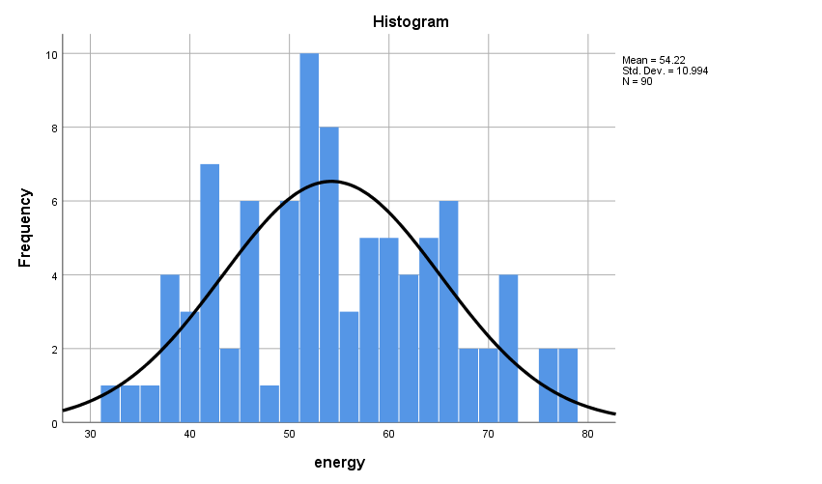
Fig 7 : Histogram with a normal curve for Group1

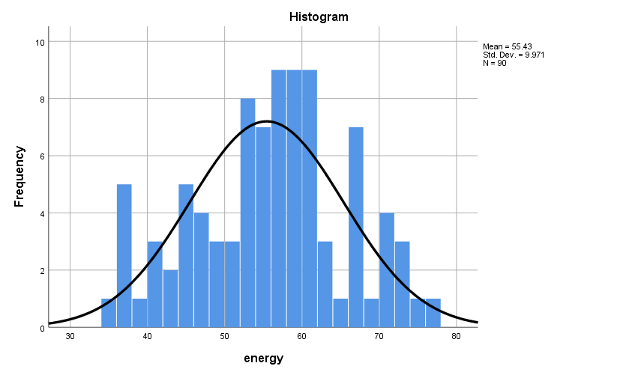
Fig 8 : Histogram with a normal curve for Group2

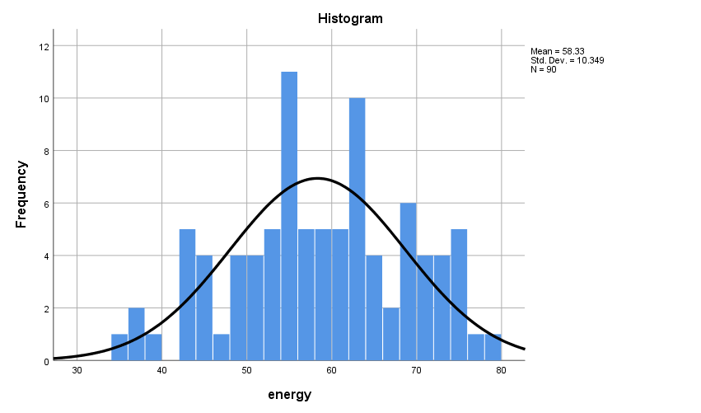
Fig 9 : Histogram with a normal curve for Group3

Visual Interpretation of Histograms

- Group 1: The normal curve is perfectly bell shaped and is fairly symmetrical. Therefore, the group is considered to be approximately normally distributed
- Group 2: The normal curve is perfectly bell shaped and is fairly symmetrical. Therefore, the group is considered to be approximately normally distributed
- Group 3: From the visual inspection of the histograms it is quite evident that the normality curve is bell shaped and shows a good symmetry. Therefore, the group is considered to approximately normally distributed

EXAMINE VARIABLES=energy BY group
/PLOT BOXPLOT NPPLOT
/COMPARE GROUPS
/STATISTICS DESCRIPTIVES
/CINTERVAL 95
/MISSING LISTWISE
/NOTOTAL.

- Normal Q-Q Plots

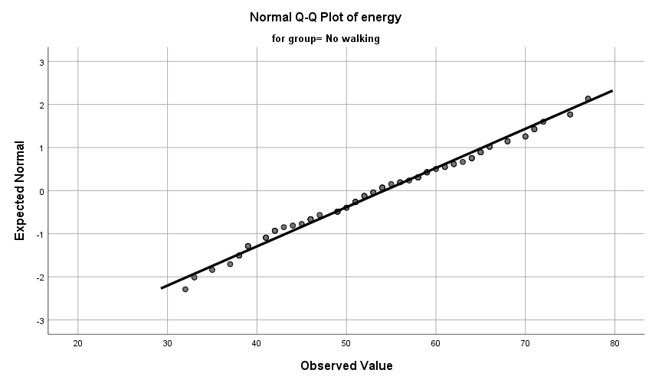
Fig 10 : Normal Q-Q plots –Group1

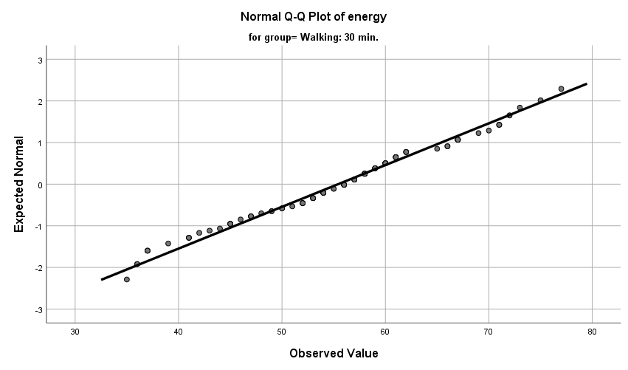

Fig 11 : Normal Q-Q plots – Group2

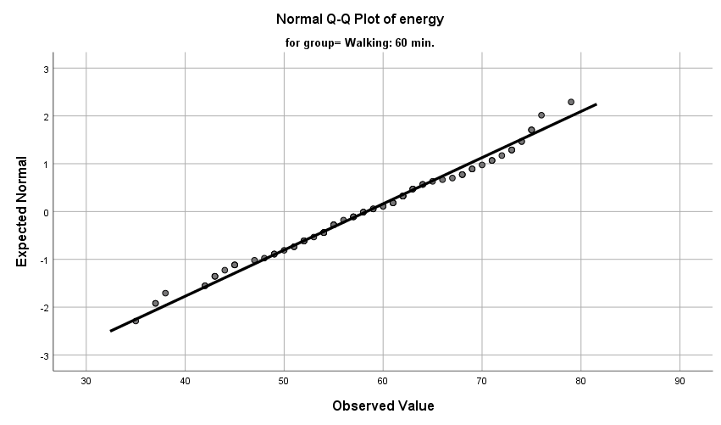

Fig 12 : Normal Q-Q plots – Group3

Visual Interpretation of Normal Q-Q Plots
In all the three groups, majority of the Normal Q-Q plots are aligned to QQ line with a few outliers in Group1. Thus, represents a reasonably normal distribution

- Box Plots

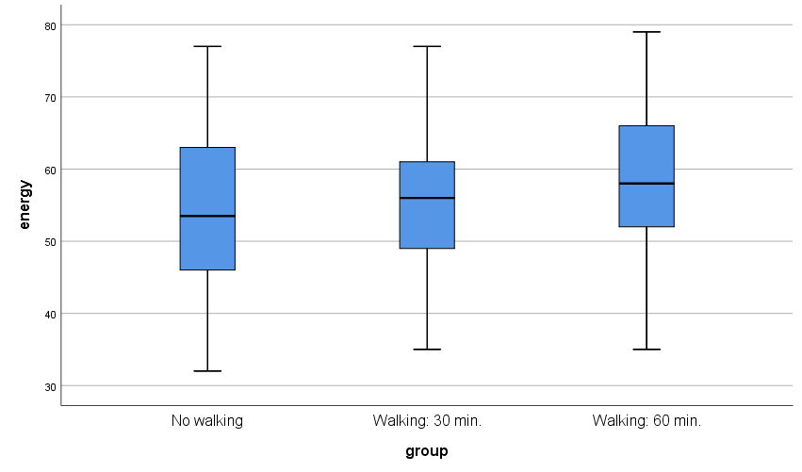
Fig 13 : Box plot – Group1, Group2 and Group3

Visual Interpretation of Box Plots
The box plots of the Group 1 ,Group 2 and Group 3 are fairly symmetrical .Therefore, the is considered to be not normally distributed

Numerical Tests of Normality

Case Processing Summary
 | group | Cases
 | group | Valid |  | Missing |  | Total
 | group | N | Percent | N | Percent | N | Percent
energy | No walking | 90 | 100.0% | 0 | 0.0% | 90 | 100.0%
energy | Walking: 30 min. | 90 | 100.0% | 0 | 0.0% | 90 | 100.0%
energy | Walking: 60 min. | 90 | 100.0% | 0 | 0.0% | 90 | 100.0%

- Shapiro-Wilk’s Test of Normality

Tests of Normality
 | group | Kolmogorov-Smirnovª |  |  | Shapiro-Wilk
 | group | Statistic | df | Sig. | Statistic | df | Sig.
energy | No walking | .064 | 90 | .200* | .982 | 90 | .256
energy | Walking: 30 min. | .065 | 90 | .200* | .982 | 90 | .236
energy | Walking: 60 min. | .058 | 90 | .200* | .982 | 90 | .260

*. This is a lower bound of the true significance.
a. Lilliefors Significance Correction

Hypotheses
H₀ – The sample distribution is normally distributed (Null Hypotheses)

Discussion
- The value of p of Shapiro-Wilk’s test for Group1 is .256
- The value of p of Shapiro-Wilk’s test for Group2 is .236
- The value of p of Shapiro-Wilk’s test for Group3 is .260

Hypotheses Resolution
- Since the Shapiro-Wilk’s value of p > α (α=.05) in all the three cases, H₀ is accepted. Therefore, the distributions of the groups is considered to be normally distributed.

Skewness and Kurtosis Test
Descriptives
 | group |  |  | Statistic | Std. Error | z value
energy | No walking | Mean |  | 54.22 | 1.159
energy | No walking | 95% Confidence Interval for Mean | Lower Bound | 51.92
energy | No walking | 95% Confidence Interval for Mean | Upper Bound | 56.52
energy | No walking | 5% Trimmed Mean |  | 54.12
energy | No walking | Median |  | 53.50
energy | No walking | Variance |  | 120.871
energy | No walking | Std. Deviation |  | 10.994
energy | No walking | Minimum |  | 32
energy | No walking | Maximum |  | 77
energy | No walking | Range |  | 45
energy | No walking | Interquartile Range |  | 17
energy | No walking | Skewness |  | .101 | .254 | 0.397
energy | No walking | Kurtosis |  | -.723 | .503 | -1.437
energy | Walking: 30 min. | Mean |  | 55.43 | 1.051
energy | Walking: 30 min. | 95% Confidence Interval for Mean | Lower Bound | 53.34
energy | Walking: 30 min. | 95% Confidence Interval for Mean | Upper Bound | 57.52
energy | Walking: 30 min. | 5% Trimmed Mean |  | 55.48
energy | Walking: 30 min. | Median |  | 56.00
energy | Walking: 30 min. | Variance |  | 99.417
energy | Walking: 30 min. | Std. Deviation |  | 9.971
energy | Walking: 30 min. | Minimum |  | 35
energy | Walking: 30 min. | Maximum |  | 77
energy | Walking: 30 min. | Range |  | 42
energy | Walking: 30 min. | Interquartile Range |  | 12
energy | Walking: 30 min. | Skewness |  | -.091 | .254 | -0.358
energy | Walking: 30 min. | Kurtosis |  | -.475 | .503 | -0.944
energy | Walking: 60 min. | Mean |  | 58.33 | 1.091
energy | Walking: 60 min. | 95% Confidence Interval for Mean | Lower Bound | 56.17
energy | Walking: 60 min. | 95% Confidence Interval for Mean | Upper Bound | 60.50
energy | Walking: 60 min. | 5% Trimmed Mean |  | 58.51
energy | Walking: 60 min. | Median |  | 58.00
energy | Walking: 60 min. | Variance |  | 107.101
energy | Walking: 60 min. | Std. Deviation |  | 10.349
energy | Walking: 60 min. | Minimum |  | 35
energy | Walking: 60 min. | Maximum |  | 79
energy | Walking: 60 min. | Range |  | 44
energy | Walking: 60 min. | Interquartile Range |  | 15
energy | Walking: 60 min. | Skewness |  | -.146 | .254 | -0.574
energy | Walking: 60 min. | Kurtosis |  | -.606 | .503 | -1.204

Discussion on Skewness and Kurtosis
Group 1 :
- The value of z obtained by Skewness/Std. Error =.101/0.254 = 0.397 is within the range of -1.96 and +1.96. Therefore, is acceptable
- The value of z obtained by Kurtosis/Std. Error =-.723/.503=-1.437 is within the range of -1.96 and +1.96. Therefore, is acceptable

Group 2 :
- The value of z obtained by Skewness/Std. Error =-.091/.254 =- 0.358 is within the range of -1.96 and +1.96. Therefore, is acceptable
- The value of z obtained by Kurtosis/Std. Error =-0.475/0.503 = -0.944 is within the range of -1.96 and +1.96. Therefore, is acceptable

Group 3:
- The value of z obtained by Skewness/Std. Error =-.146/0.254 = -0.574 is within the range of -1.96 and +1.96. Therefore, is acceptable
- The value of z obtained by Kurtosis/Std. Error =-0.606/0.503 = -1.204 is within the range of -1.96 and +1.96. Therefore, is acceptable

From the numerical analysis of Skewness and Kurtosis it is clear that the distribution of the Group1, Groups 2 and Group 3 are reasonably normal.

Discussion on Normality
From the visual interpretation of the graphical test results and through the analysis of numerical tests it is quite evident that the distributions of all the three groups are approximately normally distributed. Therefore, the pre-test criterion of Normality is satisfied

Pre-Test Condition -2 : n Quota

ONEWAY energy BY group
/STATISTICS DESCRIPTIVES HOMOGENEITY
/MISSING ANALYSIS
/POSTHOC=SIDAK ALPHA(0.05).

Descriptives
energy
 | N | Mean | Std. Deviation | Std. Error | 95% Confidence Interval for Mean
 |  |  |  |  | Lower Bound | Upper Bound
No walking | 90 | 54.22 | 10.994 | 1.159 | 51.92 | 56.52
Walking: 30 min. | 90 | 55.43 | 9.971 | 1.051 | 53.34 | 57.52
Walking: 60 min. | 90 | 58.33 | 10.349 | 1.091 | 56.17 | 60.50
Total | 270 | 56.00 | 10.550 | .642 | 54.73 | 57.26

Discussion on n-quota

Since the value of n is atleast 30 for all the groups, the pre-test condition of n-quota is met.

Pre-Test Condition -3 : Homogeneity of Variance

Test of Homogeneity of Variances
 |  | Levene Statistic | df1 | df2 | Sig.
energy | Based on Mean | .787 | 2 | 267 | .456
energy | Based on Median | .790 | 2 | 267 | .455
energy | Based on Median and with adjusted df | .790 | 2 | 266.387 | .455
energy | Based on trimmed mean | .774 | 2 | 267 | .462

Discussion
The value of p > α (p=.456, α=.05) suggests that there is no statistically significant difference between the variances of the groups. Hence, the criterion of Homogeneity of Variance is satisfied.

Documenting the Results of Pre-test Conditions of ANOVA
Following are the results of the pre-test conditions,
- Normality
- n quota
- Homogeneity of Variance
Discussion

Since the pre-test conditions of ANOVA are met, we proceed with ANOVA test

Description of the Test : ANOVA Test
ANOVA Test

ANOVA
energy
 | Sum of Squares | df | Mean Square | F | Sig.
Between Groups | 803.341 | 2 | 401.670 | 3.681 | .026
Within Groups | 29137.656 | 267 | 109.130
Total | 29940.996 | 269

Discussion
- The value of p obtained from ANOVA is .026
- Since the value of p<α (p=.026, α=0.05), there is a statistically significant difference between the groups.

Hypothesis Resolution
Reject => H₀ – There is no difference between the energy levels of the groups
Accept => H₁ – At least one group outperforms another in terms of the energy level

ANOVA – Post Hoc Test
Since there is a statistically significant difference between the groups, we perform Post Hoc tests to identify the group that outperforms the others.

Groups | Description | Comparison of Means
Group 1 : Group 2 | No walking: 30 mins walking | µ(G1):µ(G2)
Group 2 : Group 3 | 30 mins walking: 60 mins walking | µ(G2):µ(G3)
Group 1 : Group 3 | No walking: 60 mins walking | µ(G1):µ(G3)

Multiple Comparisons
Dependent Variable: energy
Tukey HSD
(I) group | (J) group | Mean Difference (I-J) | Std. Error | Sig. | 95% Confidence Interval
 |  |  |  |  | Lower Bound
No walking | Walking: 30 min. | -1.211 | 1.557 | .717 | -4.88
No walking | Walking: 60 min. | -4.111* | 1.557 | .024 | -7.78
Walking: 30 min. | No walking | 1.211 | 1.557 | .717 | -2.46
Walking: 30 min. | Walking: 60 min. | -2.900 | 1.557 | .152 | -6.57
Walking: 60 min. | No walking | 4.111* | 1.557 | .024 | .44
Walking: 60 min. | Walking: 30 min. | 2.900 | 1.557 | .152 | -.77

Documenting Results of ANOVA Post- Hoc

Groups | Comparison | p value | Discussion
Group 1 : Group 2 | µ(G1) : µ(G2)  54.22 : 55.43 | .717 | - Since p > 0.05, there is no statistically significant difference between Group 1 and Group 2
Group 2 : Group 3 | µ(G2) : µ(G3)  55.43 : 58.33 | .152 | - Since p > 0.05, there is no statistically significant difference between Group 2 and Group 3
Group 1 : Group 3 | µ(G1) : µ(G3)  54.22 : 58.33 | .024 | - Since p < 0.05, there is a statistically significant difference between Group 1 and Group 3  - By comparing the means it is quite evident that Group 3 outperforms Group 1

Discussion of the Test
In order to assess if early morning exercises will improve the energy levels of the subjects, a number of subjects are recruited and alternatively assigned to three groups, the control group (with no walking), Treatment Group1 (with 30 mins of walking everyday)and Treatment Group2 (with 60 mins of walking everyday). All the groups had 90 members (n=90). By the end of the month, the groups are asked to rate their level of energy, on a scale of 1 to 100 (where 1= low energy and 100=extremely high energy)

Since we are comparing more than two groups, we chose ANOVA. The ANOVA’s value of p < α (where p=.026 and α =0.5) indicates that there is a statistically significant difference between the groups. Therefore, we reject H₀ and accept H₁. From the results of Post hoc tests, we observed a statistically difference between the energy levels of Groups1 and Group3. To identify which group outperformed, we compare their means.

Comparing the means of the three groups,
µ(G₁) : µ(G₂) : µ(G₃)
54.22 : 55.43 : 58.33

Since Group 3 has significantly higher mean than Group 1, we conclude that Group 3 outperforms Group 1. Therefore, subjects doing 60 mins of walking everyday have higher energy levels.

Exercise Number: Ch 07 - Exercise 04A
Dataset Used : [DataSet1] C:\Users\Jaya Karthi Booven\Desktop\SPSS\7.4\Ch 07 - Exercise 04A.sav
Selection of Test :
The primary objective of the exercise is to compare the pre-test and post-test results of continuous variables and determine if there is significant difference between them. Therefore, we prefer Paired T test

Hypotheses
H₀ – Therapy has no effect on patients’ depression (Null Hypotheses)
H₁ – Therapy substantially reduces patients’ depression (Alternative Hypotheses)

Pre-test Checklist for Paired T Test
The only pre-test conditions for running Paired T test is,
- Normality of differences

Description of the Test : Pre-test Conditions for Paired T test
Pre-Test Condition - 1 : Normality of differences
Warning # 5281. Command name: GET FILE
SPSS Statistics is running in Unicode encoding mode. This file is encoded in a locale-specific (code page) encoding. The defined width of any string variables are automatically tripled in order to avoid possible data loss. You can use ALTER TYPE to set the width of string variables to the width of the longest observed value for each string variable.
DATASET NAME DataSet1 WINDOW=FRONT.

COMPUTE diff= posttest - pretest.
EXECUTE.

FREQUENCIES VARIABLES=diff
/STATISTICS=STDDEV VARIANCE RANGE MINIMUM MAXIMUM MEAN MEDIAN MODE
/HISTOGRAM NORMAL
/ORDER=ANALYSIS.

Descriptive Statistics
Statistics
diff
N | Valid | 18
N | Missing | 0
Mean |  | -1.3889
Median |  | -3.0000
Mode |  | -5.00ª
Std. Deviation |  | 4.21676
Variance |  | 17.781
Range |  | 12.00
Minimum |  | -6.00
Maximum |  | 6.00
Sum |  | -25.00
a. Multiple modes exist. The smallest value is shown

Fig 1 : Descriptive Statistics of diff

Frequencies

diff
 |  | Frequency | Percent | Valid Percent | Cumulative Percent
Valid | -6.00 | 2 | 11.1 | 11.1 | 11.1
Valid | -5.00 | 3 | 16.7 | 16.7 | 27.8
Valid | -4.00 | 3 | 16.7 | 16.7 | 44.4
Valid | -3.00 | 2 | 11.1 | 11.1 | 55.6
Valid | -1.00 | 2 | 11.1 | 11.1 | 66.7
Valid | .00 | 2 | 11.1 | 11.1 | 77.8
Valid | 5.00 | 2 | 11.1 | 11.1 | 88.9
Valid | 6.00 | 2 | 11.1 | 11.1 | 100.0
Valid | Total | 18 | 100.0 | 100.0

Fig 2 : Frequencies of diff

Normality Assessment
In this exercise, Normality is assessed in a two-step process,
- Graphical Tests of Normality
- Numerical Tests of Normality

Graphical Tests of Normality
- In graphical tests, the normality is assessed through the visual interpretation of Histograms, Normal Q-Q Plots and Box plots

Numerical Tests of Normality
- In the numerical tests, the normality of the distribution is determined based on the Shapiro -Wilk’s p value and the Skewness and Kurtosis test’s z values

Graphical Tests of Normality
- Histogram with a normal curve

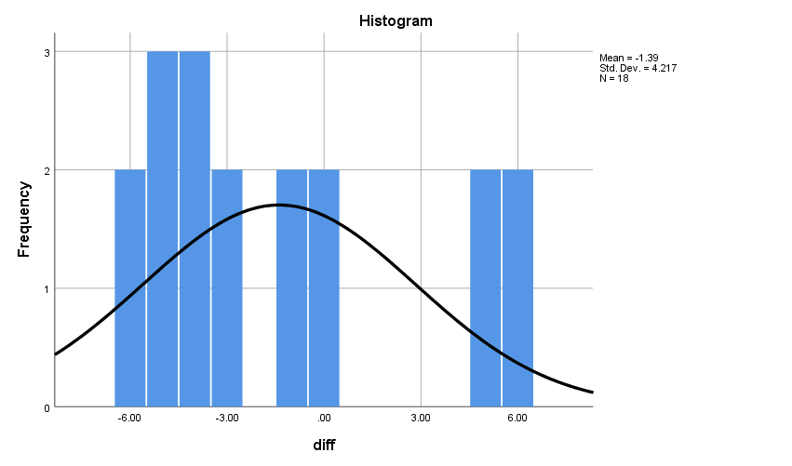
Fig 3 : Histogram with a normal curve for diff

Visual Interpretation of Histograms
- From the visual inspection of the histograms it is quite evident that majority of the values are accumulated at the left resulting in a positively skewed (right skewed) histogram.

EXAMINE VARIABLES=diff
/PLOT BOXPLOT HISTOGRAM NPPLOT
/COMPARE GROUPS
/STATISTICS DESCRIPTIVES
/CINTERVAL 95
/MISSING LISTWISE
/NOTOTAL.

- Normal Q-Q Plots

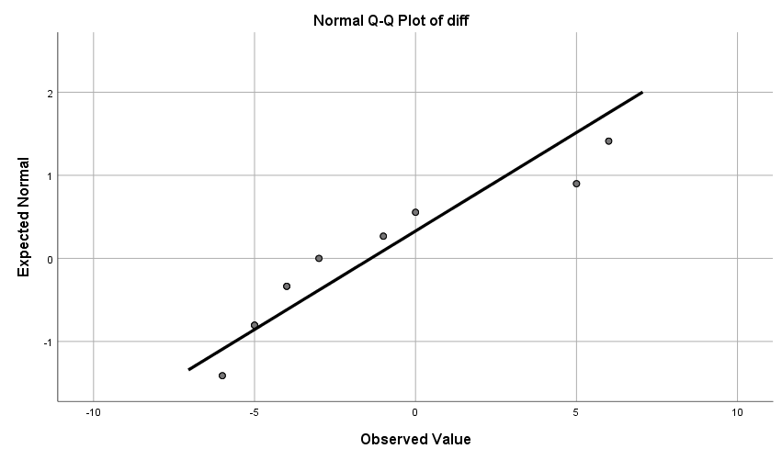
Fig 4 : Normal Q-Q plots –diff

Visual Interpretation of Normal Q-Q Plots
Majority of the Normal Q-Q plots are not aligned to QQ line. Thus, represents a distribution that is not normally distributed

- Box Plots

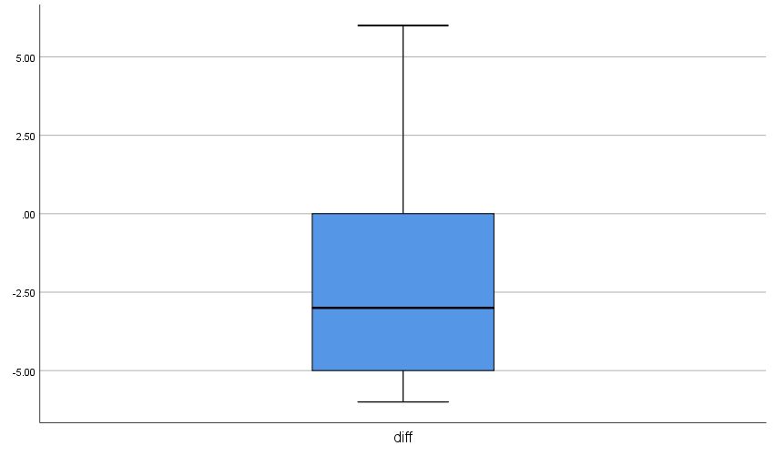

Fig 5 : Box plot – diff

Visual Interpretation of Box Plots
The box plots of the continuous variable diff is fairly symmetrical .Therefore, is considered to be normally distributed

Numerical Tests of Normality

Case Processing Summary
 | Cases
 | Valid |  | Missing |  | Total
 | N | Percent | N | Percent | N | Percent
diff | 18 | 100.0% | 0 | 0.0% | 18 | 100.0%

- Shapiro-Wilk’s Test of Normality

Tests of Normality
 | Kolmogorov-Smirnovª |  |  | Shapiro-Wilk
 | Statistic | df | Sig. | Statistic | df | Sig.
diff | .204 | 18 | .045 | .849 | 18 | .008
a. Lilliefors Significance Correction

Hypotheses
H₀ – The sample distribution is normally distributed (Null Hypotheses)

Discussion
- The value of p of Shapiro-Wilk’s test for Group1 is .008

Hypotheses Resolution
Since the Shapiro-Wilk’s value of p < α (α=.05) in all the three cases, H₀ is rejected. Therefore, the distributions of the groups is considered to be not normally distributed.

- Skewness and Kurtosis Test

Descriptives
 |  |  | Statistic | Std. Error | z value
diff | Mean |  | -1.3889 | .99390
diff | 95% Confidence Interval for Mean | Lower Bound | -3.4858
diff | 95% Confidence Interval for Mean | Upper Bound | .7081
diff | 5% Trimmed Mean |  | -1.5432
diff | Median |  | -3.0000
diff | Variance |  | 17.781
diff | Std. Deviation |  | 4.21676
diff | Minimum |  | -6.00
diff | Maximum |  | 6.00
diff | Range |  | 12.00
diff | Interquartile Range |  | 6.25
diff | Skewness |  | .825 | .536 | 1.539
diff | Kurtosis |  | -.731 | 1.038 | -0.704

Discussion on Skewness and Kurtosis
- The value of z obtained by Skewness/Std. Error =.825/.536 = 1.539 is within the range of -1.96 and +1.96. Therefore is acceptable
- The value of z obtained by Kurtosis/Std. Error =-.731/1.038=-0.704 is within the range of -1.96 and +1.96. Therefore is acceptable

From the numerical analysis of Skewness and Kurtosis it is clear that the distribution of the diff is reasonably normal.

Discussion on Normality
From the visual interpretation of the graphical test results and through the analysis of numerical tests it is quite evident that the distributions of all the three groups are approximately normally distributed. Therefore, the pre-test criterion of Normality is not satisfied

Documenting the Results of Pre-test Conditions of Paired T
Following are the results of the pre-test conditions,
- Normality of differences

Discussion

Since the pre-test condition of Paired T test is not met, we proceed with Wilcoxon test.

Description of the Test : Wilcoxon test
Wilcoxon Test

NPAR TESTS
/WILCOXON=pretest WITH posttest (PAIRED)
/MISSING ANALYSIS.

Wilcoxon Signed Ranks Test

Ranks
 |  | N | Mean Rank | Sum of Ranks
posttest - pretest | Negative Ranks | 12ª | 7.25 | 87.00
posttest - pretest | Positive Ranks | 4^{b} | 12.25 | 49.00
posttest - pretest | Ties | 2^{c}
posttest - pretest | Total | 18
a. posttest < pretest
b. posttest > pretest
c. posttest = pretest

Test Statisticsª
 | posttest - pretest
Z | -.988^{b}
Asymp. Sig. (2-tailed) | .323
a. Wilcoxon Signed Ranks Test
b. Based on positive ranks.

Discussion
The value of p obtained from the Wilcoxon test is .323, p > α (α=.05) indicates that there is no statistically significant difference between the baseline score and post-test score. Threfore, we accept H₀ and reject H₁

Hypothesis Resolution
Accept => H₀ – Therapy has no effect on patients’ depression (Null Hypotheses)
Reject => H₁ – Therapy substantially reduces patients’ depression (Alternative Hypotheses)

Discussion on the Test
In order to determine if a short-term therapy reduces the depression of patients at the mental health clinic, 18 patients (n=18) are given the short-term therapy and are asked to take Acme Depression Inventory (ADI) test both before and after the therapy session. Since we are comparing the base line score and post-test scores we preferred Paired – T test. However, we proceeded with Wilcoxon test as the pretest condition required for running Paired T is not met. For the same, we computed a continuous variable ‘diff’. Where,

diff=Posttest-Pretest

The value of p obtained from the Wilcoxon test is .323. The value of p> α represents there is no statistically significant difference betweent the pre-test and post-test scores. Therefore, we reject H₁ and accept H₀. Therefore, the therapy has no effect on patients’ depression.

Exercise Number: Ch 07 - Exercise 04B
Dataset Used : [DataSet1] C:\Users\Jaya Karthi Booven\Desktop\SPSS\7.4\Ch 07 - Exercise 04B.sav
Selection of Test :
The primary objective of the exercise is to compare the pre-test and post-test results of continuous variables and determine if there is significant difference between them. Therefore, we prefer Paired T test

Hypotheses
H₀ – Therapy has no effect on patients’ depression (Null Hypotheses)
H₁ – Therapy substantially reduces patients’ depression (Alternative Hypotheses)

Pre-test Checklist for Paired T Test
The only pre-test conditions for running Paired T test is,
- Normality of differences

Description of the Test : Pre-test Conditions for Paired T test
Pre-Test Condition - 1 : Normality of differences
Warning # 5281. Command name: GET FILE
SPSS Statistics is running in Unicode encoding mode. This file is encoded in a locale-specific (code page) encoding. The defined width of any string variables are automatically tripled in order to avoid possible data loss. You can use ALTER TYPE to set the width of string variables to the width of the longest observed value for each string variable.
DATASET NAME DataSet1 WINDOW=FRONT.

COMPUTE diff= posttest - pretest.
EXECUTE.

FREQUENCIES VARIABLES=diff
/STATISTICS=STDDEV VARIANCE RANGE MINIMUM MAXIMUM MEAN MEDIAN MODE
/HISTOGRAM NORMAL
/ORDER=ANALYSIS.

Descriptive Statistics
Statistics
diff
N | Valid | 15
N | Missing | 0
Mean |  | -2.6000
Median |  | -2.0000
Mode |  | -4.00ª
Std. Deviation |  | 3.24698
Variance |  | 10.543
Range |  | 14.00
Minimum |  | -10.00
Maximum |  | 4.00

a. Multiple modes exist. The smallest value is shown

Fig 1 : Descriptive Statistics of diff

Frequencies

diff
 |  | Frequency | Percent | Valid Percent | Cumulative Percent
Valid | -10.00 | 1 | 6.7 | 6.7 | 6.7
Valid | -6.00 | 1 | 6.7 | 6.7 | 13.3
Valid | -5.00 | 1 | 6.7 | 6.7 | 20.0
Valid | -4.00 | 3 | 20.0 | 20.0 | 40.0
Valid | -3.00 | 1 | 6.7 | 6.7 | 46.7
Valid | -2.00 | 3 | 20.0 | 20.0 | 66.7
Valid | -1.00 | 2 | 13.3 | 13.3 | 80.0
Valid | .00 | 1 | 6.7 | 6.7 | 86.7
Valid | 1.00 | 1 | 6.7 | 6.7 | 93.3
Valid | 4.00 | 1 | 6.7 | 6.7 | 100.0
Valid | Total | 15 | 100.0 | 100.0

Fig 2 : Frequencies of diff

Normality Assessment
In this exercise, Normality is assessed in a two-step process,
- Graphical Tests of Normality
- Numerical Tests of Normality

Graphical Tests of Normality
- In graphical tests, the normality is assessed through the visual interpretation of Histograms, Normal Q-Q Plots and Box plots

Numerical Tests of Normality
- In the numerical tests, the normality of the distribution is determined based on the Shapiro -Wilk’s p value and the Skewness and Kurtosis test’s z values

Graphical Tests of Normality
- Histogram with a normal curve

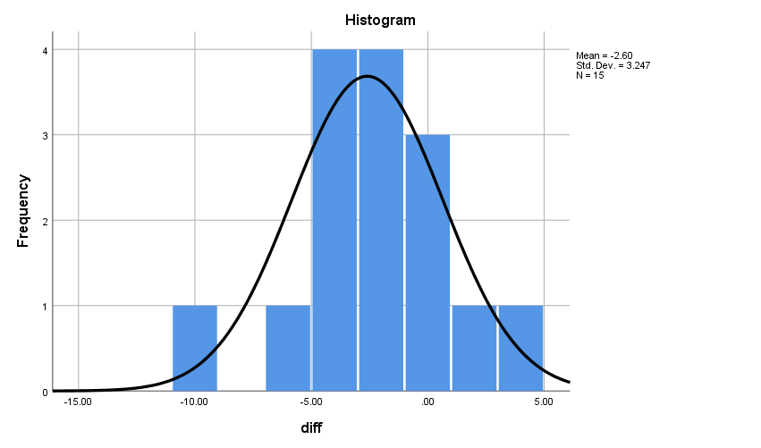
Fig 3 : Histogram with a normal curve for diff

Visual Interpretation of Histograms
- The normal curve is bell shaped and shows good symmetry with a slight skewness towards the left. Therefore, the distribution is considered to be approximately normally distributed

EXAMINE VARIABLES=diff
/PLOT BOXPLOT HISTOGRAM NPPLOT
/COMPARE GROUPS
/STATISTICS DESCRIPTIVES
/CINTERVAL 95
/MISSING LISTWISE
/NOTOTAL.

- Normal Q-Q Plots

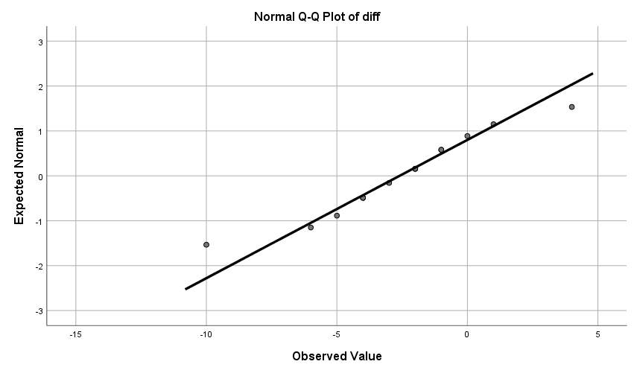
Fig 4 : Normal Q-Q plots –diff

Visual Interpretation of Normal Q-Q Plots
Majority of the Normal Q-Q plots are aligned to QQ line. Thus, represents a distribution that is reasonably normally distributed

- Box Plots

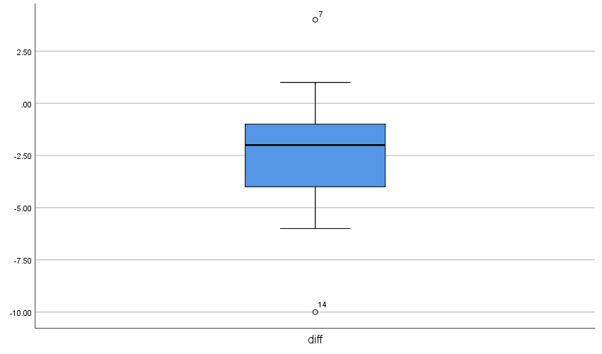

Fig 5 : Box plot – diff

Visual Interpretation of Box Plots
The box plots of the continuous variable diff is fairly symmetrical .Therefore, is considered to be normally distributed

Numerical Tests of Normality

Case Processing Summary
 | Cases
 | Valid |  | Missing |  | Total
 | N | Percent | N | Percent | N | Percent
diff | 15 | 100.0% | 0 | 0.0% | 15 | 100.0%

- Shapiro-Wilk’s Test of Normality
Tests of Normality
 | Kolmogorov-Smirnovª |  |  | Shapiro-Wilk
 | Statistic | df | Sig. | Statistic | df | Sig.
diff | .133 | 15 | .200* | .969 | 15 | .847

*. This is a lower bound of the true significance.
a. Lilliefors Significance Correction

Hypotheses
H₀ – The sample distribution is normally distributed (Null Hypotheses)

Discussion
- The value of p of Shapiro-Wilk’s test for Group1 is .847

Hypotheses Resolution
Since the Shapiro-Wilk’s value of p > α (α=.05) in all the three cases, H₀ is accepted. Therefore, the distributions of the groups is considered to be reasonably normal.

- Skewness and Kurtosis Test

Descriptives
 |  |  | Statistic | Std. Error | z value
diff | Mean |  | -2.600 | .83837
diff | 95% Confidence Interval for Mean | Lower Bound | -4.3981
diff | 95% Confidence Interval for Mean | Upper Bound | -.8019
diff | 5% Trimmed Mean |  | -2.5556
diff | Median |  | -2.0000
diff | Variance |  | 10.543
diff | Std. Deviation |  | 3.24698
diff | Minimum |  | -10.00
diff | Maximum |  | 4.00
diff | Range |  | 14.00
diff | Interquartile Range |  | 3.00
diff | Skewness |  | -.255 | .580 | -0.439
diff | Kurtosis |  | 1.472 | 1.121 | 1.313

Discussion on Skewness and Kurtosis
- The value of z obtained by Skewness/Std. Error =-.255/.580 = -0.439 is within the range of -1.96 and +1.96. Therefore is acceptable
- The value of z obtained by Kurtosis/Std. Error =1.472/1.121=1.313 is within the range of -1.96 and +1.96. Therefore is acceptable

From the numerical analysis of Skewness and Kurtosis it is clear that the distribution of the diff is reasonably normal.

Discussion on Normality
From the visual interpretation of the graphical test results and through the analysis of numerical tests it is quite evident that the distributions of all the three groups are approximately normally distributed. Therefore, the pre-test criterion of Normality is satisfied

Documenting the Results of Pre-test Conditions of Paired T
Following are the results of the pre-test conditions,
- Normality of differences

Discussion

Since the pre-test condition is met, we proceed with Paired T test.

Description of the Test : Paired T test
Paired T Test

T-TEST PAIRS=pretest WITH posttest (PAIRED)
/CRITERIA=CI(.9500)
/MISSING=ANALYSIS.

Paired Samples Statistics
 |  | Mean | N | Std. Deviation | Std. Error Mean
Pair 1 | pretest | 69.80 | 15 | 2.007 | .518
Pair 1 | posttest | 67.20 | 15 | 3.968 | 1.024

Paired Samples Correlations
 |  | N | Correlation | Sig.
Pair 1 | pretest & posttest | 15 | .579 | .024

Paired Samples Test
 |  | Paired Differences
 |  | Mean | Std. Deviation | Std. Error Mean | 95% Confidence Interval of the Difference
 |  |  |  |  | Lower | Upper
Pair 1 | pretest - posttest | 2.600 | 3.247 | .838 | .802 | 4.398

Discussion
The value of p obtained from the Paired T test is .024, p < α (α=.05) indicates that there is a statistically significant difference between the baseline score and post-test score. Threfore, we accept H₁ and reject H₀

Hypothesis Resolution
Reject => H₀ – Therapy has no effect on patients’ depression (Null Hypotheses)
Accept => H₁ – Therapy substantially reduces patients’ depression (Alternative Hypotheses)

Discussion on the Test
In order to determine if a short-term therapy reduces the depression of patients at the mental health clinic, 15 patients (n=15) are given the short-term therapy and are asked to take Acme Depression Inventory (ADI) test both before and after the therapy session. Since we are comparing the base line score and post-test scores we preferred Paired – T test. For the same, we computed a continuous variable ‘diff’. Where,
diff=Posttest-Pretest

the value of p obtained from the Paired T test is .024. We also observe a significant difference in the mean between the posttest and pretest score (µ _{Posttest-Pretest} =2.600). Furthermore, the value of p< α represents this difference is statistically significant. Hence, we reject H₀ and accept H₁. Therefore, the therapy substantially reduces patients’ depression.

Exercise Number: Ch 08 - Exercise 06A
Dataset Used : [DataSet1] C:\Users\Jaya Karthi Booven\Desktop\SPSS\8.6\Ch 08 - Exercise 06A.sav

Selection of Test :

The primary objective of the exercise is to determine the correlation between the age of the participants and the number of meals they have outside home in an average month’s duration. Since we are statistically assessing the correlation between two continuous variables, we prefer Pearson’s Regression and Correlation Analysis.

Variables

Continuous Variable 1 : Age of participants (age)
Continuous Variable 2 : Number of times the participants have had outside meals in a month (mealsout)

Hypotheses

H₀ – There is no correlation between the age of the participants and the number of outside meals they have in an average month
H₁ - There is correlation between the age of the participants and the number of outside meals they have in an average month

Pre-test Checklist for Pearson Test

Following are the pre-test conditions for running Pearson’s regression and correlation analysis,
- Normality
- Linearity
- Homoscedasticity

Description of the Test : Pre-test Conditions for Pearson’s Regression Analysis

Pre-Test Condition - 1 : Normality

Warning # 5281. Command name: GET FILE
SPSS Statistics is running in Unicode encoding mode. This file is encoded in a locale-specific (code page) encoding. The defined width of any string variables are automatically tripled in order to avoid possible data loss. You can use ALTER TYPE to set the width of string variables to the width of the longest observed value for each string variable.
DATASET NAME DataSet1 WINDOW=FRONT.

FREQUENCIES VARIABLES=age mealsout
/STATISTICS=STDDEV VARIANCE RANGE MINIMUM MAXIMUM MEAN MEDIAN MODE
/HISTOGRAM NORMAL
/ORDER=ANALYSIS.

Descriptive Statistics

Statistics
 |  | age | mealsout
N | Valid | 21 | 21
N | Missing | 0 | 0
Mean |  | 35.33 | 11.14
Median |  | 38.00 | 12.00
Mode |  | 41 | 12
Std. Deviation |  | 13.272 | 5.425
Variance |  | 176.133 | 29.429
Range |  | 47 | 20
Minimum |  | 14 | 2
Maximum |  | 61 | 22
Sum |  | 742 | 234

Fig 1 : Descriptive Statistics for age and mealsout

Frequencies

age
 |  | Frequency | Percent | Valid Percent | Cumulative Percent
Valid | 14 | 1 | 4.8 | 4.8 | 4.8
Valid | 18 | 1 | 4.8 | 4.8 | 9.5
Valid | 19 | 1 | 4.8 | 4.8 | 14.3
Valid | 20 | 1 | 4.8 | 4.8 | 19.0
Valid | 21 | 1 | 4.8 | 4.8 | 23.8
Valid | 22 | 1 | 4.8 | 4.8 | 28.6
Valid | 25 | 1 | 4.8 | 4.8 | 33.3
Valid | 29 | 1 | 4.8 | 4.8 | 38.1
Valid | 34 | 1 | 4.8 | 4.8 | 42.9
Valid | 35 | 1 | 4.8 | 4.8 | 47.6
Valid | 38 | 2 | 9.5 | 9.5 | 57.1
Valid | 41 | 3 | 14.3 | 14.3 | 71.4
Valid | 45 | 1 | 4.8 | 4.8 | 76.2
Valid | 48 | 1 | 4.8 | 4.8 | 81.0
Valid | 49 | 1 | 4.8 | 4.8 | 85.7
Valid | 51 | 1 | 4.8 | 4.8 | 90.5
Valid | 52 | 1 | 4.8 | 4.8 | 95.2
Valid | 61 | 1 | 4.8 | 4.8 | 100.0
Valid | Total | 21 | 100.0 | 100.0

Fig 2 : Frequencies of continuous variable - age

mealsout
 |  | Frequency | Percent | Valid Percent | Cumulative Percent
Valid | 2 | 1 | 4.8 | 4.8 | 4.8
Valid | 3 | 2 | 9.5 | 9.5 | 14.3
Valid | 5 | 1 | 4.8 | 4.8 | 19.0
Valid | 7 | 2 | 9.5 | 9.5 | 28.6
Valid | 8 | 1 | 4.8 | 4.8 | 33.3
Valid | 9 | 1 | 4.8 | 4.8 | 38.1
Valid | 11 | 2 | 9.5 | 9.5 | 47.6
Valid | 12 | 3 | 14.3 | 14.3 | 61.9
Valid | 13 | 1 | 4.8 | 4.8 | 66.7
Valid | 14 | 1 | 4.8 | 4.8 | 71.4
Valid | 15 | 1 | 4.8 | 4.8 | 76.2
Valid | 16 | 1 | 4.8 | 4.8 | 81.0
Valid | 17 | 2 | 9.5 | 9.5 | 90.5
Valid | 18 | 1 | 4.8 | 4.8 | 95.2
Valid | 22 | 1 | 4.8 | 4.8 | 100.0
Valid | Total | 21 | 100.0 | 100.0

Fig 3 : Frequencies of continuous variable – mealsout

Normality Assessment
Normality is assessed in a two-step method,
- Graphical Tests of Normality
- Numerical Tests of Normality

Graphical Tests of Normality
- In graphical tests normality is assessed through the visual interpretation of Histograms, Normal Q-Q Plots and Box plots

Numerical Tests of Normality
- In the numerical tests, the normality of the distribution is determined based on the Shapiro -Wilk’s p value and Skewness and Kurtosis test’s z values

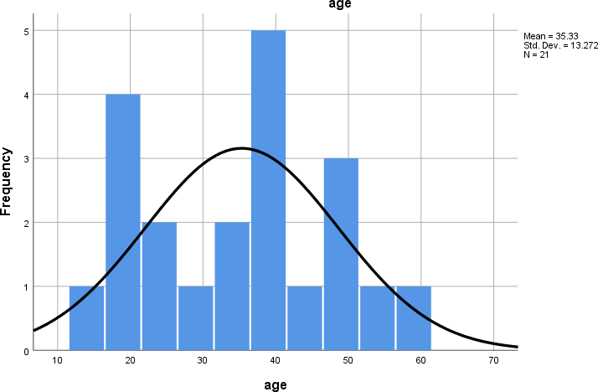
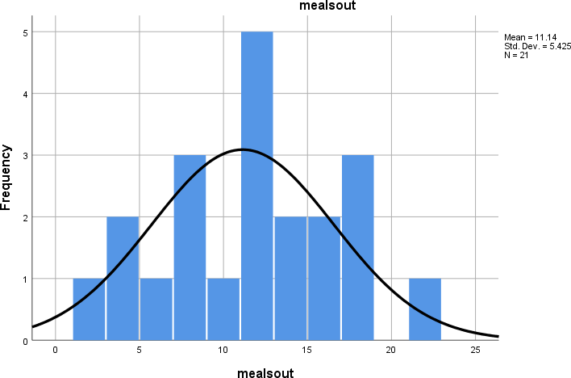
Graphical Tests of Normality
- Histogram with a normal curve

Fig 4 : Histogram with a normal curve for continuous variable - age

Fig 5 : Histogram with a normal curve for continuous variable - mealsout

Visual Interpretation of Histograms
From the visual inspection of both the histograms it is quite evident that the normality curve is bell shaped and shows a good symmetry. Thus the distribution of continuous variables ‘age’ and ‘mealsout’ is considered to be approximately normally distributed.
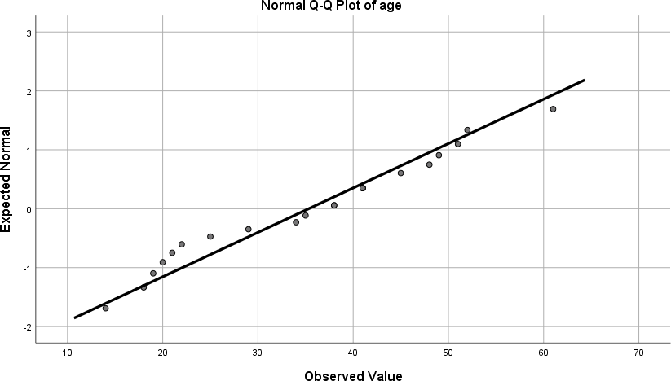
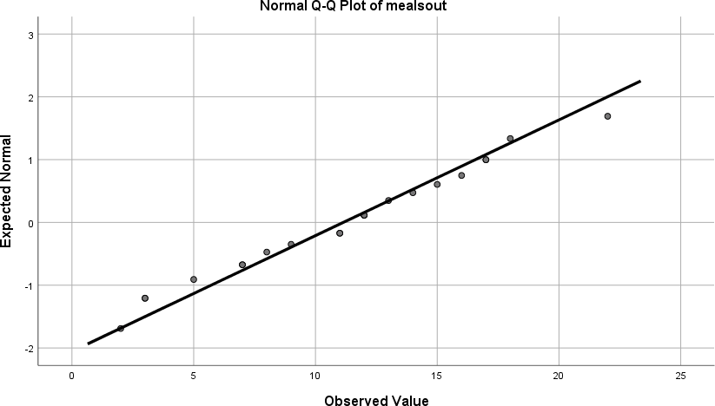
EXAMINE VARIABLES=age mealsout
/PLOT BOXPLOT HISTOGRAM NPPLOT
/COMPARE GROUPS
/STATISTICS DESCRIPTIVES
/CINTERVAL 95
/MISSING LISTWISE
/NOTOTAL.

Normal Q-Q Plots

Fig 6 : Normal Q-Q plots -age

Fig 7 : Normal Q-Q plots -mealsout
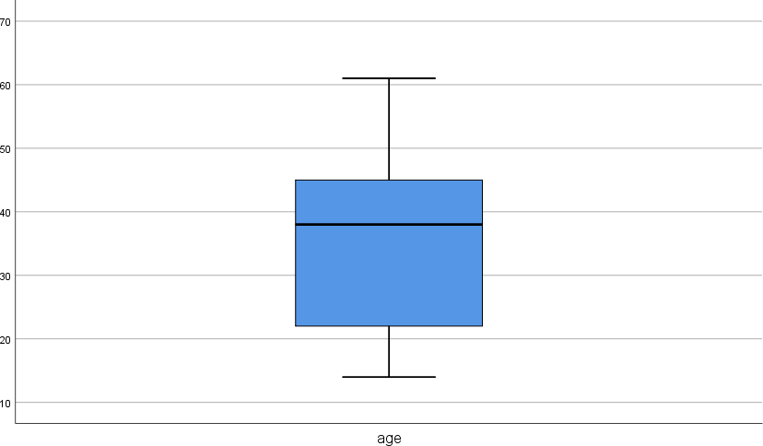
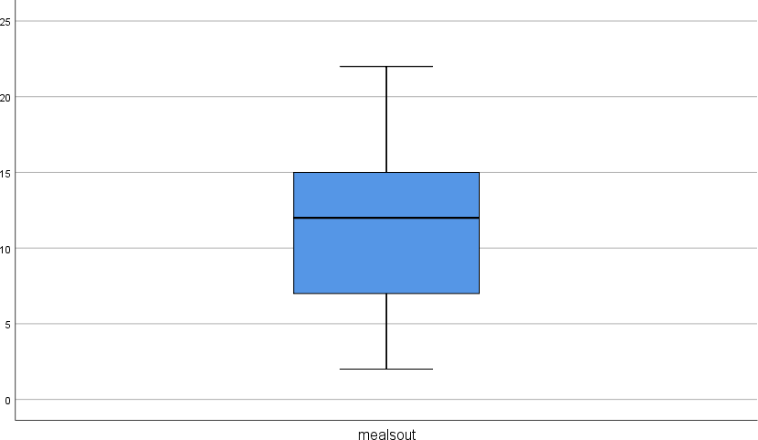

Visual Interpretation of Normal Q-Q Plots

Majority of the Normal Q-Q plots of both the continuous variables are aligned to QQ line ,thus, represents a reasonably normal distribution

Box Plots

Fig 8 : Box plot - age

Fig 9 : Box plot – mealsout

Visual Interpretation of Box Plots
The box plots of both the continuous variables are fairly symmetrical thus represents an approximately normal distribution.

Numerical Tests of Normality

Case Processing Summary
 | Cases
 | Valid |  | Missing |  | Total
 | N | Percent | N | Percent | N | Percent
age | 21 | 100.0% | 0 | 0.0% | 21 | 100.0%
mealsout | 21 | 100.0% | 0 | 0.0% | 21 | 100.0%

- Shapiro-Wilk’s Test of Normality

Tests of Normality
 | Kolmogorov-Smirnovª |  |  | Shapiro-Wilk
 | Statistic | df | Sig. | Statistic | df | Sig.
age | .128 | 21 | .200* | .957 | 21 | .460
mealsout | .109 | 21 | .200* | .974 | 21 | .814

*. This is a lower bound of the true significance.
a. Lilliefors Significance Correction

Hypotheses
H₀ – The sample distribution is normally distributed (null Hypotheses)

Discussion

The value of p of Shapiro-Wilk’s test for the continuous variable age is .460
The value of p of Shapiro-Wilk’s test for the continuous variable mealsout is .814

Hypotheses Resolution
Since the value of p > α (α=0.05) in both the cases, H₀ is accepted. Therefore, the distribution of the continuous variables is approximately normally distributed.

Skewness and Kurtosis Test

Descriptives
 |  |  | Statistic | Std. Error | z value
age | Mean |  | 35.33 | 2.896
age | 95% Confidence Interval  for Mean | Lower Bound | 29.29
age | 95% Confidence Interval  for Mean | Upper Bound | 41.37
age | 5% Trimmed Mean |  | 35.11
age | Median |  | 38.00
age | Variance |  | 176.133
age | Std. Deviation |  | 13.272
age | Minimum |  | 14
age | Maximum |  | 61
age | Range |  | 47
age | Interquartile Range |  | 25
age | Skewness |  | .045 | .501 | 0.089
age | Kurtosis |  | -.995 | .972 | -1.024
mealsout | Mean |  | 11.14 | 1.184
mealsout | 95% Confidence Interval  for Mean | Lower Bound | 8.67
mealsout | 95% Confidence Interval  for Mean | Upper Bound | 13.61
mealsout | 5% Trimmed Mean |  | 11.06
mealsout | Median |  | 12.00
mealsout | Variance |  | 29.429
mealsout | Std. Deviation |  | 5.425
mealsout | Minimum |  | 2
mealsout | Maximum |  | 22
mealsout | Range |  | 20
mealsout | Interquartile Range |  | 9
mealsout | Skewness |  | -.018 | .501 | -0.036
mealsout | Kurtosis |  | -.605 | .972 | -0.622

Fig 10 : Skewness and Kurtosis for age and mealsout

Discussion
Continuous Variable 1 : Age
- The value of z obtained by Skewness/Std. Error =.045/.501 = 0.089 is within the range of -1.96 and +1.96. Therefore, is acceptable
- The value of z obtained by Kurtosis/Std. Error =-.995/.972 = -1.024 is within the range of -1.96 and +1.96. Therefore, is acceptable

Continuous Variable 2 : mealsout
- The value of z obtained by Skewness/Std. Error =-.018/.501 = -0.036 is within the range of -
  - and +1.96. Therefore, is acceptable
- The value of z obtained by Kurtosis/Std. Error =-.605/.972 = -0.622 is within the range of -1.96 and +1.96. Therefore, is acceptable

From the numerical analysis of Skewness and Kurtosis it is clear that the distribution of both the continuous variables are approximately normally distributed

Discussion on Normality
From the visual interpretation of graphical tests and through the analysis of numerical tests it is evident that the distributions of the continuous variables are approximately normally distributed. Therefore, the pre-test criterion of Normality is satisfied

Pre-Test Condition -2 : Linearity
- Chart Builder. GGRAPH
/GRAPHDATASET NAME="graphdataset" VARIABLES=mealsout age MISSING=LISTWISE REPORTMISSING=NO
/GRAPHSPEC SOURCE=INLINE
/FITLINE TOTAL=NO. BEGIN GPL
SOURCE: s=userSource(id("graphdataset")) DATA: mealsout=col(source(s), name("mealsout")) DATA: age=col(source(s), name("age"))
GUIDE: axis(dim(1), label("mealsout")) GUIDE: axis(dim(2), label("age"))
GUIDE: text.title(label("Simple Scatter of age by mealsout")) ELEMENT: point(position(mealsout*age))
END GPL.
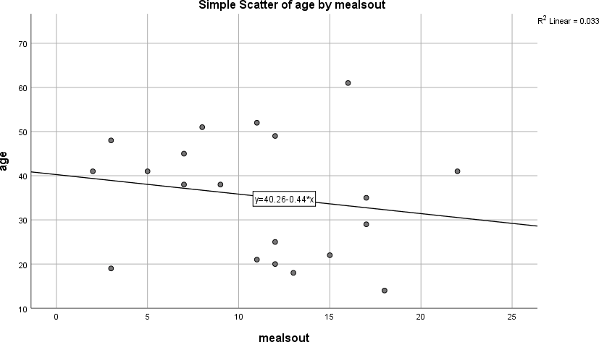

Fig 11 : Scatter plot for age and mealsout

Discussion on Linearity
  - The points in the scatter plot forms a relatively straight line. Furthermore, the regression line takes the middle of the road path through the cloud of points.
  - Therefore, the criterion of Linearity is satisfied.

Pre-Test Condition - 3 : Homoscedasticity

Fig 12 : Scatter plot for age and mealsout
CORRELATIONS
/VARIABLES=age mealsout
/PRINT=TWOTAIL NOSIG
/MISSING=PAIRWISE.
Pearson’s Regression Analysis
Description of the Test : Pearson’s Regression Analysis

Discussion on Homoscedasticity
- The density of points along the regression line is high in the middle and tapers off at the ends
- Since the cloud of points are focused in the middle of the regression line, it is assumed that the criterion of Homoscedasticity is satisfied

Documenting Results of Pre-test Conditions
- Normality
- Linearity
- Homoscedasticity
Since all the required pre-test conditions are satisfied, we proceed with Pearson’s Correlation test.

Correlations
 |  | age | mealsout
age | Pearson Correlation | 1 | -.181
age | Sig. (2-tailed) |  | .433
age | N | 21 | 21
mealsout | Pearson Correlation | -.181 | 1
mealsout | Sig. (2-tailed) | .433
mealsout | N | 21 | 21

Discussion
- The Pearson correlation (r) of -0.181 with a p > 0.05 (p=.433) indicates statistically insignificant negative correlation between the age of the participants and the number of outside meals they have in a month.
- Furthermore, the value of correlation (r) close to 0 indicates a relatively weak correlation by strength.
- Since r = -0.181 is a negative correlation by direction, the two continuous variables move in the different direction
  - Age : mealsout
  - Age : mealsout

Hypothesis Resolution
Accept => H₀ – There is no correlation between the age of the participants and the number of outside meals they have in an average month

Reject => H₁ - There is a correlation between the age of the participants and the number of outside meals they have in an average month

Discussion of the Test
In order to find the correlation between the age of the participants and the number of outside meals they have in an average month, we recorded the age of twenty-one individuals (n=21). The recorded age of participants had a mean (µ) of 35.33 and a Standard deviation (σ) of 13.272. Each participant is then recorded the number of time they have meal outside home (mealsout), which, had a mean (µ) of 11.14 and a Standard deviation (σ) of 5.425. In order to statistically assess the correlation between the above-mentioned continuous variables we perform Pearson Correlation and Regression test.

To proceed with Pearson’s Test, the pre-test conditions of Normality, Linearity and Homoscedasticity should be met. From the visual interpretation of the graphical test results and through the analysis of the numerical tests, it is evident that the data is approximately normally distributed.

Furthermore, on regression analysis, the cloud of points on the scatter plot graph forms a relatively straight line, and is also dense along the middle of the regression line. Thus it satisfied the pre-test conditions of linearity and homoscedasticity. Since all the pre-test criteria for correlation test are met, we proceeded with Pearson’s correlation test.

The results of Pearson’s test discovered a statistically insignificant negative correlation between the age and the number of outside meals had by the participants (r=-0.181 and p>α; where p=0.433 and α=0.05). Since p > α, we reject H₁ and accept H₀. Therefore, there is no statistically significant correlation between non-work hours spent on computer and social relationship satisfaction score.
Exercise Number: Ch 08 - Exercise 06B
Dataset Used : [DataSet1] C:\Users\Jaya Karthi Booven\Desktop\SPSS\8.6\Ch 08 - Exercise 06B.sav
Selection of Test :
The primary objective of the exercise is to determine the correlation between the age of the participants and the number of meals they have outside home in an average month’s duration. Since we are statistically assessing the correlation between two continuous variables, we prefer Pearson’s Regression and Correlation Analysis.

Variables
Continuous Variable 1 : Age of participants (age)
Continuous Variable 2 : Number of times the participants have had outside meals in a month (mealsout)

Hypotheses
H₀ – There is no correlation between the age of the participants and the number of outside meals they have in an average month
H₁ - There is correlation between the age of the participants and the number of outside meals they have in an average month

Pre-test Checklist for Pearson Test
Following are the pre-test conditions for running Pearson’s regression and correlation analysis,
- Normality
- Linearity
- Homoscedasticity

Description of the Test : Pre-test Conditions for Pearson’s Regression Analysis
Pre-Test Condition - 1 : Normality
Warning # 5281. Command name: GET FILE
SPSS Statistics is running in Unicode encoding mode. This file is encoded in a locale-specific (code page) encoding. The defined width of any string variables are automatically tripled in order to avoid possible data loss. You can use ALTER TYPE to set the width of string variables to the width of the longest observed value for each string variable.
DATASET NAME DataSet1 WINDOW=FRONT.

FREQUENCIES VARIABLES=age mealsout
/STATISTICS=STDDEV VARIANCE RANGE MINIMUM MAXIMUM MEAN MEDIAN MODE /HISTOGRAM NORMAL
/ORDER=ANALYSIS.

Descriptive Statistics

Statistics
 |  | age | mealsout
N | Valid | 16 | 16
N | Missing | 0 | 0
Mean |  | 35.81 | 14.25
Median |  | 36.50 | 15.00
Mode |  | 41 | 15ª
Std. Deviation |  | 14.901 | 5.639
Variance |  | 222.029 | 31.800
Range |  | 54 | 20
Minimum |  | 14 | 2
Maximum |  | 68 | 22
Sum |  | 573 | 228

a. Multiple modes exist. The smallest value is shown

Fig 1 : Descriptive Statistics for age and mealsout

Frequencies

age
 |  | Frequency | Percent | Valid Percent | Cumulative Percent
Valid | 14 | 1 | 6.3 | 6.3 | 6.3
Valid | 18 | 1 | 6.3 | 6.3 | 12.5
Valid | 19 | 1 | 6.3 | 6.3 | 18.8
Valid | 20 | 1 | 6.3 | 6.3 | 25.0
Valid | 22 | 1 | 6.3 | 6.3 | 31.3
Valid | 29 | 1 | 6.3 | 6.3 | 37.5
Valid | 34 | 1 | 6.3 | 6.3 | 43.8
Valid | 35 | 1 | 6.3 | 6.3 | 50.0
Valid | 38 | 1 | 6.3 | 6.3 | 56.3
Valid | 41 | 2 | 12.5 | 12.5 | 68.8
Valid | 45 | 1 | 6.3 | 6.3 | 75.0
Valid | 48 | 1 | 6.3 | 6.3 | 81.3
Valid | 49 | 1 | 6.3 | 6.3 | 87.5
Valid | 52 | 1 | 6.3 | 6.3 | 93.8
Valid | 68 | 1 | 6.3 | 6.3 | 100.0
Valid | Total | 16 | 100.0 | 100.0

Fig 2 : Frequencies of continuous variable - age

mealsout
 |  | Frequency | Percent | Valid Percent | Cumulative Percent
Valid | 2 | 1 | 6.3 | 6.3 | 6.3
Valid | 7 | 1 | 6.3 | 6.3 | 12.5
Valid | 8 | 1 | 6.3 | 6.3 | 18.8
Valid | 9 | 1 | 6.3 | 6.3 | 25.0
Valid | 11 | 1 | 6.3 | 6.3 | 31.3
Valid | 13 | 1 | 6.3 | 6.3 | 37.5
Valid | 14 | 1 | 6.3 | 6.3 | 43.8
Valid | 15 | 2 | 12.5 | 12.5 | 56.3
Valid | 16 | 1 | 6.3 | 6.3 | 62.5
Valid | 17 | 1 | 6.3 | 6.3 | 68.8
Valid | 19 | 2 | 12.5 | 12.5 | 81.3
Valid | 20 | 1 | 6.3 | 6.3 | 87.5
Valid | 21 | 1 | 6.3 | 6.3 | 93.8
Valid | 22 | 1 | 6.3 | 6.3 | 100.0
Valid | Total | 16 | 100.0 | 100.0

Fig 3 : Frequencies of continuous variable – mealsout

Normality Assessment
Normality is assessed in a two-step method,
- Graphical Tests of Normality
- Numerical Tests of Normality

Graphical Tests of Normality
- In graphical tests normality is assessed through the visual interpretation of Histograms, Normal Q-Q Plots and Box plots
Numerical Tests of Normality
- In the numerical tests, the normality of the distribution is determined based on the Skewness Shapiro -Wilk’s p value and Kurtosis test’s z values

Graphical Tests of Normality
- Histogram with a normal curve
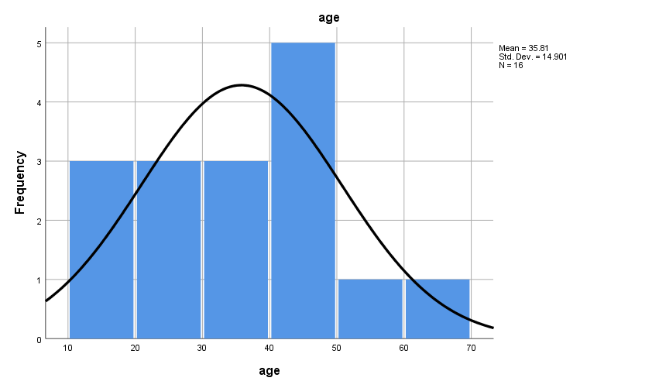
Fig 4 : Histogram with a normal curve for continuous variable - age

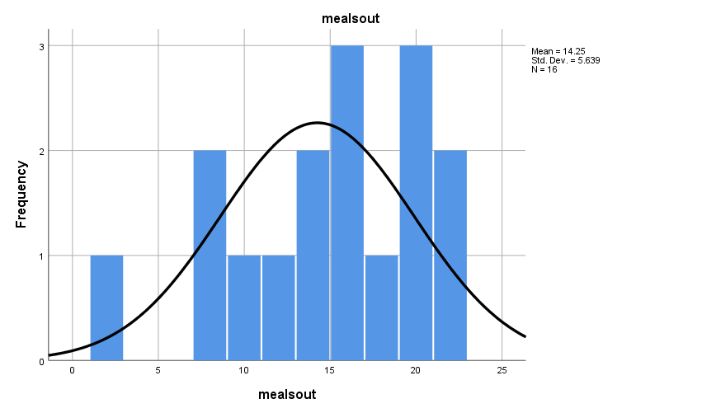
Fig 5 : Histogram with a normal curve for continuous variable - mealsout

Visual Interpretation of Histograms
From the visual inspection of both the histograms it is quite evident that the normality curve is bell shaped and shows a good symmetry. The histogram for age is slightly skewed towards the right; also, the histogram for mealout shows a slight skewness towards the left. Thus the distribution of continuous variables ‘age’ and ‘mealsout’ is considered to be approximately normally distributed.

EXAMINE VARIABLES=age mealsout
/PLOT BOXPLOT HISTOGRAM NPPLOT
/COMPARE GROUPS
/STATISTICS DESCRIPTIVES
/CINTERVAL 95
/MISSING LISTWISE
/NOTOTAL.

- Normal Q-Q Plots
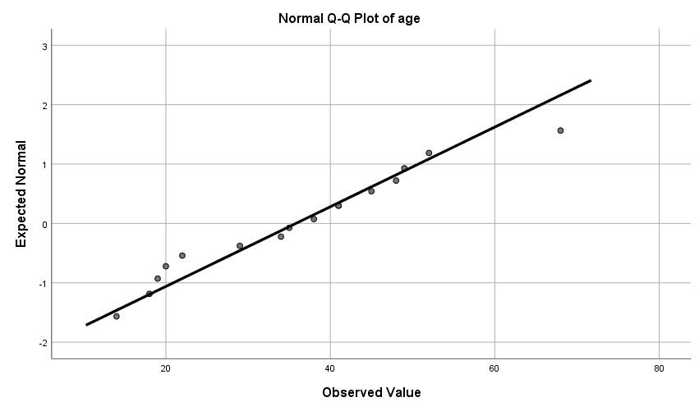
Fig 6 : Normal Q-Q plots -age

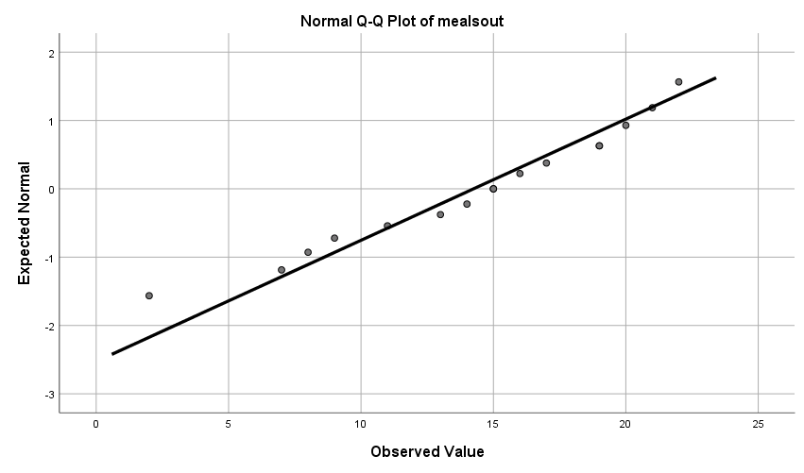
Fig 7 : Normal Q-Q plots -mealsout

Visual Interpretation of Normal Q-Q Plots
Majority of the Normal Q-Q plots of both the continuous variables are aligned to QQ line. Thus, represents a reasonably normal distribution

- Box Plots
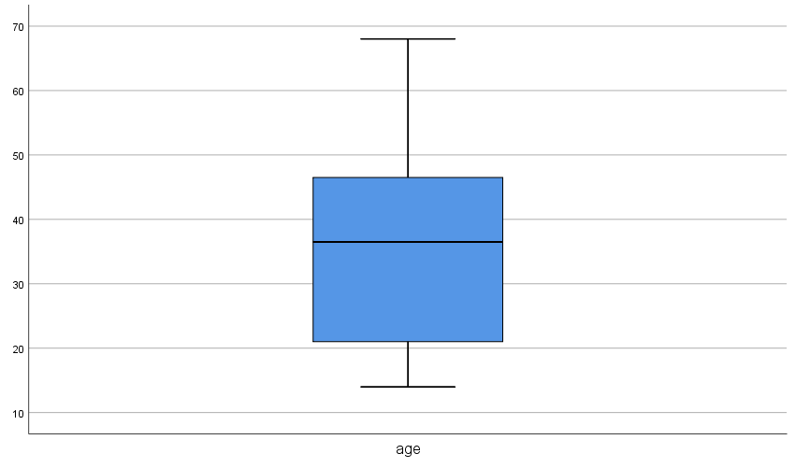
Fig 8 : Box plot for age
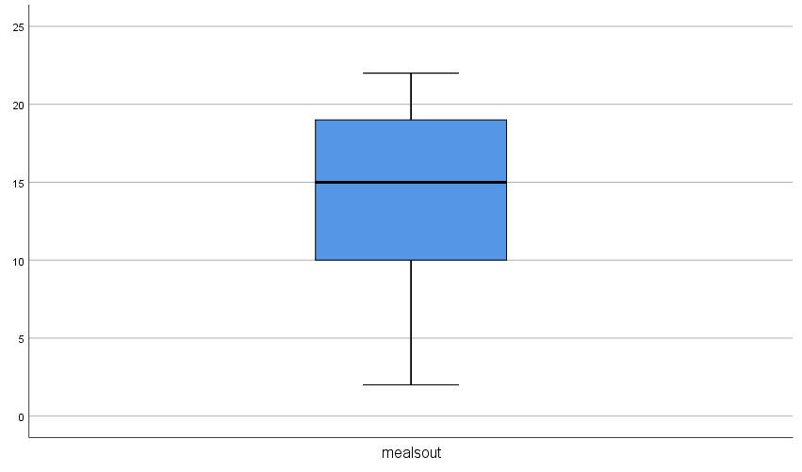
Fig 9 : Box plot for mealsout

Visual Interpretation of Box Plots
The box plots of both the continuous variables are fairly symmetrical thus represents an approximately normal distribution.

Numerical Tests of Normality

Case Processing Summary
 | Cases
 | Valid |  | Missing |  | Total
 | N | Percent | N | Percent | N | Percent
age | 16 | 100.0% | 0 | 0.0% | 16 | 100.0%
mealsout | 16 | 100.0% | 0 | 0.0% | 16 | 100.0%

- Shapiro-Wilk’s Test of Normality

Tests of Normality
 | Kolmogorov-Smirnovª |  |  | Shapiro-Wilk
 | Statistic | df | Sig. | Statistic | df | Sig.
age | .136 | 16 | .200* | .958 | 16 | .628
mealsout | .115 | 16 | .200* | .957 | 16 | .600

*. This is a lower bound of the true significance.
a. Lilliefors Significance Correction

Hypotheses
H₀ – The sample distribution is normally distributed (Null Hypotheses)

Discussion
The value of p of Shapiro-Wilk’s test for the continuous variable age is .628
The value of p of Shapiro-Wilk’s test for the continuous variable mealsout is .600

Hypotheses Resolution
Since the value of p > α (α=0.05) in both the cases, H₀ is accepted. Therefore, the distribution of the continuous variables is approximately normally distributed.

Skewness and Kurtosis Test

Descriptives
 |  |  | Statistic | Std. Error | z value
age | Mean |  | 35.81 | 3.725
age | 95% Confidence Interval for Mean | Lower Bound | 27.87
age | 95% Confidence Interval for Mean | Upper Bound | 43.75
age | 5% Trimmed Mean |  | 35.24
age | Median |  | 36.50
age | Variance |  | 222.029
age | Std. Deviation |  | 14.901
age | Minimum |  | 14
age | Maximum |  | 68
age | Range |  | 54
age | Interquartile Range |  | 27
age | Skewness |  | .347 | .564 | 0.615
age | Kurtosis |  | -.251 | 1.091 | -0.230
mealsout | Mean |  | 14.25 | 1.410
mealsout | 95% Confidence Interval for Mean | Lower Bound | 11.25
mealsout | 95% Confidence Interval for Mean | Upper Bound | 17.25
mealsout | 5% Trimmed Mean |  | 14.50
mealsout | Median |  | 15.00
mealsout | Variance |  | 31.800
mealsout | Std. Deviation |  | 5.639
mealsout | Minimum |  | 2
mealsout | Maximum |  | 22
mealsout | Range |  | 20
mealsout | Interquartile Range |  | 10
mealsout | Skewness |  | -.612 | .564 | -1.085
mealsout | Kurtosis |  | -.207 | 1.091 | -0.189

Fig 10 : Skewness and Kurtosis for age and mealsout

Discussion
Continuous Variable 1 : Age
- The value of z obtained by Skewness/Std. Error =.347/.564 = 0.615 is within the range of -1.96 and +1.96. Therefore, is acceptable
- The value of z obtained by Kurtosis/Std. Error =-.251/1.091 = -0.230 is within the range of -1.96 and +1.96. Therefore, is acceptable

Continuous Variable 2 : mealsout
- The value of z obtained by Skewness/Std. Error =-.612/.564 = -1.085 is within the range of -1.96 and +1.96. Therefore, is acceptable
- The value of z obtained by Kurtosis/Std. Error =-.207/1.091 = -0.189 is within the range of -1.96 and +1.96. Therefore, is acceptable

From the numerical analysis of Skewness and Kurtosis it is clear that the distribution of both the continuous variables are approximately normally distributed

Discussion on Normality
From the visual interpretation of graphical tests and through the analysis of numerical tests it is evident that the distributions of the continuous variables are approximately normally distributed. Therefore, the pre-test criterion of Normality is satisfied

Pre-test Condition -2 : Linearity

* Chart Builder.
GGRAPH
/GRAPHDATASET NAME="graphdataset" VARIABLES=mealsout age MISSING=LISTWISE REPORTMISSING=NO
/GRAPHSPEC SOURCE=INLINE
/FITLINE TOTAL=NO.
BEGIN GPL
SOURCE: s=userSource(id("graphdataset"))
DATA: mealsout=col(source(s), name("mealsout"))
DATA: age=col(source(s), name("age"))
GUIDE: axis(dim(1), label("mealsout"))
GUIDE: axis(dim(2), label("age"))
GUIDE: text.title(label("Simple Scatter of age by mealsout"))
ELEMENT: point(position(mealsout*age))
END GPL.

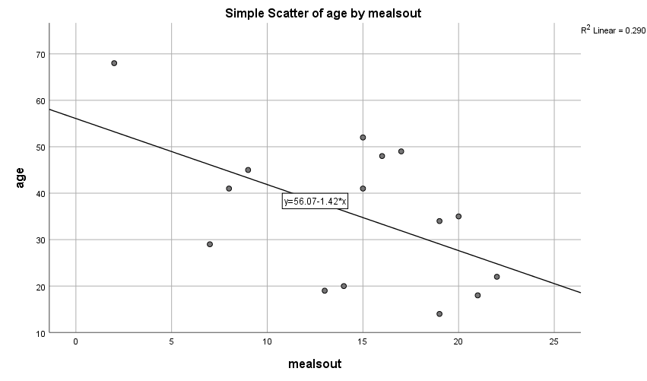
Fig 11 : Scatter plot for age and mealsout

Discussion on Linearity
- The points in the scatter plot forms a relatively straight line. Furthermore, the regression line takes the middle of the road path through the cloud of points.
- Therefore, the criterion of Linearity is satisfied.

Pre-test Condition - 3 : Homoscedasticity
Fig 12 : Scatter plot for age and mealsout

Discussion on Homoscedasticity
- The density of points along the regression line is high in the middle and tapers off at the ends
- Since the cloud of points are focused in the middle of the regression line, it is assumed that the criterion of Homoscedasticity is satisfied

Documenting Results of Pre-test Conditions
- Normality
- Linearity
- Homoscedasticity
Since all the required pre-test conditions are satisfied, we proceed with Pearson’s bivariate correlation test.

Description of the Test : Pearson’s Regression Analysis
Pearson’s Regression Analysis

CORRELATIONS
/VARIABLES=age mealsout
/PRINT=TWOTAIL NOSIG
/MISSING=PAIRWISE.

Correlations
 |  | age | mealsout
age | Pearson Correlation | 1 | -.538*
age | Sig. (2-tailed) |  | .032
age | N | 16 | 16
mealsout | Pearson Correlation | -.538* | 1
mealsout | Sig. (2-tailed) | .032
mealsout | N | 16 | 16

*. Correlation is significant at the 0.05 level (2-tailed).

Discussion
- The Pearson correlation (r) of -0.538 with a p < 0.05 (p=.032) indicates statistically significant negative correlation between the age of the participants and the number of outside meals they have in a month.
- Furthermore, the value of correlation (r) close to 0 indicates a relatively weak correlation by strength.
- Since r = -0.538 is a negative correlation by direction, the two continuous variables move in the different direction
- Age : mealsout
- Age : mealsout

Hypothesis Resolution
Reject => H₀ – There is no correlation between the age of the participants and the number of outside meals they have in an average month
Accept => H₁ - There is a correlation between the age of the participants and the number of outside meals they have in an average month

Discussion of the Test
In order to find the correlation between the age of the participants and the number of outside meals they have in an average month, we recorded the age of sixteen individuals (n=16). The recorded age of participants had a mean (µ) of 35.81 and a Standard deviation (σ) of 14.901. Each participant is then recorded the number of time they have meal outside home (mealsout), which, had a mean (µ) of 14.25 and a Standard deviation (σ) of 5.639. In order to statistically assess the correlation between the above-mentioned continuous variables we perform Pearson Correlation and Regression test.

To proceed with Pearson’s Test, the pre-test conditions of Normality, Linearity and Homoscedasticity should be met. From the visual interpretation of the graphical test results and through the analysis of the numerical tests, it is evident that the data is approximately normally distributed.

Furthermore, on regression analysis, the cloud of points on the scatter plot graph forms a relatively straight line, and is also dense along the middle of the regression line. Thus it satisfied the pre-test conditions of linearity and homoscedasticity. Since all the pre-test criteria for correlation test are met, we proceeded with Pearson’s bivariate correlation test.

The results of Pearson’s test discovered a statistically significant negative correlation between the age and the number of outside meals had by the participants (r=-0.538 and p<α; where p=0.032 and α=0.05). Since p < α, we reject H₀ and accept H₁. Therefore, there is a statistically significant correlation between age of the participants and the number of outside meals they have in a month.

Exercise Number: Ch 09 - Exercise 01A
Dataset Used : [DataSet1] C:\Users\Jaya Karthi Booven\Desktop\SPSS\9.1\Ch 09 - Exercise 01A.sav
Selection of Test:
The primary objective of the given exercise is to assess the correlation between two categorical variables. Hence, we prefer Chi-Square test
Hypotheses:
H₀: There is no correlation between the age groups of people and their preferred bill-paying method
H₁: There is a correlation between the age groups of people and their preferred bill-paying method

Pre-test Checklist for Chi-Square
The only pre-test condition for running Chi-Square is,
- n>=5 per cell

Description of the Test : Pre-Test Conditions for Chi-Square
Pre-Test Condition 1 : n>=5 per cell

Warning # 5281. Command name: GET FILE
SPSS Statistics is running in Unicode encoding mode. This file is encoded in a locale-specific (code page) encoding. The defined width of any string variables are automatically tripled in order to avoid possible data loss. You can use ALTER TYPE to set the width of string variables to the width of the longest observed value for each string variable.

DATASET NAME DataSet1 WINDOW=FRONT.
CROSSTABS
/TABLES=age BY billpay
/FORMAT=AVALUE TABLES
/STATISTICS=CHISQ
/CELLS=COUNT ROW COLUMN TOTAL
/COUNT ROUND CELL
/BARCHART

Crosstabs

Case Processing Summary
 | Cases
 | Valid |  | Missing |  | Total
 | N | Percent | N | Percent | N | Percent
age * billpay | 164 | 100.0% | 0 | 0.0% | 164 | 100.0%

age * billpay Crosstabulation
 |  |  | billpay |  |  | Total
 |  |  | Check | E-pay | Other | Total
age | 18 - 25 | Count | 7 | 25 | 9 | 41
age | 18 - 25 | % within age | 17.1% | 61.0% | 22.0% | 100.0%
age | 18 - 25 | % within billpay | 13.2% | 31.3% | 29.0% | 25.0%
age | 18 - 25 | % of Total | 4.3% | 15.2% | 5.5% | 25.0%
age | 26 - 35 | Count | 6 | 19 | 5 | 30
age | 26 - 35 | % within age | 20.0% | 63.3% | 16.7% | 100.0%
age | 26 - 35 | % within billpay | 11.3% | 23.8% | 16.1% | 18.3%
age | 26 - 35 | % of Total | 3.7% | 11.6% | 3.0% | 18.3%
age | 36 - 55 | Count | 12 | 28 | 6 | 46
age | 36 - 55 | % within age | 26.1% | 60.9% | 13.0% | 100.0%
age | 36 - 55 | % within billpay | 22.6% | 35.0% | 19.4% | 28.0%
age | 36 - 55 | % of Total | 7.3% | 17.1% | 3.7% | 28.0%
age | 56 - 99 | Count | 28 | 8 | 11 | 47
age | 56 - 99 | % within age | 59.6% | 17.0% | 23.4% | 100.0%
age | 56 - 99 | % within billpay | 52.8% | 10.0% | 35.5% | 28.7%
age | 56 - 99 | % of Total | 17.1% | 4.9% | 6.7% | 28.7%
Total |  | Count | 53 | 80 | 31 | 164
 |  | % within age | 32.3% | 48.8% | 18.9% | 100.0%
 |  | % within billpay | 100.0% | 100.0% | 100.0% | 100.0%
 |  | % of Total | 32.3% | 48.8% | 18.9% | 100.0%

Discussion
- The value of n is at least 5 per cell in the crosstabulation. Therefore, the pretest condition for Chi-Square is met.
- Hence, proceed with the Chi Square Test.

Description of the Test : Chi-Square
Chi-Square Test

Chi-Square Tests
 | Value | df | Asymptotic Significance (2-sided)
Pearson Chi-Square | 30.983ª | 6 | .000
Likelihood Ratio | 32.731 | 6 | .000
Linear-by-Linear Association | 7.707 | 1 | .006
N of Valid Cases | 164

- 0 cells (0.0%) have expected count less than 5. The minimum expected count is 5.67.

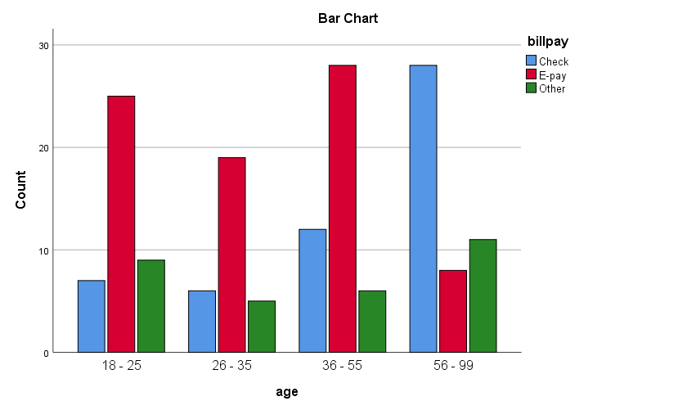

Fig 1 : Bar Chart of Categorical variables Age and Billpay

Interpretation of the Results:
- From the Chi Square test the obtained value of p =.000
- The value of p < .05 indicates that there is a statistically significant difference between the age group of people and their preferred bill-paying method. Therefore, we accept H₁

Hypotheses resolution:
Reject => H₀: There is no statistically significant correlation between the age groups of people and their preferred bill-paying method
Accept => H₁: There is a statistically significant correlation between the age groups of people and their preferred bill-paying method
Graphic Observation:
From the visual interpretation of the bar chart, it is quite evident that people of age groups (18-25), (26-35) and (36-55) predominantly preferred E-pay over other payment methods. Whereas, people of age group (56-99) predominantly preferred Check payment over other bill-paying methods.

Discussion on the Test
In a survey organised by Acme Bank, 164 persons from different age groups were asked to record the type of bill-paying method they prefer (E-pay, Check or Other). To help the bank in making crucial decisions, the association between the age group of respondent and the preferred payment method is taken into consideration. Since we are comparing two categorical variables, we perform the Chi Square test to assess the correlation between them.

According to the results of Chi-Square, we observed a statistically significant difference (p=.000, α = .05) in payment methods opted by people of different age groups. On an average at least 60% of people from age groups (18-25), (26-35) and (36-55) predominantly preferred E-pay. On the contrary, 59.6% of people in (56-99) age group predominantly preferred payment by Check and only 17.0% accounted for E-pay. Summing up, 80 out of 164 preferred E-pay, contributing to a leaping 48.8%, Check payment stood second with 32.3%
And 18.9% of people preferred other payment methods.

Since the value of p < .05, we reject H₀ and accept H₁. Therefore, there is a statistically significant correlation between the age groups of people and their preferred bill-paying method.

Exercise Number: Ch 09 - Exercise 01B
Dataset Used : [DataSet1] C:\Users\Jaya Karthi Booven\Desktop\SPSS\9.1\Ch 09 - Exercise 01B.sav
Selection of Test:
The primary objective of the given exercise is to assess the correlation between two categorical variables. Hence, we prefer Chi-Square test
Hypotheses:
H₀: There is no correlation between the age groups of people and their preferred bill-paying method
H₁: There is a correlation between the age groups of people and their preferred bill-paying method

Pre-test Checklist for Chi-Square
The only pre-test condition for running Chi-Square is,
- n>=5 per cell in the crosstabulation

Description of the Test : Pre-Test Conditions for Chi-Square
Pre-Test Condition 1 : n>=5 per cell in the crosstabulation

Warning # 5281. Command name: GET FILE
SPSS Statistics is running in Unicode encoding mode. This file is encoded in a locale-specific (code page) encoding. The defined width of any string variables are automatically tripled in order to avoid possible data loss. You can use ALTER TYPE to set the width of string variables to the width of the longest observed value for each string variable.

DATASET NAME DataSet1 WINDOW=FRONT.
CROSSTABS
/TABLES=age BY billpay
/FORMAT=AVALUE TABLES
/STATISTICS=CHISQ
/CELLS=COUNT ROW COLUMN TOTAL
/COUNT ROUND CELL
/BARCHART

Crosstabs

Case Processing Summary
 | Cases
 | Valid |  | Missing |  | Total
 | N | Percent | N | Percent | N | Percent
age * billpay | 300 | 100.0% | 0 | 0.0% | 300 | 100.0%

age * billpay Crosstabulation
 |  |  | billpay |  |  | Total
 |  |  | Check | E-pay | Other | Total
age | 18 - 25 | Count | 6 | 53 | 18 | 77
age | 18 - 25 | % within age | 7.8% | 68.8% | 23.4% | 100.0%
age | 18 - 25 | % within billpay | 14.0% | 26.0% | 34.0% | 25.7%
age | 18 - 25 | % of Total | 2.0% | 17.7% | 6.0% | 25.7%
age | 26 - 35 | Count | 8 | 39 | 9 | 56
age | 26 - 35 | % within age | 14.3% | 69.6% | 16.1% | 100.0%
age | 26 - 35 | % within billpay | 18.6% | 19.1% | 17.0% | 18.7%
age | 26 - 35 | % of Total | 2.7% | 13.0% | 3.0% | 18.7%
age | 36 - 55 | Count | 10 | 62 | 11 | 83
age | 36 - 55 | % within age | 12.0% | 74.7% | 13.3% | 100.0%
age | 36 - 55 | % within billpay | 23.3% | 30.4% | 20.8% | 27.7%
age | 36 - 55 | % of Total | 3.3% | 20.7% | 3.7% | 27.7%
age | 56 - 99 | Count | 19 | 50 | 15 | 84
age | 56 - 99 | % within age | 22.6% | 59.5% | 17.9% | 100.0%
age | 56 - 99 | % within billpay | 44.2% | 24.5% | 28.3% | 28.0%
age | 56 - 99 | % of Total | 6.3% | 16.7% | 5.0% | 28.0%
Total |  | Count | 43 | 204 | 53 | 300
 |  | % within age | 14.3% | 68.0% | 17.7% | 100.0%
 |  | % within billpay | 100.0% | 100.0% | 100.0% | 100.0%
 |  | % of Total | 14.3% | 68.0% | 17.7% | 100.0%

Discussion
- The value of n is at least 5 per cell in the crosstabulation. Therefore, the pretest condition for Chi-Square is met. Hence, proceed with the Chi Square Test.

Description of the Test : Chi-Square
Chi-Square Test

Chi-Square Tests
 | Value | df | Asymptotic Significance (2-sided)
Pearson Chi-Square | 10.508ª | 6 | .105
Likelihood Ratio | 10.359 | 6 | .110
Linear-by-Linear Association | 4.866 | 1 | .027
N of Valid Cases | 300

a. 0 cells (0.0%) have expected count less than 5. The minimum expected count is 8.03.

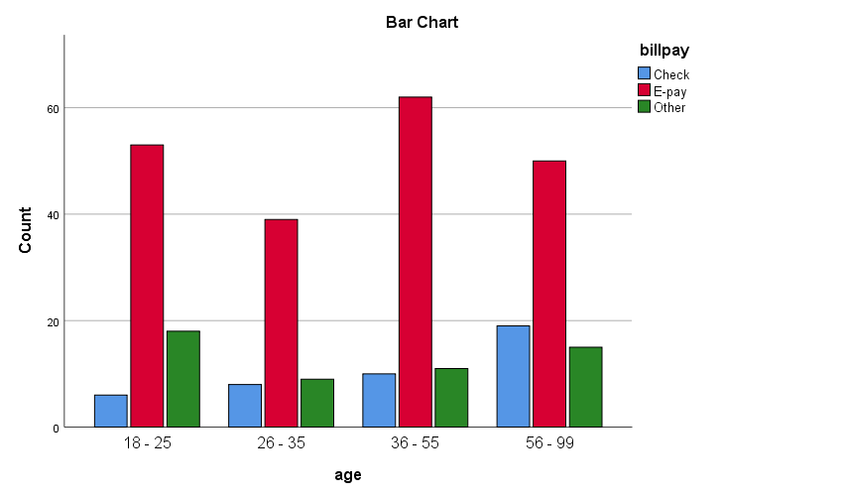

Fig 1 : Bar Chart of Categorical variables Age and Billpay

Interpretation of the Results:
- From the Chi Square test the obtained value of p =.105
- The value of p > .05 indicates that there is a no statistically significant difference between the age group of people and their preferred bill-paying method.

Hypotheses resolution:
Accept => H₀: There is no statistically significant correlation between the age groups of people and their preferred bill-paying method
Reject => H₁: There is a statistically significant correlation between the age groups of people and their preferred bill-paying method

Graphic Observation:
From the visual interpretation of the bar chart, it is quite evident that people of all the age groups (18-25), (26-35), (36-55) and (56-99) predominantly preferred E-pay over other payment methods.

Discussion on the Test
In a survey organised by Acme Bank, 300 persons from different age groups were asked to record the type of bill-paying method they prefer (E-pay, Check or Other). To help the bank in making crucial decisions, the association between the age group of respondent and the preferred payment method is taken into consideration. Since we are comparing two categorical variables, we perform the Chi Square test to assess the correlation between them.

According to the results of Chi-Square, we observed no statistically significant difference (p=.105, α = .05) in payment methods opted by people of different age groups. On an average nearly 60% of people from all different age groups preferred E-Pay, where, 74.7% of people of age group (36-55) and 69.6% of (26-35) age group people topped the list of people who preferred E-Pay the most. To Sum up, 68.0% of the total respondent preferred E-Pay. About 17.7% preferred other payment methods and a feeble 14.3% preferred payment by Check.

Since the value of p > .05, we reject H₁ and accept H₀. Therefore, there is no statistically significant correlation between the age groups of people and their preferred bill-paying method.

